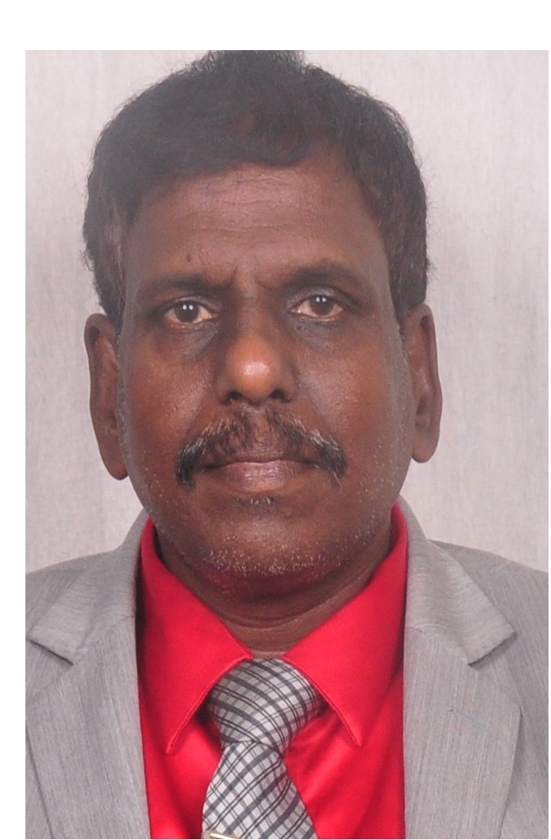

Swiss-cheese ventricles
Ramachandran Muthiah
Morning star hospital, Marthandam, Kanyakumari district, India
Abstract
Myocardial rupture is a laceration or tearing of the ventricular wall and most commonly occurs in the setting of acute myocardial infarction. Ischemic myocardial rupture occurs between the time of collagen degradation and the laying down of new fibrous tissue (2-14 days) and typically seen between 3 to 5 days after infarction. It is more common in patients aged > 60 years and usually seen in women (1.4 : 1). Common sites of myocardial rupture are anterior or lateral walls and a mid ventricular position along the apex to base axis is most frequent (66%). Blow-out and ooze ruptures are the other pathological variations sometimes used. Historically, the first clinical reference to post-infarction left ventricular wall rupture was reported by William Harvey in 1647. London and London in an analysis of 1000 cases of fatal myocardial infarction found that 50% of ruptures occurred within 3 days and 89% within 14 days. Multiple sites of rupture in the left ventricular myocardium including the interventricular septum following an acute myocardial infarction is uncommon. Even though most of the ventricular ruptures occur in the free wall of the left ventricle, the rupture occurs in the interventricular septum in approximately 15 to 20% of cases. Acute onset of shortness of breath, chest pain, diaphoresis, unexplained emesis, cool and clammy skin and syncope may herald the onset of ventricular septal rupture in acute myocardial infarction. Postinfarction ventricular septal defects may be small or multiple or consists of linear tears and coexisting with left free wall rupture and it resembles the Emmantel Cheese, a yellow, medium-hard cheese, riddled with holes that originate in the area around Emmantel in Switzerland and so described as “Swiss-Cheese” ventricle.
Medical therapy is initiated in an attempt to stabilize the patient hemodynamically by reducing the afterload with vasodilators and by increasing the cardiac output with inotropic agents. Intravenous nitropglycerin is the preferred agent. Transcatheter closure of ventricular septal rupture by using Amplatzer septal occluder may be the treatment of choice in patients with subacute ventricular septal rupture. Serpigenous defects may complicate significant leakage around the defect and freshly infarcted myocardium may exhibit ongoing necrosis and making device instability. Surgical intervention is the most important factor determining the outcome and in-hospital survival and confer a survival rate as high as 75%. The time between the onset of acute myocardial infarction and surgical intervention is the most important factor determining the outcome and in-hospital survival. The ideal time for surgical repair is 2-3 weeks after the rupture when the edges of the defect become firmer and fibrotic. When multiple defects are present, they are concealed by the trabeculae of the ventricle and there is difficulty in defining the borders of the defect and so poor surgical results may occur. In such cases, a technique of endocardial patch with infarct exclusion is performed by avoiding the damage to the dysfunctional right ventricle and to restore the geometry of left ventricular myocardium.

Biography
Ramachandran Muthiah, Consultant Physician & Cardiologist, Morning star hospital, Marthandam, Kanyakumari District, India. Born in a small village at Keezhkulam on 10/5/1966 and father (Muthiah) belongs to Enayam Thoppu and mother (Swornam from Keezhkulam) and parents were farmers and having one sister (Litta Padmavathi, a private school teacher). Got married Rajula Shanthi, a PhD scholar in Agriculture sciences in 1992 from North street, Marthandam at Vilavancode Assembly limits of Kanyakumari District, who worked as scientist at Sugarcane breeding Institute at Coimbatore under Indian counsil of Agriculture, Govt of India, New Delhi, having one son (with mother), got separated as exparty- divorce in 2004. School education at Govt primary school at Ananvilai, Keezhkulam and higher school education at Concordia Higher Secondary School, Pootteti in Therubukadai near Kaungal in Kanyakumari District .Medical graduation from Tirunelveli medical college (1988-MBBS (Madurai kamaraj), MD (1996-Tirunelveli, DM (2003- Madurai under Tamil Nadu Dr.MGR Medical University and completed 6 months course in Interventional cardiology at Batra Heart centre, New Delhi under National Board of Examinations, Ministry of Health, Govt of India. Worked as medical officer in Rural health services for 5 years (keezhachekarakudi Primary health centre in Thoothukudi District, Aryapapuram Primary health centre near Tenkasi in Tirunelveli District, ESI hospital, Singanallur in Coimbatore) and in teaching category as Assistant Professor at Madras, coimbatore, thoothukudi and kanyakumari medical colleges and Professor at Dr.SMCSI Mission hospital & Medical college, Karakonam, Trovandrum and Azeezia Medical college, Kollam in Kerala state..
Research Interests
Published many papers in Cardiosource, American College of Cardiology Foundation, Case Reports in Clinical Medicine (SCIRP) and Journal of Saudi Heart Association. Special research on Rheumatic fever and Endomyocardial fibrosis in tropical belts, Myxomas, Ineffective endocarditis, apical hypertrophic cardiomyopathy, Ebstein’s anomaly, Swiss cheese ventricles, Mineralization of heart valves, Aortic dissections, Rheumatic Taussig-Bing Heart, Costello syndrome and Tetralogy of Fallot and acute pancreatitis.
Author details & contacts
Full name : Ramachandran Muthiah
- mail ID : cardioramachandran@yahoo.co.uk
Landline +91 7598755201 (relative house- Palaninta vilai, keezhkulam-629193,
Kanyakumari district, Tamil nadu state, India
Mobile : +91 7598755201

