Multi-center Experience: Early outcome of Mitral Valve Repair in Patients with Ischemic Mitral Regurgitation
∗Mohamed Abdelwahab Hussein,∗∗ Ayman Ramadan Abdelrehim,∗∗∗ Yasser Shaban M. Mubarak***
* Al Azhar University, assistant professor of cardiothoracic surgery, consultant of cardiac surgery at Madinah Cardiac Center KFH, zado33@ yahoo.com. ** Menoufya University, lecturer of cardiothoracic surgery, Ayman_elmeghawry@yahoo.com, ORCID: 0000-0002-1947-2839. *** Minia University, assistant professor of cardiothoracic surgery. yassermubarak73@gmail.com, ORCID: 0000-0001-8460-2778.
Corresponding Author: Yasser Shaban Mohamed Mubarak. Tel: +966560708223.
Abstract
Background: Ischemic mitral regurgitation (IMR) is associated with poor outcomes. The optimal surgical strategy for management of IMR is still debated. The objective of this study is to evaluate early mortality and morbidity of mitral valve repair (MVr) in patients with IMR undergoing coronary artery bypass grafting (CABG).
Patients and Methods: We performed a retrospective, observational; cohort study was undertaken of prospectively collected data on 136 consecutive CABG patients with IMR undergoing MVr between January 2016 and January 2020. Perioperative echo findings, operative procedure, and outcome were analyzed.
Results: The overall mortality rate was 4.4%. Mitral valve repair with low Ejection Fraction (EF) has a 4-fold increase in the risk of death compared with MVr with preserved EF >30%. However, after adjusting for preoperative risk factors, the number of grafts was not an independent risk factor for mortality (OR 0.18, 95% CI 0.03–2.81, P = 0.84). Multivariable analysis showed that preoperative LVEF (OR 1.14, 95% CI 0.82–4.86, P = <0.01), and preoperative LVESD (OR 1.03, 95% CI 0.65–3.51, P = <0.01) and preoperative LVED (OR 0.99, 95% CI 0.64–3.28, P = 0.04) were independent risk factors of mortality.
Conclusions: MV Repair can be performed safely, concomitantly with CABG, in patients with (moderate, moderately severe, and severe) IMR.
Keywords: Ischemic Mitral Regurgitation, Mitral Valve Repair, Coronary Artery Bypass Grafting, Annuloplasty.

Introduction:
IMR is not a valve disease by itself because mitral valve leaflets are normal. It is a Functional MR (FMR) or Secondary to infarction. It is a sequence of tethering force and annular dilatation. Its incidence is approximately 1/5 of acute myocardial infarction (AMI) and 1/2 of congestive heart failure (CHF) [1].

One of mechanical complications of MI is IMR and it is associated with poor outcome. IMR is classified into acute and chronic; acute IMR develops within a week after AMI, due to rupture of papillary muscle, and chronic IMR develops more than one week and associated with segmental left ventricle (LV) wall motion abnormalities. IMR most frequently develops after inferior MI (38%) and anteroseptal MI (10%) [1, 2].

After MI, there is often progressive LV remodeling and dilatation, that leads to mitral annular (MA) dilatation especially anteroseptal dimension, loss of papillary muscle systolic shortening, increased inter-papillary muscle distance and displacement of the papillary muscles posteriorly, laterally, and apically. Tethering of the mitral leaflets lead to more apical position of the leaflets and their coaptation point and characteristic deformity of AML described as seagull sign in echo [3]. Carpentier classification of IMR is; mainly type IIIb, less common type I, and rare Type II [4].

Management of IMR has been an issue of continued debate for several decades. The possible therapeutic approaches are: mitral valve replacement (MVR) with CABG, MVr with CABG, or CABG alone. CABG alone has proven not adequate for severe mitral regurgitation (SMR), with an evidence of persistence MR up to 77% of cases. IMR reduces survival even after CABG [5, 6]. IMR according to degree of severity is associated with an increased risk of mortality and heart failure, [1,7]. MVr or MVR can eliminate or decrease MR in most cases. Although MVr or MVR did not reveal any significant differences in survival, but MVr is associated with lower in-hospital mortality [5, 6].

IMR in the setting of ischemic cardiomyopathy (ICM) portends a poor prognosis. Combined MVr with CABG are result in lesser post-operative MR compared with CABG alone. MVr was performed with downsized complete rigid annuloplasty ring which is the procedure of choice for IMR [8,9]. Complete annuloplasty ring is decreasing mitral leaflet strain and improving leaflet coaptation geometry, and enhance repair durability. Also, Cosgrove flexible band is designed for preserving MA dynamics. It has been suggested that the saddle shape and the sphincter mechanism of the mitral valve can be preserved for up to five years after implantation of this band [10].

Patients and Methods: - Data were collected from our records after obtaining clearance from the institutional ethics committee. Cases of CABG with MVr are 136 cases from 945 cases of CABG alone or with other procedure.
Inclusion criteria:- CABG with MVr for moderate and more IMR.
Exclusion criteria: - Redo – OPCAB - CABG alone – CABG with MR rather than ischemic – CABG with MVR – CABG with other procedure rather than MVr.
Echocardiographic criteria of MR; vena contracta in IMR is not circular but is elongated. Severe IMR is defined; vena contracta > 7 mm, EROA ≥ 20 mm², regurgitant volume ≥ 30 ml, regurgitation fraction ≥ 50%, systolic flow in pulmonary vein is reversed. Moderate IMR is defined; EROA <20 mm2, regurgitant volume <30 mL, and regurgitant fraction <50%, systolic flow in pulmonary vein is biphasic
After a median sternotomy, pedicled left internal mammary artery (LIMA) and saphenous vein (SVG) were harvested. In case of emergency, IABP was inserted before induction of anesthesia, and cardiopulmonary bypass (CPB) was established with LIMA harvested on pump or only SVG harvested. Once the aorta was cross-clamped and antegrade cold blood cardioplegia was given. Distal coronary anastomoses with the exception of LAD were performed first. Distal LIMA to LAD and proximal SVGs were done after MVrepair [figure (1)]. The mitral valve was exposed through a left atriotomy incision in most cases [figure (2,3)]. In cases of small left atrium (LA), both venae cavae were snared and trans-septal approach was performed. Downsizing the ring was determined after careful measurement of the height of the anterior mitral leaflet (AML). Rings were inserted using deep interrupted horizontal sutures using Ethibond 2-0 or Ti-Cron 2-0. MVr is performed using rigid complete ring (Carpentier-Edwards Physio). In (14) cases, posterior mitral leaflet are partially tethered to annulus and required release of secondary chordae along the length of annulus. Only in (2) cases, papillary muscle (PM) approximation or realignment was performed by 2-3 mattress 3/0 polypropylene sutures with PTEE pledget. Approximation was done between anterior and posterior PM in their muscle portion to come into contact with each other. Valve competence was visually tested before closure of the left atrium and by TEE after weaning off bypass. The rest of operation was completed classically. TTE was done before discharge and one-year follow-up was observed for morbidity and mortality. Major postoperative morbidity included postop. MI, IABP support, redo for bleeding, blood transfusion, pulmonary complications (including postoperative pneumonia and respiratory failure), stroke, renal failure (RF) requiring hemodialysis (HD), and deep sternal wound infection (DSWI).
Statistical analysis
Data was analyzed using SPSS software (version 18, IBM). Quantitative data were presented as mean ± SD (range). Qualitative data were presented as No. (%). Logistic regression was used for univariate analysis of continuous variables. P< 0.05 was considered significant.
Results
This is a retrospective, observational, cohort study that was undertaken of prospective collected data on (136) CABG patients with IMR undergoing MVr at multicenter [cardiac surgery departments at Minia, Menoufya, EL Azhar university hospitals and Madinah cardiac center] with one-year follow-up. Coronary angiography showed a predominance of 3-vessel disease (70%), and to a less extent 2 -vessel disease (5%), with only (25%) showing a hemodynamically significant left main lesion.

Table (1): Baseline characteristics and preoperative data.
Descriptive (n=136) | Variable
62.3±9.8 ( 16-91) | Age (years)
Male 95(69.9%)  Female 41(3.1%) | Sex
Mean±SD (range) 19.35±22  Median 12.8 | Total hospital stay (day)
Mean ± SD ( range) 13.6±18.9  Median 8.5 | ICU stay (day)
Elective 73 (53.7%)  Urgent 63 (46.3%) | Operative Status
Class I 4(2.9%)  Class II 34(25%)  Class III 74(55.4%)  Class VI 21(15.4%) | NYHA Class
71(52.2%) | CHF
Chronic 5 (3.7%)  Acute 7(5.1%) | Afib
33(24.3%) | Obesity
27(19.9%) | Smoking
127(93.4%) | Dyslipidemic
98(72.1%) | Diabetes Mellitus
79(58.1%) | HTN
12(8.8%) | Hypothyroidism
10(7.4%) | PVD
10(7.4%) | CVA
12(8.8%) | COPD
136.9±125.6 (53-854) | S.Creatinine
6.67±2.81(2-16) | Euro Score
+2 Moderate 17(12.5%) | Degree of MVR
+3 moderately severe 80(58.8%)
+4 severe 39(28.7%)
Severe 22(16.2%) | Tricuspid repair
58.2± 6.9 [44-74mm] | LVEDD (mm)
44.4 ± 8 [ 25-63mm] | LVESD (mm)
38 ± 10.6 [18-60%] | EF (%)
Mean age is above 60 years old and more predominant in male patients. Most cases of IMR are moderate +2&+3degree (71.32%), severe TR presents in 16.2%.

Table (2): Operative and postoperative data.
Variable | Descriptive ( n=136)
Bypass time (min.) | 122.2±50.1
Cross clamp time (min) | 101.8±43.5
Prolonged ventilation >24hrs. | 35(25.7%)
Pneumonia or chest infection | 20(14.7%)
Sternal wound infection  (SWI) | 25(18.4%) superficial SWI  2(1.5%) Deep SWI
Stroke | 3(2.2%)
Renal Failure | 8(5.9%)
Low cardiac output (LCO) | 42(30.9%)
Afib | 65(47.8%)
Grade I residual MR | 47 (34.6%)
Grade II residual MR | 16(11.8%)
Grade III residual MR | 3(2.2%)
Grade VI residual MR | 2(1.5%)
LVEDD (mm) | 54.8 ± 8.5 (33-75)
LVESD (mm) | 43.1 ± 9.3 (22-64)
EF (%) | 40.4 ± 10.9 (20-60)
S.Creatinine is (136.9±125.6), LCO is (30.9%), and renal failure (5.9%) is very low. Very success rate of repair without residual is (47.1%) and most of postoperative residual MR is mild (34.6%).
Table (3): Postoperative death
In hospital ≤ 30 days death | 3(2.2%)
Death during one year follow up | 3(2.2%)
Total mortality | 6 (4.4%)
Causes of death | Cardiac 4 (2.9%)  Infection 1 (0.7%)  MOF 1 (0.7%)
Table (4): Comparison between pre and postoperative echo data.
Variable | Preoperative | Postoperative | P.value
LVEDD (mm) | 58.2 ± 6.9 | 54.8 ± 8.5 | <0.01**
LVESD (mm) | 44.4 ± 8.0 | 43.1 ± 9.3 | 0.05*
EF (%) | 38.2 ± 7.8 | 40.4 ± 10.9 | 0.01*
LV dimensions are reduced postoperative and EF is improved significantly, when repair was performed by either band or ring.
Table (5): Mortality and other variables.
Variable | Lived (n=130) | Died (n=6) | P.value (significant)
Preoperative LVEDD(mm) | 58.4 ± 6.8 | 52.7 ± 8.1 | 0.04*
Preoperative EF (%) | 38.4 ± 7.6 | 31.4 ± 6.1 | 0.03*
Postoperative EF (%) | 40.7 ± 10.8 | 22.5 ± 9.4 | 0.02*
Age, sex, NYHA, obesity, smoking, hyperlipidemia, diabetes mellitus, hypertension, hypothyroidism, CVA, PVD, COPD, and preoperative LVESD are insignificant. Table (6): Univariate and multivariate predictors of mortality.
Variable | Univariate model  Odds ratio P.value | Multivariate model  Odds ratio P.value
LVEDD(mm) | 1.02 (0.71-3.64) 0.02* | 0.99 (0.64-3.28) 0.04*
LVESD(mm) | 1.08 (0.68-3.57) <0.01** | 1.03 (0.65-3.51) <0.01**
EF (%) | 1.26 (0.87-4.29) <0.01** | - 0.82-4.36) <0.01**
Implant type ( ring) | Odd Ratio 6.16(0.34-112.1) | P.value 0.22
Age, sex, obesity, smoking, hyperlipidemia, diabetes mellitus, hypertension, and NYHA are insignificant. Overall rate of mortality is (4.4%). MVr with low EF has a 3-fold increase in the risk of death compared with MVr with preserved EF (OR = 3.02, 95% CI 0.79-11.5, P = 0.03). The number of grafts was not an independent risk factor for mortality (OR 0.18, 95% CI 0.03–2.81, P = 0.84). Multivariable analysis showed that preoperative EF% (OR 1.14, 95%, CI 0.82–4.86, P = <0.01), preoperative LVESD (OR 1.03, 95% CI 0.65–3.51, P = <0.01) and preoperative LVEDD (OR 0.99, 95% CI 0.64–3.28, P = 0.04) were independent risk factors of mortality. All implant types are insignificant and their effects could be explained by the small sample size
Table (7): Operative data.
Variable | Numbers of patients
Median mitral ring size mm ( range) | ( 24-30)
Ring size 24 mm | 20
Ring size 26 mm | 56
Ring size 28 mm | 18
Ring size 30 mm | 2
Mitral band | 40
Mitral valve area cm2 | 2.7±0.75
No. of grafts ≤ 2 grafts | 30%
3 grafts | 60%
≥ 4 grafts | 10%
Table (8): implant manufacture
Descriptive ( n = 136 ) | Variable
93 (68.4%) | Ring ± cut of secondary chordae
41 (30.1% ) | Band ± cut of secondary chordae
2 (1.5%) | Ring with PM approximation
Table (9): Comparison between ring and band implant.
Variable | Ring implant  (n=95) | Band implant  (n=41) | P.value
Postop LVEDD(mm) | 54.1±7.9 | 56.6± 9.5 | 0.11
Postop LVESD(mm) | 42.4±8.5 | 45.3± 8.6 | 0.04
Postop EF (%) | 41.7±9.5 | 37.7±10.5 | 0.04
Death | 6 | 0 | 0.09

Discussion
CABG alone in case of severe IMR is not an acceptable surgical strategy, and in cases of moderate IMR did not improve MR and had negative impact on long-term survival [4]. CABG combined with MVA is superior to CABG alone with respect to reduction of MR and symptomatic improvement in early postoperative period [1]. So, all cases of moderate IMR in our study underwent MVrepair (16) cases (11.8%).

Mitral annuloplasty is performed in relatively low-risk CABG patients with moderate IMR whose symptoms are dominated by heart failure [4]. In our study, about (71) cases (52.2%) patients had CHF due to MI and IMR with low risk surgery had undergone MVr with CABG.

High annuloplasty failure rate are present in case of mitral annular diameter (MAD) ≥ 3.7cm, severe LV dysfunction, higher preoperative grade of MR, complex jet, increased LV sphericity and severe leaflet tethering [4]. In our study, most cases are moderately to severe (58.8%), MAD is (2.7 ±0.75), and EF is (38.2±10.6), so we have high rate of success.

In cases of severe IMR, undersized annuloplasty in lower risk CABG is recommended. However, in high risk patients, those with more severe CHF, emergency and those with high risk features for repair failure on preoperative echo, chordal sparing MVR is recommended [4] Our emergency operation is 63(46.3%) and Euro Score is (6.67±2.81), so MVr is well planned and has good success rate.

Instead of partial (C-ring) annuloplasty ring, a complete ring should be used to avoid recurrence of MR as anterior annulus may dilate as well. Chordal cutting of secondary chordae of anterior leaflet improve coaptation, reduce persistent IMR without impairing EF. PM approximation would reduce LV circumferential diameter, and reducing leaflet tethering [1]. In our study, mitral annuloplasty performed by complete ring in (68.4%) and band in (30.1%). PM approximation performed in (1.5%). Some cases needed cut of secondary chordae.

The results of the meta-analysis focusing on RCTs are of sufficient robustness to state that the combination of CABG and MVr can be performed safely, and that the benefit of eliminating MR with its associated adverse impact on LV remodelling supports the notion that a combined operation may be advantageous over isolated CABG [11]. In our study, IMR from moderate to severe even with low EF performed MVr, once CABG is indicated and low surgical risk except mild IMR or non-viable myocardium (CABG contraindicated).

The mechanism of IMR is the remodelling of LV, which may lead to annular dilatation and displacement of PM with leaflet tethering [12]. So, in our study, MVA ring or band with some cases of PM approximation preformed with CABG.

Although both MVr and MVR may improve outcomes, repair has been associated with better short-term outcomes and replacement with a more durable correction of the MR [13]. We recommended MVr in IMR, if repairable rather than CABG alone or MVR, with good result.

MVr with restrictive rigid ring has been associated with equal remodeling and mortality rates when compared with a MVR. Although patients had higher MR recurrence following a repair, the reoperation rates did not differ between the repair and the replacement groups [14]. We recommended long-term follow up after MVr and compared with MVR. Residual MR after MVr of (136) cases are mostly mild to trivial MR. Mortality in our study is (4.4%).

Although using UMRA looked promising by improving EF and NYHA class, there was still incidence of recurrences about 20-50% within a few years [9]. There is a relationship between the amount of non-viable LV segments, especially in posterior and inferior walls, and the recurrence of MR after the combined surgery [15]. Restrictive MVA combined with CABG can provide good results. Mitral annuloplasty in patients with moderate IMR is recommended [16]. Restrictive MVA can provide good results in patients with severe dilatation LV and tethering of leaflets without negative impact on the morbidity or mortality [17]. In our study, preoperative echo data helped us in decision making and TEE intraoperative give us idea about immediate result of repair. We have low rate of recurrence within one-year follow up. In some cases with low EF and irreparable IMR, we did not losing time but decision taken preoperative for MVR but not included in the study.

Ring annuloplasty is the favored treatment for addressing the MV component of IMR. A proposed surgical decision making tree for IMR taking into account the potential for LV remodeling and predictors of repair failure [18]. Preoperative AML tethering is a powerful predictor of MR recurrence after UMRA independently of LV geometry and LV dilatation. Assessment of leaflet tethering by 2D-echo should be incorporated into clinical risk assessment and prediction models [17]. So, in our study according to preoperative echo data some cases needed cutting of secondary chordae with UMRA to avoid failure and recurrent MR.

Some study concluded that MVA without addressing fundamental ventricular pathology is not sufficient to improve long-term clinical outcome. It is consensus that IMR occurs not from the valve itself but from the ventricular muscle. That study was underwent PM realignment or approximation [18]. So, preoperative echo data should include distance between PMs to recommend PM approximation as done in our study.
Study limitations short period of follow up, small number of patients and that is not comparative study.
Conclusions Mitral valve repair with CABG for IMR more than mild can be performed safely with improving symptoms, quality of life, decreased cost of readmission, low rate of recurrence, and without increasing mortality.
Abbreviations: IMR: Ischemic Mitral Regurgitation. CABG: Coronary Artery Bypass Grafting. MVr: Mitral Valve Repair. MVA: Mitral Valve Annuloplasty. MAD: Mitral Annular Diameter. CHF: Congestive Heart Failure. FMR: Functional Mitral Regurgitation MI: Myocardial Infarction. AMI: Acute MI. LV: Left Ventricle. LVESD: Left Ventricle End Systolic Dimension. LVEDD: Left Ventricle End Diastolic Dimension MA: Mitral Annulus. SMR: Severe Mitral Regurgitation. EROA: Effective Regurgitant Orifice Area. ICM: Ischemic Cardiomyopathy. PM: Papillary Muscle. COPD: Chronic Obstructive Pulmonary Disease. CVA: Cerebro-Vascular Accident. IABP: Intra-Aortic Balloon Pump. UMRA: Undersized Mitral Ring Annuloplasty. IHD: Ischemic Heart Disease. NYHA: New Yew Heart Association. PVD: Peripheral Vascular Disease. RCT: Randomized Controlled Trial. LM: Left Main coronary artery.
Conflict of interest: none declare.
Funding: The authors declare that they did not receive any funding.
Reference
[1] Varma PK, Krishna N, Jose RL, Madkaiker AN. Review Article: ischemic mitral regurgitation. Ann Cardiac Anesth. 2017: 20(4):432-39.
[2] Malhotra A, Sharma P, Garg P, Bishnoi A, Kothari J, Pujara J. Ring Annuloplasty for Ischemic mitral regurgitation: A single center experience. Asian Cardiovasc Thorac Ann. 2014:22(7); 781-86.
[3] Christos G. Mihos 1, Orlando Santana. Mitral valve repair for ischemic mitral regurgitation: lessons from the Cardiothoracic Surgical Trials Network randomized study. J Thorac Dis. 2016; 8(1):94-99.
[4] Mick S, Keshavamurthy S, Gillinov A. Mitral valve repair versus replacement. Ann Cardiothorac Surg. 2015; 4(3):230-37.
[5] LaPar D, Acker M, Gelijns A, Kron I. Repair or replace for severe ischemic mitral regurgitation: prospective randomized multicenter data. Ann Cardiothorac Surg. 2015;4(5):411- 16.
[6] Kulik A. Aortic Root Enlargement: Worth the Effort? Ann Thorac Surg 2010; 90:703–5.
[7] Ji Q, Xiao-Min Q, Jin-Qiang S, Yu-Lin W, Ye Y, Wen-Jun D, et al. Patients over 70 years of age with moderate ischemic mitral regurgitation undergoing surgical revascularization plus mitral valve repair: insights from a single-center study of propensity-matched data. Cardiovasc Diagn Ther. 2019; 9(6):568-77.
[8] Ahsan M, Rahman L, Islam S, Rahman M. case report: Aortic Root Enlargement In Case of Double Valve Replacement. KYAMC Journal. 2020;11(2): 108-10.
[9] Mohammad H, Bahare S, Mohammad A, Farshid A, Farideh R . Long-term effect of papillary muscle approximation combined with ventriculoplasty on left ventricle function in patients with ischemic cardiomyopathy and functional mitral regurgitation. Euro J Cardiothorac Surg. 2011; 40: 756—60.
[10] Wan S, Lee AP, Jin CN, et al. The choice of mitral annuloplastic ring—beyond “surgeon’s preference”. Ann Cardiothorac Surg. 2015; 4(3): 261-65.
[11]. Tomislav K, Hrvoje G, Carlos A, Davor M, Bojan B. Meta-analysis of concomitant mitral valve repair and coronary artery bypass surgery versus isolated coronary artery bypass surgery in patients with moderate ischemic mitral regurgitation. Euro J Cardiothorac Surg. 2016; 50: 212–22.
[12] Antonio L, Antonio M, Egidio V, et al. Mitral valve repair versus replacement in patients with ischemic mitral regurgitation and depressed ejection fraction: risk factors for early and mid-term mortality. Interact Cardiovasc Thorac Surg. 2014; 19: 64–69.
[13] Ferket B, Gorav A, Annetine C, et al. Cost-Effectiveness of Mitral Valve Repair Versus Replacement for Severe Ischemic Mitral Regurgitation .A Randomized Clinical Trial From the Cardiothoracic Surgical Trials Network. Circ Cardiovasc Qual Outcomes. 2018; 11:e004466. DOI: 10.1161/CIRCOUTCOMES.117.004466.
[14] Leonidas V, Roberto P, Prakash P, Yusuf S, Thanos A. A technical review of subvalvular techniques for repair of ischaemic mitral regurgitation and their associated echocardiographic and survival outcomes. Interactive Cardiovasc Thorac Surg. 2017; 25: 975–982.
[15] Sigita G, Egle U, Zaneta P, et al. Predictors of ischemic mitral regurgitation recurrence in patients undergoing combined surgery: additional value of cardiovascular magnetic resonance imaging. Interactive Cardiovasc Thorac Surg. 2018; 27: 222–28.
[16]Kallaf A, Elzayadi M, Alkady H, Elnaggar A. Result of coronary artery bypass grafting versus combined surgical revascularization and mitral repair in patients with moderate ischemic mitral regurgitation. The Heart Surgery Forum. 2020; 23 (3): 270-74.
[17] Kopjara T, Gasparovica H, Mestresb C, Milicicc D, Biocina B. Meta-analysis of concomitant mitral valve repair and coronary artery bypass surgery versus isolated coronary artery bypass surgery in patients with moderate ischemic mitral regurgitation. Euro J Cardiothorac Surg. 2016; 50: 212–22.
[18] George J, Shiv K, Rinett S. Surgical management of ischemic mitral regurgitation. Indian J Thorac Cardiovasc Surg. 2017; 33(3): 229–36.

Figure Legends

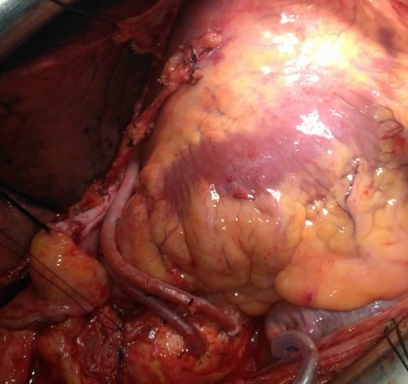
Figure (1):- CABG three-vessels [LIMA /LA D – SVG /D – SVG /OM] after Mitral Valve Repair.

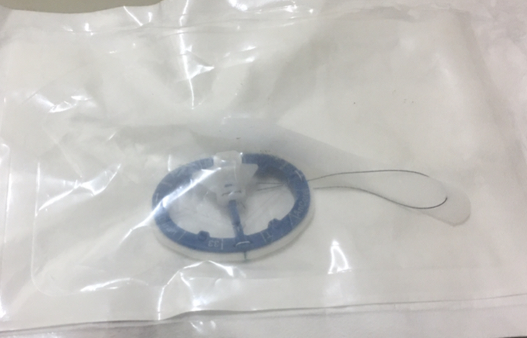
Figure (2):- Complete mitral annuloplasty ring.

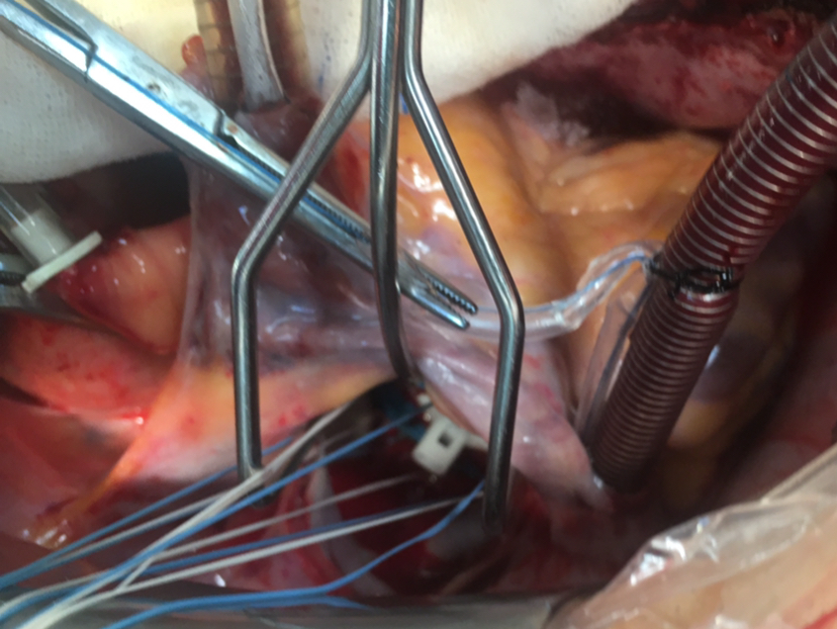
Figure (3):- Mitral Valve Annuloplasty with ring through left atriotomy after all distal anastomosis except LIMA to LAD.

