CASE REPORT
(DOUBLE TROUBLE – ADVANCED CORONARY BLOOD FLOW DIVERTION:a Coronary Subclavian Steal Syndrome)

Subclavian Artery stenosis/thrombosis in a post CABG patient while undergoing dialysis for CKD using Left AV fistula, presenting as ST elevation MI and Acute Limb Ischemia

Authors: Ryan D. Andal, M.D.¹, Jasmin Melissa Bernardo, M.D.², Joaquin Jison, M.D.^{3,}

¹ Fellow, Department of Cardiology, Makati Medical Center, Makati City
^{2, 3}Department of Cardiology, Makati Medical Center, Makati City
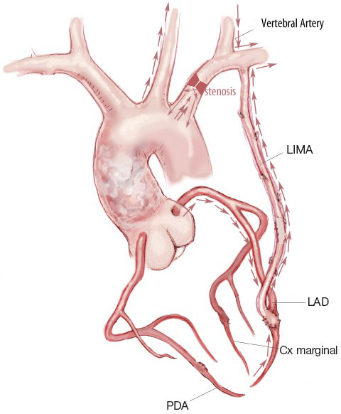
Diagram 1.Schematic representation of the circulation involved in coronary subclavian steal syndrome.
It shows flow diversion secondary to a proximal subclavian artery stenosis.

Introduction
Coronary subclavian steal syndrome is a rare disorder, mostly unrecognized and underdiagnosed , seen in patients developing subclavian artery (SA) stenosis after Coronary Artery Bypass Graft (CABG) using the LIMA –LAD graft diverting blood flow from the native coronary LAD back to the graft LIMA –LAD into the subclavian artery in a retrograde fashion. This is also the same for the vertebral artery where blood is diverted back from the brain into the subclavian artery.

This disorder causes significant symptoms which is brought about by ischemia coming from the heart, left upper extremity and the brain . It is a catastrophic event where only very few case reports have been described and reported .

Moreover, it has been also described that a coronary steal from a LIMA graft post CABG can present as angina while undergoing hemodialysis. This phenomenon is documented through cardiac catheterization with evidence blood flow steal from the internal mammary artery graft while on dialysis, without subclavian subclavian artery stenosis.
This is a case report of a patient with coronary-subclavian steal syndrome caused by a proximal subclavian artery stenosis in a post CABG patient with a LIMA-LAD graft aggravated by ongoing dialysis using AV fistula on the left arm. A combination f 2 phenomena that can lead to detrimental outcome if not treated appropriately though revascularization.

Case Presentation
We describe a case of a 58-year-old male, with history of diabetes mellitus , hypertension , post CABG using LIMA-LAD graft and Mitral valve replacement6 years ago,who developed Chronic Kidney Disease (CKD) requiring dialysis 3x a week , post AV fistula left arm a year ago. Since the bypass surgery, the patient had been doing well with no anginal symptoms andwas maintained. 1 week prior, he developed grade 3-4/10 chest heaviness, dull in character with associated headache and left arm pain while having dialysis using the left AV fistula. Hemodialysis (HD) blood flow rate was reduced to decrease the symptoms. He was generally weak post HD with shortness of breath on exertion. The symptoms persisted everytime during HD. On the day od admission , symptoms recurred and persisted until 30 minutes post HD now with severe intensity 10/10 chest pain radiating to left shoulder with associated left hand numbness , headache and shortness of breath.

On physical examination the patient had an interarmblood pressure difference of 110mmHg (40 palpatory BP in the leftarm and 149/83 in right arm),cold pale looking left upper extremity with faint pulses and poor capillary refill, no AV fistula bruit, left , whereas the pulses in the lower extremities were normal. There was no supraclavicular bruit. Electrocardiogram (ECG) showed sinus rhythm with ST elevation at v2-v4, 1st degree AV block (figure 1 ).

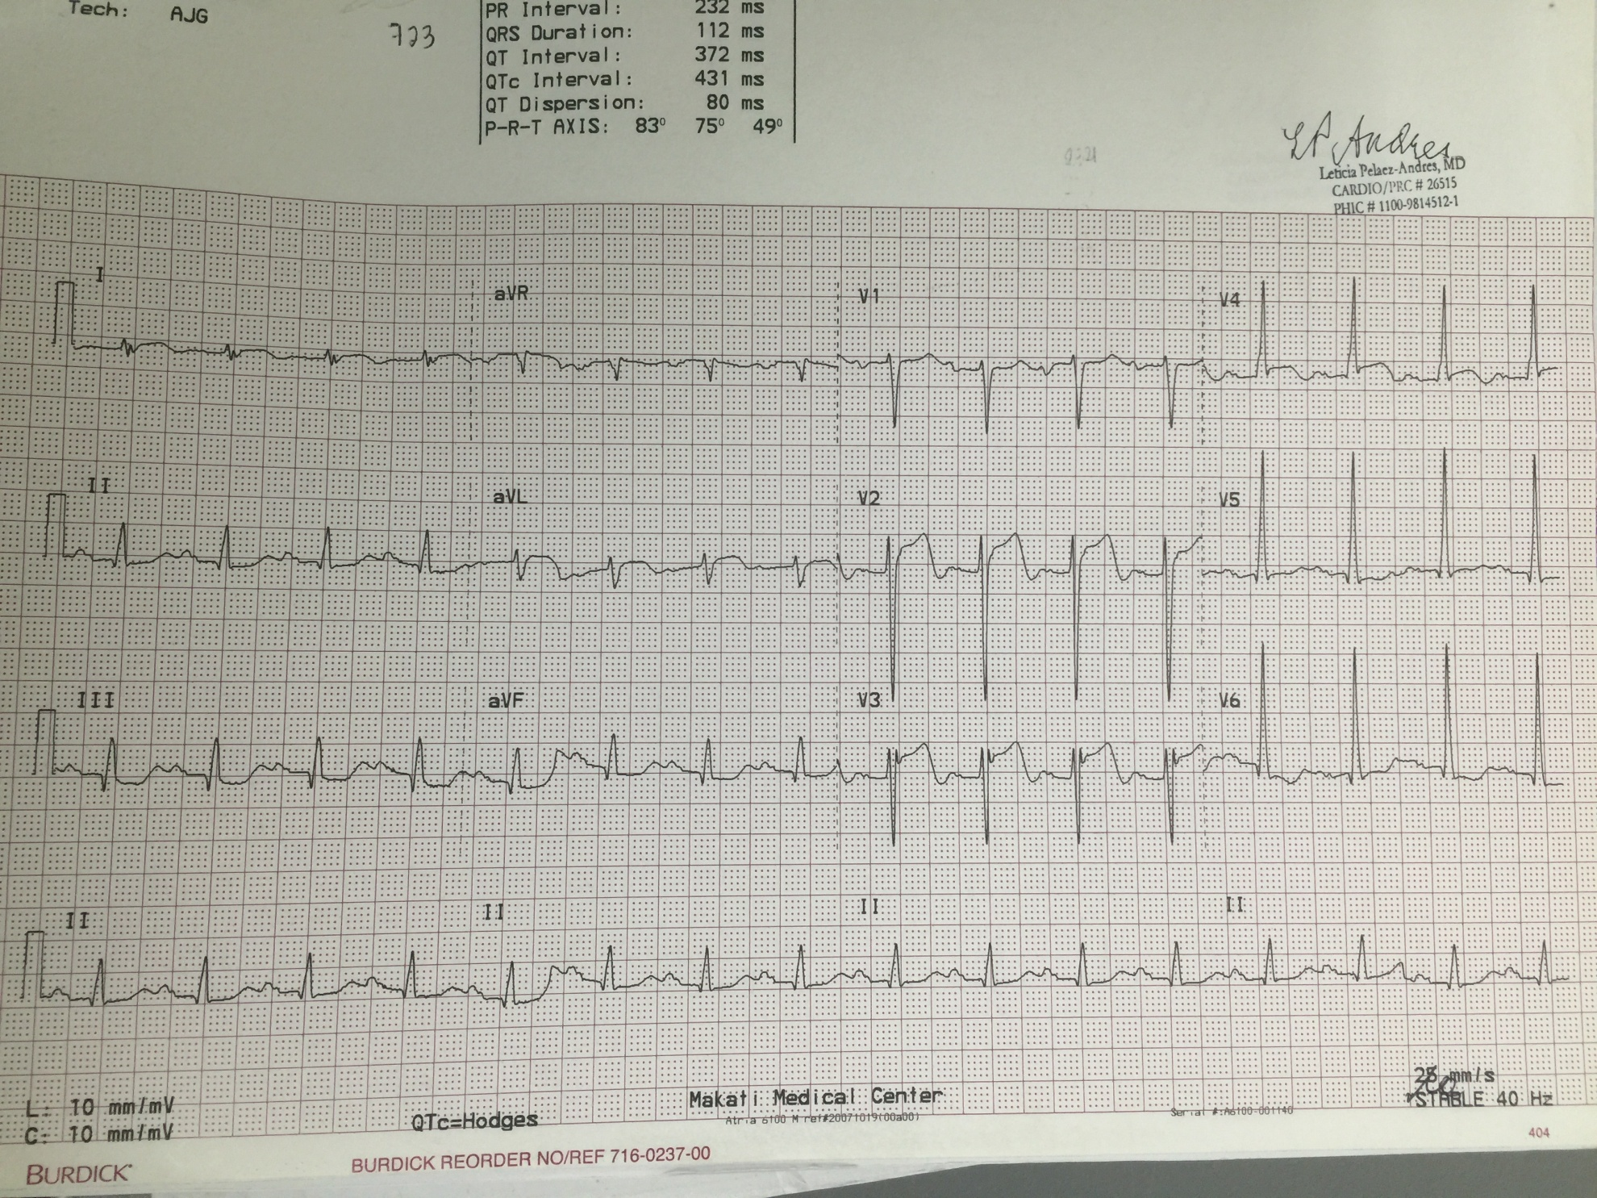
Figure 1.ECG tracing of the patient at the ER showing ST segment elevation

Chest X-Ray showed pulmonary congestion and beginning edema.Troponin I wasincreased to 0.54 ng/mL (normal range 0.00–0.04 ng/mL) , increased CPKMB 20.7. ABG showed hypoxemia, He was initially diagnosed with anteroseptal wall ST elevation myocardial infarction but given the patients symptoms of chest pain with radiation to left shoulder and probable acute limb ischemia , a Computed Tomography (CT) of the chest with constrast was done to rule out aortic dissection . (Figure 2)
There was no aortic dissection seen in the study , however, the patient was incidentally noted to have a short segment thrombus in the proximal left subclavian artery at its origin from the aortic arch, resulting in severe luminal stenosis or near total occlusion. Immediate referral to Vascular Surgery was done.

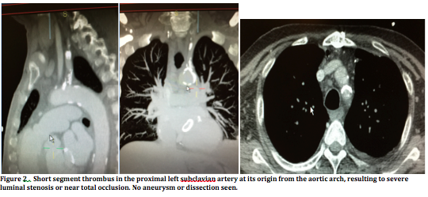

.

Left heart catheterization with coronary angiography,selective angiogram of the left subclavian and right brachiocephalic artery was performed. This confirmed the presence of a 90-95 percent occlusion at the proximal subclavian artery most probably due to a calcific plaque and or athrombus. Attempt was made to pass the guidewire through the occlusion but was unsuccessful. Since the lesion could not be percutaneously reperfused, decision to proceed to catheter directed thrombolysis was made with plansfor surgery afterwards. Vascular access for hemodialysis via right intra jugular veinwas inserted was made prior to thrombolysis.

A catheter directed streptokinase 250,000 IU was injected over 30 mins . Repeat angiogram after streptokinase infusion showed persistence of the occlusion despite thrombolysis. Hemodialysis was initiated post angiogram. Surgical options were discussed : carotid-subclavian, and subclavian subclavian artery bypasses; however, the patient declined surgical intervention due to the risks involved and financial considerations. There was slight improvement in the pulse, color and temperature of the left hand but the left AV fistula remain without bruit. Anticoagulation using enoxaparin and antiplatelets were given.

Repeat selective angiography of the SA showed calcified left subclavian artery with 10% narrowing at the base with good arterial flow all the way to the left brachial artery. The vertebral artery and LIMA-LAD grafts were patent.

No furtherintervention was contemplated at this point. The stenosis did not warrant angioplasty nor any surgical considerations. Anticoagulation was continued for prevention of further thrombosis. Vascular access was relocated by creating a right AV fislula.

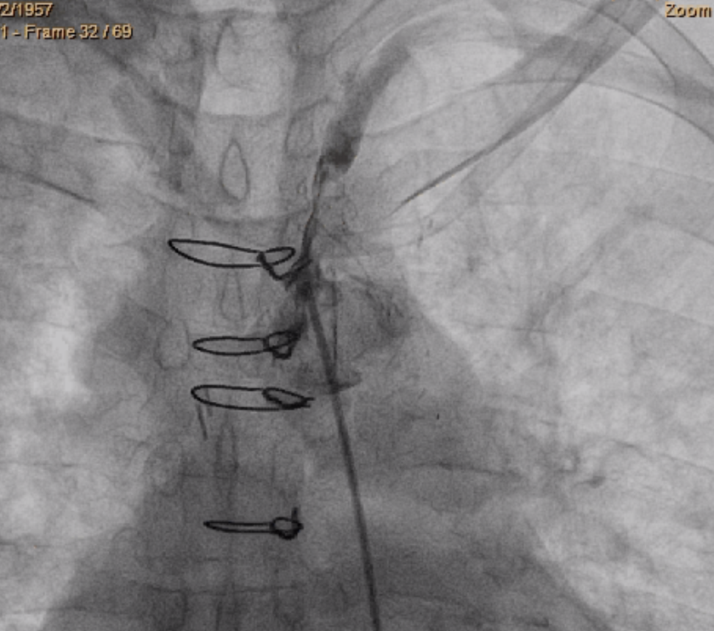
Figure 3. Selective subclavian angiogram shows the sub total occlusion (90%) of the proximal leftsubclavian artery with patent LIMA-LAD shown (arrow) but with poor flow . The vertebral artery was also seen to be patent .

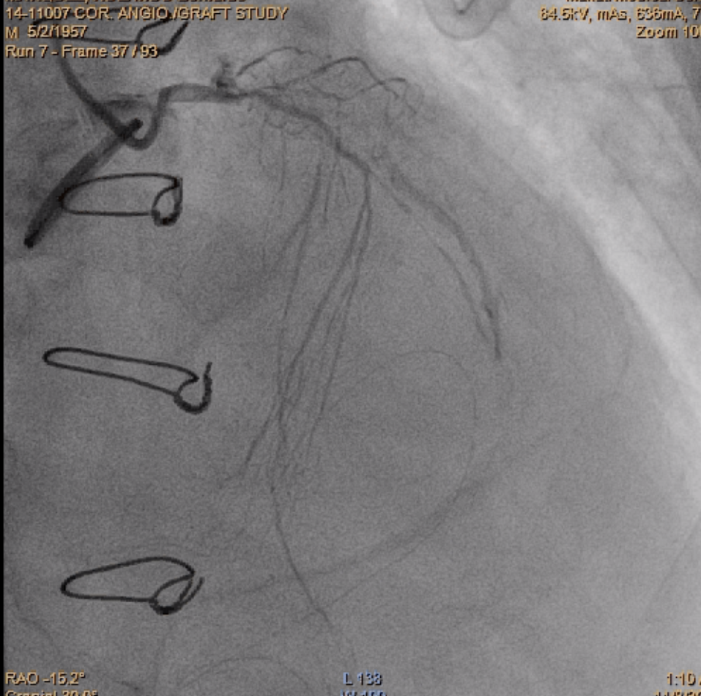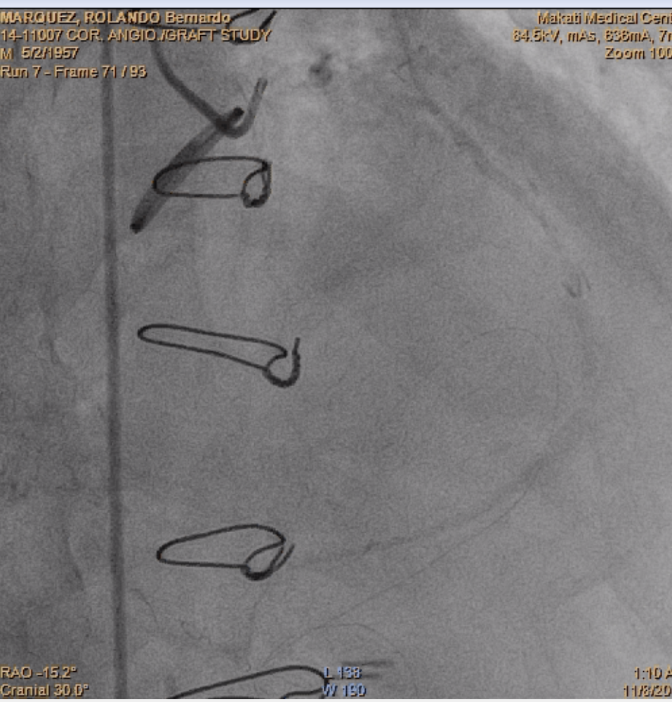
Fig. 4. A. Left coronary angiography reveals severe stenosis of the LADand circumflex artery.
B. Three seconds interval delay showing retrograde flow up to the LIMA graft .
(right anterior oblique projection).
LAD, left anterior descending;LIMA, left internal mammary artery.

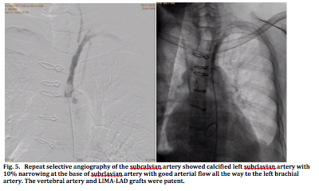

Discussion

Coronary subclavian steal syndrome is a rare cause of chest pain post CABG wheremyocardial ischemiais secondary to diversion of blood flow from the native coronary artery to the LIMA-LAD in a retrograde fashion supplying the more distal subclavian artery.

While the use of a LIMAgraft with CABG has become widely accepted as the standardof care, left subclavian artery stenosis can compromise anterogradeblood flow in the LIMA and if severe, can result in coronarysubclavian steal syndrome .

Ipsilateral subclavianartery stenosis is most commonly caused by atherosclerosis (1), or can be aggravated by other conditions such as vasculitic syndromes Takayasu arteritis(4), radiationarteritis (5)or from presence of hemodialysis AV fistula. (6). The presence of an AV fistula increases the blood flow rate going into the subclavian artery with preferential flow into the low resistance shunt. During dialysis the (Qb) , or blood flow requirement through the subclavian artery is magnified.Placement of AV access may result in increased cardiac output and increased cardiac oxygen demand in these patients. In the presence of a post CABG LIMA-LAD graft, it is documented though angiography of a retrograde flow through the LIMA-LAD during dialysis causing steal from the coronary arteries. (6) In this setting , the presence of a proximal subclavian artery stenosis would be catastrophic exhibiting a wide range of symptoms including neurologic , limb ischemia , and coronary symptoms from the profound coronary subclavian steal syndrome during dialysis. The closure of the AV fistula , left was able to help decrease the rate of steal effect .

SA stenosis /thrombosis in this patient has been associated with riskfactors such as age, hypertension, diabetes mellitus,smoking, and nonsubclavian vascular calcification (2) have been implicated . Mitral valvular replacement, and the presence of advanced atherosclerotic tendency of having dialysis using anipsilateral AV fistula has not been implicated.A history of peripheral vascular disease along with thepresence of an interarm blood pressure difference greaterthan 20mmHg has been proposed as clinical predictor of SA stenosis (7) . It is suggested that if there is a post CABG patient on dialysis, the presence of a supraclavicularbruit andan interatrial BP difference of at least 20 mmhg should be routinely done prior to dialysis detect early SA stenosis , especially if during dialysis they have symptoms of chest pain , vertebrobasilar insufficiencyincluding dizziness, syncope, ataxia, blurry vision, dropattacks, and limb ischemia like upper extremity claudication, and numbness would be valuable.

Definitive diagnosisis established with direct subclavian angiography, howeverroutine performance of this test prior toconsideration of coronary bypass surgery is ideal but impractical.
Alternative is arterial duplex scanning of upper extremity or venous mapping

Current treatment options for coronary subclavian artery stenosis include endovascularor surgical revascularization. The endovascular approachwith percutaneous transluminal angioplasty andperipheral stenting has been considered as first line treatment (8). In our patient this was not an option due to inability to advance the guidewire to the stenosed area.

Coronary subclavian steal syndrome has been reported to be successfully managed via thoracotomy with carotid-subclavian, axillo-axillary bypass, and transposition of the subclavian artery up to the common carotid artery or even to the aorta(9,10). Peri-operative mortality is low (0–0.8%), and stroke rate ranges from 0.5–5%. Five-year primary patency rates range from 92–95%, and 8–10-year primary patency ranges from 83–95%. (9)
In severe stenosis without revascularization, there is limited data on outcomes with medical management.
Finally, other causes of acute limb ischemia on top of subclavian stenosis lin in situ thrombosis or most especiallycardioembolic cuases like intermittent atrial fibrillation should be throuroughly investigated and ruled out for these patients may require prolonged indefinite anticoagulant to prevent events.
Close follow-up of such patients is of utmost importance, as any futurerecurrent symptoms could be fatal due to the underlyingfunctionally impaired conduit. Attention should be placed in considering site of HD access in post valve repair and post CABG requiring dialysis by carefully ruling out the presence subclavian artery stenosis by interarm BP measurements and if possible to perform also subclavian angiography whenever a post CABG patient on HD undergoes coronary angiogram.

Reference:

[1] Usman Younus, Brandon Abbott, Deepika Narasimha, and Brian J. Page et al., “Coronary Subclavian Steal Syndrome: An Unusual Cause of Angina in a Post-CABG Patient,” Case Reports in Cardiology, Volume 2014, Article ID 769273, 6 pages
[2] A. Prasad, C. L. Wassel, N. E. Jensky, and M. A. Allison,“The epidemiology of subclavian artery calcification,” Journalof Vascular Surgery, vol. 54, no. 5, pp. 1408–1413, 2011.
[3] R. S. Bilku, S. S. Khogali, and M. Been, “Subclavian arterystenosis as a cause for recurrent angina after LIMA graftstenting,” Heart, vol. 89, no. 12,Article ID 1429, 2003.
[4] A. Cardon, C. Leclercq, S. Brenugat, P. Jego, and Y. Kerdiles,“Coronary subclavian steal syndrome after left internal mammarybypass in a patient with Takayasu’s disease,” Journal ofCardiovascular Surgery, vol. 43, no. 4, pp. 471–473, 2002.
[5] M. C. Hull, C. G. Morris, C. J. Pepine, and N. P. Mendenhall,“Valvular dysfunction and carotid, subclavian, and coronaryartery disease in survivors of hodgkin lymphoma treated with
radiation therapy,” Journal of theAmericanMedical Association,vol. 290, no. 21, pp. 2831–2837, 2003.
[6] S. D. Crowley, D. W. Butterly, R. H. Peter, and S. J. Schwab,“Coronary steal from a left internal mammary artery coronarybypass graft by a left upper extremity arteriovenous hemodialysis
fistula,” The American Journal of Kidney Diseases, vol. 40, no.4, pp. 852–855, 2002.
[7] L. A. Osborn, S. M. Vernon, B. Reynolds, T. C. Timm, and K.Allen, “Screening for subclavian artery stenosis in patients: whoare candidates for coronary bypass surgery,” Catheterization andCardiovascular Interventions, vol. 56, no. 2, pp. 162–165, 2002.
[8] M. Henry, M. Armor, I. Henry, G. Ethevenot, K. Tzvetanov,and Z. Chati, “Percutaneous transluminal angioplasty of thesubclavian arteries,
[9]Olsen CO, Dunton RF, Maggs PR, Lahey SJ. Review of coronary-subclavian steal following internal mammary artery-coronary artery bypass surgery. Ann Thorac Surg 1988;46:675–678.
[10]Chung DA, Large SR. Relocation of the internal mammary artery graft in a case of coronary-subclavian steal. Thorac Cardiovasc Surg 2000;48:39–40
[11]. Figure 1 was edited from the image taken from a website , http://hmatter.blogspot.com/2014/05/coronary-artery-bypass-graft-surgery.html

