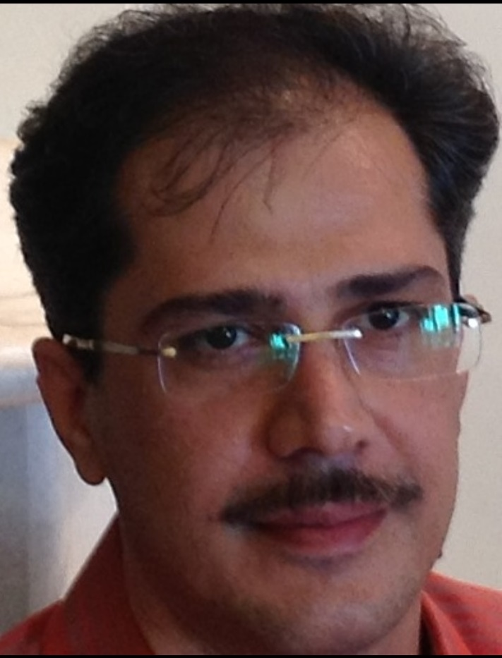

Name: bahram pourmehdi kasmai

shiraz university medical school

abstract: The first step. With the new method I offer in the treatment of various cancers, we are using antibiotic culture and treatment. Initially, cancer cells are biopsy, in environments We test different bacteria culture and then consider that group of cancer cells that are infected in a particular bacterial or viral environment. Step 2: Infect the cancer cells in a way that we take care of sepsis. The third step is the culturing of infectious cancer cells and the selection of antibiotics that are effective in the treatment.

Biography:I am a medical Dr.surgeory shiraz university medical school

