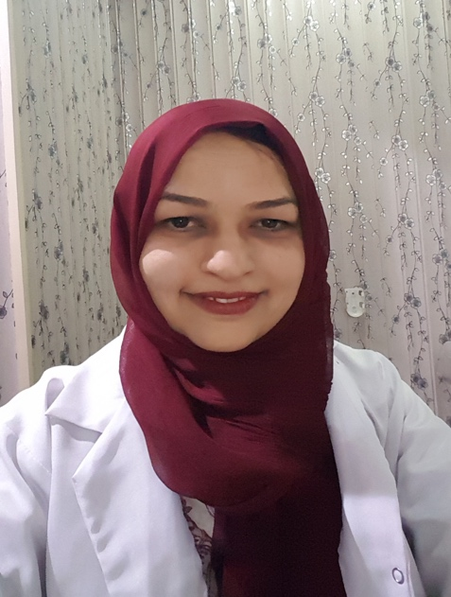

ONCOLOGICAL AND COSMETIC OUTCOMES OF ONCOPLASTIC BREAST SURGERY: A PIONEERING EXPERIENCE IN 3RD WORLD SETTING.

Saira Saleem ¹, Saadia Hamid ², Nayab Aliya³, Irshad Ahmad⁴, Bashir Ahmad⁵.
^{1,2,3,4,5} Madina Teaching Hospital & The University of Faisalabad, Pakistan

Abstract: In developing countries mastectomy has been the mainstay of treatment in operable breast cancers. However with increasing awareness, a good number of patients present at an early stage. So the surgical community needs to learn new techniques of oncoplastic breast surgery for breast conservation and reconstruction.
This manuscript aimed to assess the oncological and cosmetic outcomes of oncoplastic breast surgery as a pioneering experience in underprivileged patients of 3rd world setting. This observational, prospective study was conducted from January 2018 to April 2019 in the Department of Surgery, Madina Teaching Hospital, Faisalabad, Pakistan. Female patients with invasive breast cancer having tumour size of upto 5 cm in medium size breast, Locally advanced tumour after neoadjuvant chemotherapy, single focus tumour, preferably peripheral tumours and patients younger than 70 years were included in study. Main Outcome measures were margin involvement, time lag for the start of chemotherapy, local recurrence, metastatic disease, death number & patient satisfaction with cosmesis. 32 female patients underwent oncoplastic surgery. In 28 patients wide local excision and therapeutic mammoplasty was done while in 4 patients flap reconstruction was done. In 3 patients LICAP flap and in one patient AICAP flap was used. Regarding oncological outcome, in all cases except one, clear margins were achieved. Chemotherapy start time varied from 3 to 8 weeks after surgery. Local recurrence or metastasis was not noticed in any of the case. Majority of the patients (90.6%) gave excellent or good score to cosmetic outcome of surgery.
Key words: Oncoplastic surgery. Oncological outcome. Cosmetic outcome
Images:
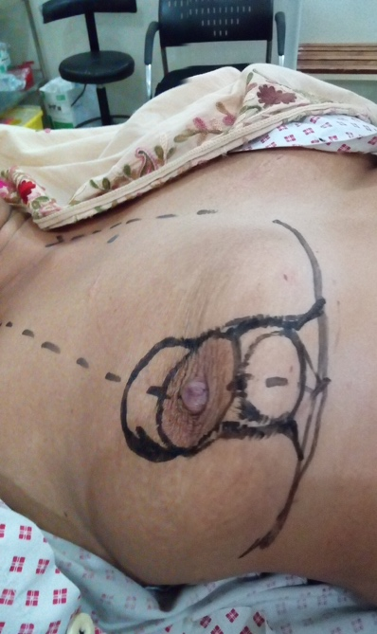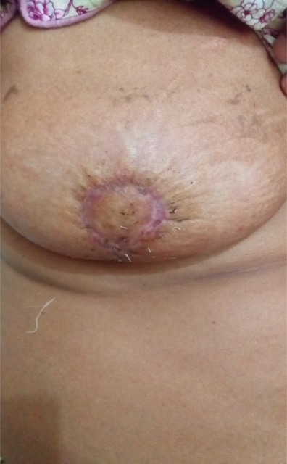
Fig 1: Central breast tumour managed by central quadrantectomy and grissotti flap reconstruction
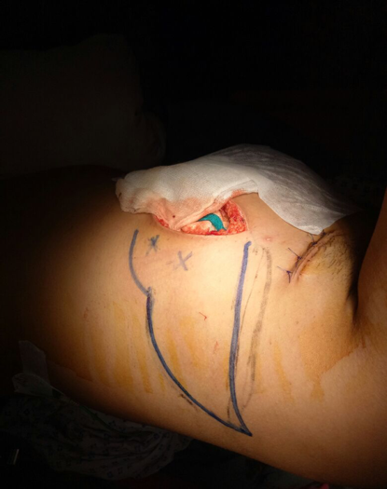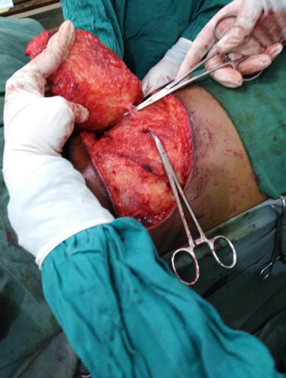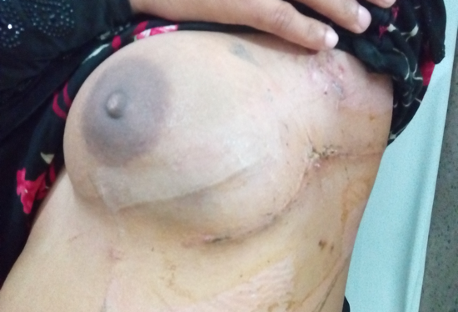
Fig 2: Licap Flap reconstruction after wide local excision of breast cancer
¹BIOGRAPHY:
Dr. Saira Saleem is working as Associate Professor Surgery (Pakistan). She did Surgery Fellowship from College of Physicians and Surgeons, Pakistan in 2004 and has been in specialist practice for 15 years. She has published 11 research articles in national and international journals. She received Royal College of Physicians and Surgeons Glasgow Travelling Fellowship award (2017) and learnt oncoplastic breast surgery (OPS) skills from Nottingham Breast Institute-UK. On coming back, she practiced innovative techniques of OPS and underprivileged patients of her country gained a great benefit. She was the organizing secretary of breast conference, seminars and workshops and speaker in national and international conferences.

RECENT PUBLICATIONS:
- Saleem S, Hayat N, Ahmad I, Ahmad T, Rehan AG. Risk factors associated with poor outcome in diabetic foot ulcer patients. Turkish J Med Sci 2017 12; 47(3): 826-831. Doi: 10.3906/sag-1602-119.
- Ahmad I, Saleem S, Anjum S, Rehan A G. Splenectomy; Postoperative Splenectomy Complications. Professional Med J Sep 2017;24(9):1322-6

PRESENTING AUTHOR DETAIL:
Full Name: Saira Saleem
Designation: Associate Professor of Surgery
Institution: Madina Teaching Hospital & The University of Faisalabad. Pakistan
Mobile No: 00923450771989
Official Email ID: dsairaijaz32@yahoo.com
Presentation Type: Oral presentation
Category: Invited talk
Track Number: Track 1-2
Research interest: Breast cancer
Date of Birth: 05-11-1975
Facebook: https//www.facebook.com/saira.saleem
Postal address: House No. 12, Ismaeel city, Daewoo Road,
Faisalabad (38000), Pakistan

