
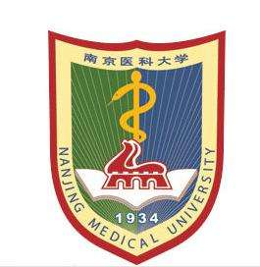

Title: Establishment of a Scoring Model based on MEWS for Predicting the Risk of Intra-abdominal Infection after Gastric Cancer Surgery
Name: Xu Xinyi, Xu Qin

Nanjing Medical University, Nanjing Jiangsu 211166, China

Objective To establish a simple, effective and practical scoring model based on MEWS for predicting risk of intra-abdominal infection (IAI) after gastric cancer surgery in order to identify and nurse high-risk patients. Methods A retrospective study was conducted on 683 patients with gastric cancer surgery. The risk factors of IAI were screened by univariate analysis and multiple logistic regression analysis. The risk prediction model was constructed according to the beta value of each risk factor in the model. Hosmer- Lemeshow test and the receiver operating characteristic (ROC) curve were used to evaluate the predictive compliance degree and discriminant validity of the model. The cut-off value of risk factors was determined according to ROC curve and Youden index and the classification criteria of IAI risk was determined based on the cut-off value and score. Results IAI rate was 9.22%. A established scoring model of IAI risk were postoperative WBC > 9.95 (1 point), heart rate > 98 (1 point), temperature > 37.5℃ (3 points), abdominal pain (3 points), abdominal distension (4 points). The validation indicated that the scoring system had higher predictive value (AUC = 0.987, 95%CI:0.948 - 0.999, P<0.05) and high goodness of fit (χ²=1.152, P = 0.997). The scoring table was further divided into low risk group (0~4 point), moderate risk group (5~7 point), high risk group (8~12 point). Conclusion The scoring model for predicting risk of IAI after gastric cancer surgery is effective and practical. However, a multicenter, large sample prospective study is needed for further validation.

Biography

Xu Xinyi is a postgraduate student studying in Nanjing Medical University, her major is gastrointestinal cancer care. She has published papers in reputed journals. Her tutor is Xu Qin. She is the dean of Nursing College. She has published more than 40 papers and has been serving as a committee member of Chinese Medical Association.

Presenting author details
Full name:Xu Xinyi
Contact number:+86 13776512060
Twitter account:
Linked In account:Xinyi Xu
Session name/ number:
Category: (Oral presentation/ Poster presentation)

