Retrograde tracheal intubation in Mongolia
Bolormaa Batnasan, MD, National Cancer Center, MONGOLIA
(Case reports)

Anesthesia process:The patient's back and place the O₂ mask using the 20 G intravenous IV Fentanyl 100 μg. We reported successful and un successful anesthesia retrograde tracheal intubations in NCC.
Case I. 03 June 2015. A 30 year-old male patient was posted for elective surgery head and neck department. The surgery required to recurrent tumor (d= 6cm) of Rt. Sub mandible gland T₂N₁M₀ do MND tumor remove. On examination of the airway, all parameters such as mouth not opening (he had big accidence and neck surgery in 2002, 2007, 2012). Chin-thyroid distance: less than 2 cm. Dentures, removable teeth. (Picture1.)

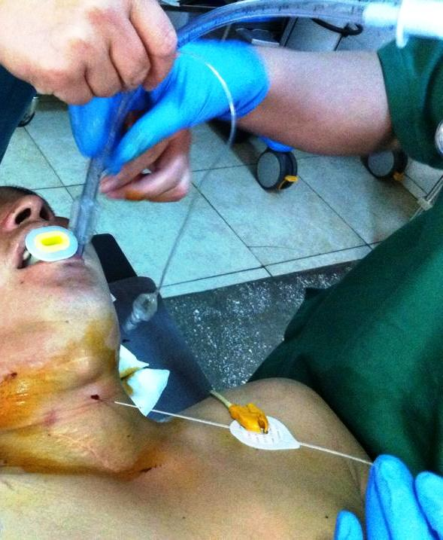
Case II. 19 Sep 2015. A 66 year-old male patient posted for emergency case head and neck surgery department. The patient had two surgeries NCC. First elective surgery was 17 Sep 2015 (required to big tumor resection and reconstruction by ALTFF in cancer mandibles) with normal intubation. Second emergency surgery was 19 Sep 2015(free plat to restore the blood supply and airway oxygen supply to increase) with retrograde intubation. He was breathing periodically interrupted. ( Picture 2.)
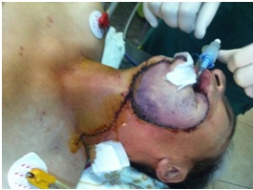
Case Ш. 11 Apr 2016. A 46 year-old male patient posted for elective surgery head and neck department. He was very (Fibroptic picture 3.) difficult slowly breathing. The patient had tongue (root) cancer surgeries NCC. Elective surgery required to big tumor resection with tracheostomy. We can`t put retrograde intubation. Because his was trachea d=0.2-0.3mm. After resection we know, it is intubation tube (size № 4-5.5) was too big.

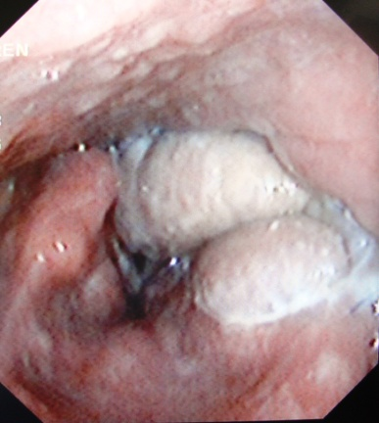

Case IV. 13 Jan 2013. A 57 year-old male patient posted for elective surgery head and neck department. The patient had surgery big tumor resection and reconstruction in cancer mandibles with successful anesthesia retrograde tracheal intubations in NCC. (Picture 4.)
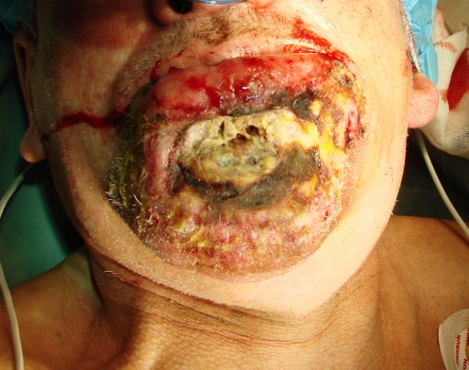
Discussion: Number of Retrograde Intubations in the Literature make an effort 539 Patients and 137 Cadavers. (http://clinicalgate.com/retrograde-intubation-techniques/). If high professional anesthesia team put retrograde intubation successful then, low trauma in patient, may be easier surgical team as fiberoptic and tracheostomy.
Recent Publications (minimum 5)

- Sasanka S. Aids to tracheal intubation. Anaesthesia up date. 2003;17:1.
- Mehta A, Daftary S. Retrograde intubation in a patient with post burns neck contracture. J Anaesth Clin Pharmacol. 2005;21:325–7.
- Bhattacharya P, Biswas BK, Baniwal S. Retrieval of retrograde catheter using suction, in patients who cannot open their mouth. Br J Anaesth. 2004;92:888–901. [PubMed]
- Hung OR, al-Qatari M. Light-guided retrograde intubation. Can J Anaesth 1997 Aug;44(8):877-82.
- Ramsey CA, Dhaliwal SS. Retrograde and submental intubation. Atlas Oral Maxillofac Surg Clin North Am 2010 Mar;18(1):61-8.
- Rosenblatt WH, Wagner PJ, Ovassapian A, Kain ZN. Practice patterns in managing the difficult airway by anesthesiologists in the United States. Anesth Analg 1998 Jul;87(1):153-7.
- Osborn IP, Cohen J, Soper RJ, Roth LA. Laryngeal mark airway – a novel method of airway protection during ERCP: comparison with endotracheal intubation. Gastrointest Endosc 2002 Jul;56(1):122-8.
- Raval C, Patel H, Patel P, Kharod U. Retrograde intubation in a case of ankylosing spondylitis posted for correction of deformity of spine. Saudi J Anaesth 2010 Jan;4(1):38-41.
- Tüfek A, Uçan MC, Tokgöz O, Çelik F, Ağaçayak S. Evaluation of retrograde intubation in patients with limited mouth opening. J Anesth 2013 Aug;27(4):631-2.
- Krishna R, Shenoy TV, Goneppanavar U. Airway management in an infant with congenital trismus: the role of retrograde intubation. South Afr J Anaesth Analg 2012 May;18(5):267-9.
- Sharma R . Retrograde nasal intubation technique in Pierre Robin Syndrome: a suggestion. Paediatr Anaesth 2010 Mar;20(3):281.
- Bissinger U, Guggenberger H, Lenz G. Retrograde-guided fiberoptic intubation in patients with laryngeal carcinoma. Anesth Analg. 1995;81:408–10. [PubMed]
- Roberts KW, Solgonick RM. A modification of retrograde wire–guided fiberoptic-assisted endotracheal intubation in a patient with ankylosing spondylitis. Anaesth Analg. 1996;82:1290–1. [PubMed]

 WORK EXPERIENCE
- 1997-1999 BUMBAT Co medical doctor, Tuv aimake, Mongolia
- 2000 since - Intensivist and Anesthesiologist doctor National Cancer Center of Mongolia
EDUCATION
- Master degree (2008 ) World Federation Society Anesthesiology – Training course in Thailand
- Hospital Management course ( 2009) Arab Republic of Egypt
- Anesthesiology Fellowship course ( 2010) Soul, Korea
- Studying doctorate Sep 2010 since in Medical University of Mongolia
- Anesthesiology Fellowship course ( 2012) Lausanne, Switzerland

Email: Batnasan_bolormaa@yahoo.com

Notes/Comments:

