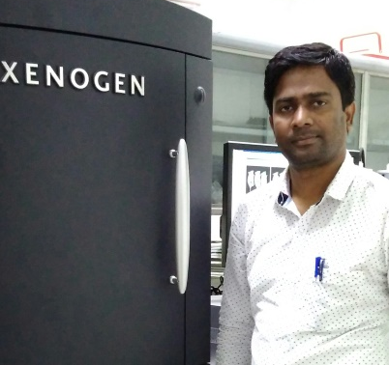

Title: Title: Red Emissive Liposomal Nanopitchers for Localized Diagnosis and Phototriggered Tumor Ablation
Rajendra Prasad†, Mahadeo Gorain§, Deepak S. Chauhan†, Amit S. Yadav§, Janhavi Devrukhkar†, Barkha Singh†, Mayur Temgire∆, Jayesh Bellare∆, Gopal Kundu§, Rohit Srivastava†
†Department of Biosciences and Bioengineering, Indian Institute of Technology Bombay, Powai, Mumbai, India, §Laboratory of Tumor Biology, Angiogenesis and Nanomedicine Research, National Center for Cell Science, Pune, India ,∆Department of Chemical engineering, Indian Institute of Technology Bombay, Powai, Mumbai, India

Abstract:

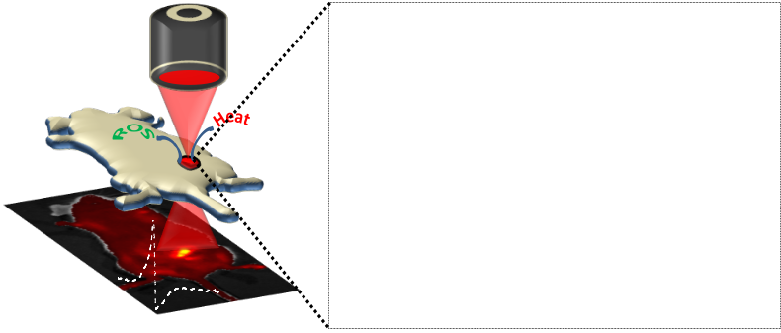
Selective targeting and phototriggered tumor ablation are remaining challenges in nanomedicine. Here, we report a light triggered platform viz., red fluorescent carbon dots liposomal nanopitchers for deep tissue visualization and on demand localized cancer therapy. Unsaturated carbon dots (C-dots), anchored to the liposomes, convert near-infrared (NIR) light into heat and produce Reactive Oxygen Species, cause phototriggered cell death and tumor regression. Monodispersed spherical particles show light mediated enhanced cellular uptake, release of Reactive Oxygen Species, specific tumor diagnosis, good photothermal response (62 °C in 5 minutes) and biocompatibility. Safe irradiation of 808 nm light produced on demand localized tumor ablation and bioresponsive degradation with minimum side effects.

Biography:
Mahadeo Gorain has completed his PhD at the age of 31 years from Forest Research Institute Deemed University, Dehradun, India in Forest (Entomology). After PhD he has joined National Centre for Cell Science (NCCS), Pune as Technician IVIS Imaging system facilities. He has published more than 15 papers in reputed journals like EMBO Report, Oncogene, JBC, Journal of Investigative Dermatology (JID), BMC Cancer, CDD, PlosOne etc and many more. He has a expertise specially in In-Vivo and Ex-Vivo (Mice and Rat) experiments.

