RETROSPECTIVE STUDY ON THE RELATIONSHIP BETWEEN TUMOR LOCATION, SIZE AND WHO GRADE IN MENINGIOMA AT TIKUR ANBESSA SPECILIZED HOSPITAL & MCM, ADDIS ABABA, ETHIOPIA


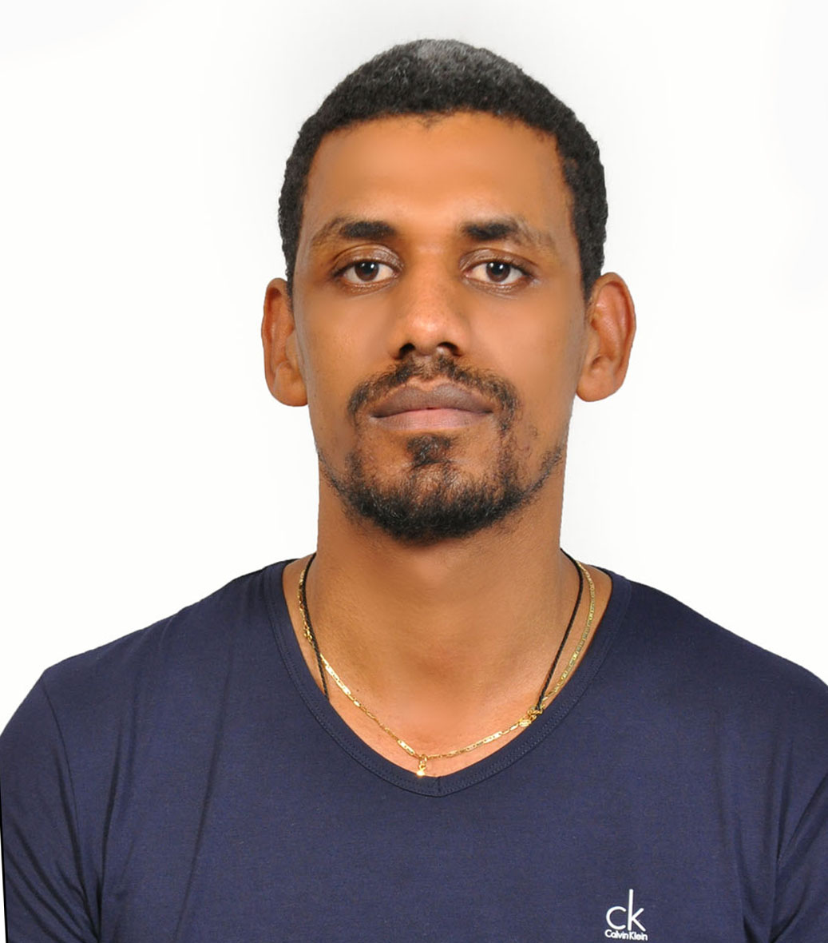
Name: Temesgen G. Assefa
Bahir Dar University

Abstract:
Objective: The objective of this study is to look for the relationship between tumor size and location with tumor grade in patients operated for intracranial meningioma at two neurosurgical training hospitals in Addis Ababa.
Methods: A retrospective clinical, neuroimaging and pathological data was collected from patients undergoing meningioma resection at Tikur Anbesa specialized teaching hospital and Myung sung Christian medical college hospital, between Jan, 2018 and Aug,2019. The largest tumor diameter on contrast enhanced MRI is used as tumor size. The location of a tumor is determined both from MRI and intraoperative finding and classified into skull base, non-skull base and intraventricular. 2016 WHO CNS tumor classification is used for tumor pathological grading. Univariate and multivariate logistic regression was done to investigate the relationship between tumor size and location with tumor grade.
Results: 192 patients were included in the study. Univariate logistic analysis was done if age, sex, tumor location and size were significantly associated with tumor grade. Age was not found to be a significant risk factor for atypical meningioma (P=0.29). Male sex was a significant predictor of tumor grade (OR 3.44, 95% CI 1.41-8.39, P=0.007). Larger tumor size was significantly associated with a meningioma being WHO grade II (P=0.028).Tumor location was found to be a significant predictor of being atypical meningioma, predicting that convexity, PSM and falx meningiomas have atypical WHO grade (OR 10.625, 95% CI 3.03-37.2, P=0.000). Up on multivariate logistic analysis,only tumor location was found to be independently associated with atypical meningioma (OR 6.93, 95% CI 1.828-26.275, P= 0.004). Non skull base meningiomas were associated with WHO grade II tumors.
Conclusions: In our series, tumor location is an independent risk factor for atypical meningioma but size or gender are not.
Biography: I am an assistant professor of neurosurgery in Bahir Dar University, Ethiopia. I am a newly graduated young neurosurgeon interested to be a clinician, academician and a researcher in the field of neurosurgery. I am currently involved in global neuro trauma outcome study which is a multicenter prospective study organized by university of Cambridge.
I finished my neurosurgical training in Addis Ababa university, Tikur Anbesa specialized teaching hospital which is supported by Haukeland University in Norway. I am currently serving as head of neurosurgery unit in department of surgery, college of medicine and health science.

