Molecular and hormonal evaluation of treatment induced infertility of female rats with Traditional Chinese herbs (Herba Leonuri and Radix Salviae Miltiorrhizae)
Ali M. Mutlag
PH.D. Assistant Prof., Wasit University, Iraq.

Abstract
Fertility in mammalian females is dependent on the growth of follicles, structural units consisting of an oocyte, granulosa cells, and theca cells with an extracellular matrix separating the cell layers. The ovaries play the key roles in reproduction and any impairment in their functions can results in either sterility or infertility. Traditional Chinese medicine (TCM) plays a very important role in health keeping. Alternative holistic therapies, such as Traditional Chinese Medicine, offer less invasive and less costly physical and emotional treatment compared with standard Western Medical treatment. However, awareness of TCM therapy for infertility is generally low and often not suggested by Western Medical practitioners. Western medical treatment could depress the blood pressure rapidly and surely through reducing blood volume and dilating blood vessels, while traditional medicine (TM) shows its superiorities in alleviating clinical symptoms, improving patients' quality of life, lessening or reversing the damage on terminal organs and preventing the occurrence of serious complication. Herba leonuri, also named Chinese Motherwort or Siberian Motherwort, belongs to the Labiatae family in the plant kingdom. Native to China, central Europe, Scandinavia and Russia, it is now naturalized in Japan, Java, Malaysia and North America. Radix Salvia miltiorrhizae (RSM), the root of Salvia miltiorrhiza Bunge, is one of the most widely used traditional herb medicines for the treatment of a variety of conditions. It is commonly used either alone or in combination with other herbs in traditional Chinese medicine for the prevention and treatment of numerous ailments, including coronary artery disease, hypertension, hyperlipidemia, stroke, renal diseases, and diabetes, peripheral and pulmonary vascular disease. Cadmium Chloride (CdCl2) used in this study to induced infertility of female Wister rats IP injection , many parameters were conducted in this study to evaluated the treatment using Chinese herbs mentioned above these parameters include (FSH, LH, E2, INH-B, INH-A) and quantitative gene expression of (Matrix Metalloproteinase (MMP-1 , 2) and Sterile motif alpha domain containing 3 (Smad3), the results summarized in figures below. conclusion the study approved using a combination of Herba leonuri and Radix salviae miltiorrhizae provided optimum treatment of female infertility through repairing the ovarian function and adjustment the levels of hormones to the normal values, maintain the endocrine mechanism related to the reproduction and the ovarian functions by increase the quality and numbers of developing follicles due to augmentation of the molecules referring to increasing the numbers and maturation of the follicles (Inhibins, hormones, MMP1, 2 and the Newly aspect approves through positive effects on expression of Smad3 gene in the ovarian tissue.

Images
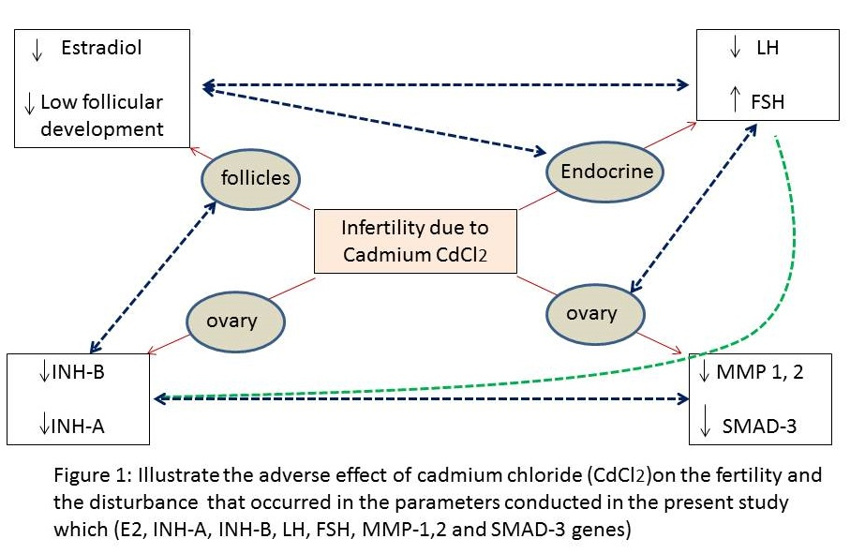

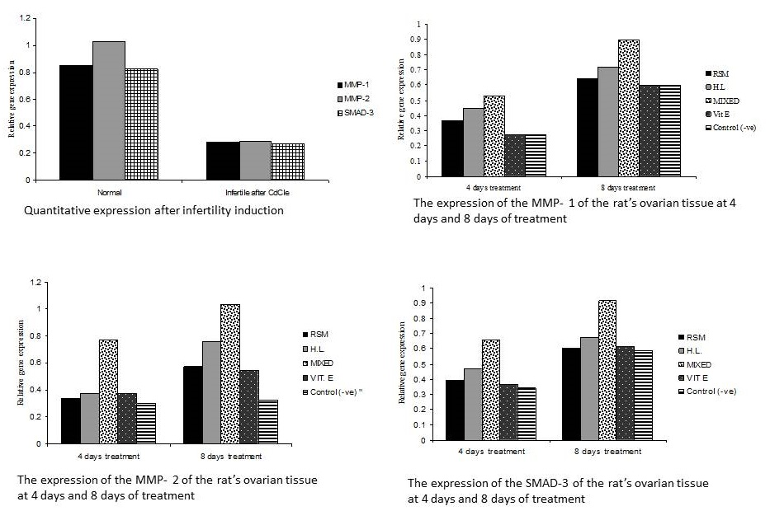
Figure 2: The results of MMP-1,2 and SMAD-3

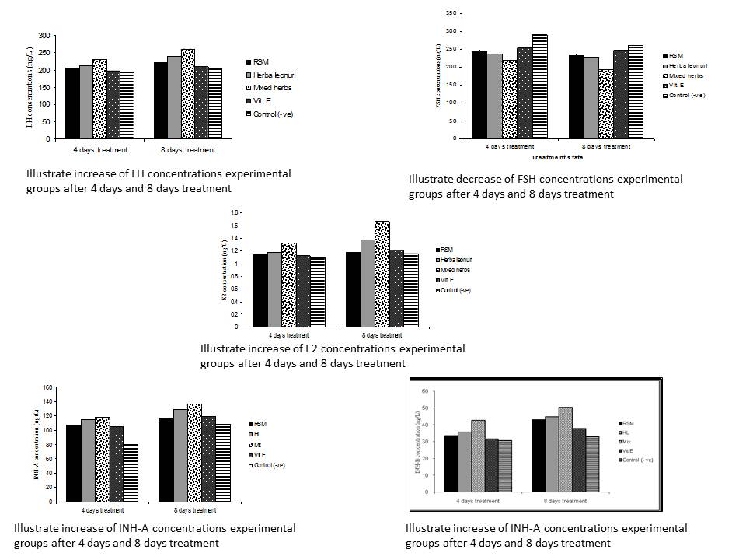
Figure 3: The results of LH, FSH, E2, INH-A, INH-B

Recent publications
- Guo-hua D., Tong Z., Hui-juan L. Discussion on the TCM Treatment of Hypertension from Pathogenetic Viewpoints of Modern Medicine. Chinese journal of Integrative Medicine. 2004, 10(4) : 304—307.
- Ahmad A., Alkarkhi A. F. M., Hena S., Siddique B. M., Dur K. W., Optimization of Soxhlet Extraction of Herba Leonuri Using Factorial Design of Experiment. International Journal of Chemistry. 2010, 2(1), 198 – 205.
- Liang XY., Li H., Yang XY., Zhou WY., Niu JG., Chen BD., Effect of Danshen aqueous extract on serum hs-CRP, IL-8, IL-10, TNF-a levels, and IL-10 mRNA, TNF-a mRNA expression levels, cerebral TGF-b1 positive expression level and its neuroprotective mechanisms in CIR rats. Molecular Biology of Reproduction 2013, 40:3419 – 3427
- McGee EA, Hsueh AJ. Initial and cyclic recruitment of ovarian follicles. Endocrine Review 2000, 21:200–214.
- Kamel M M., Abd El Razek AH., Ahmed K A and Kamel G M. Exposure of adult male rats to cadmium: assessment of sexual behaviour, fertility, aggression as well as anxiety like behaviour with special reference to biochemical and pathological alterations. Life Sciences 2011, 8(2): 106 – 119.
- Tomic D, Miller KP, Kenny HA, Woodruff TK, Hoyer P, Flaws JA. Ovarian follicle development requires Smad3. J Molecular Endocrinology 2004, 18: 2224–2240.
- Alfred A, Ried K. Traditional Chinese medicine — women’s experiences in the treatment of infertility. Australian Family Physician 2011, 40(9):718-22.

Biography

My research area always focus in the following fields (General histology research, histochemistry and Immunohistochemistry, Molecular cell biology field of diseases in lab animals, Molecular embryological research field, Herbal extraction and uses for treatment for induced diseases . I am expert how to use the herbs, selection and combination between them to find the best way of treatment of induced diseases, My works done of the common disease that causes big problems to community using traditional therapy, because of their efficiency to give relief diseases and protection for long period, with less cost expenses and availability, also the major this in these kinds of medicine have no bad side effects. I am expert in immunohistochemistry work, histopathology work related with diseases induction and progression and methods to finds the treatment.
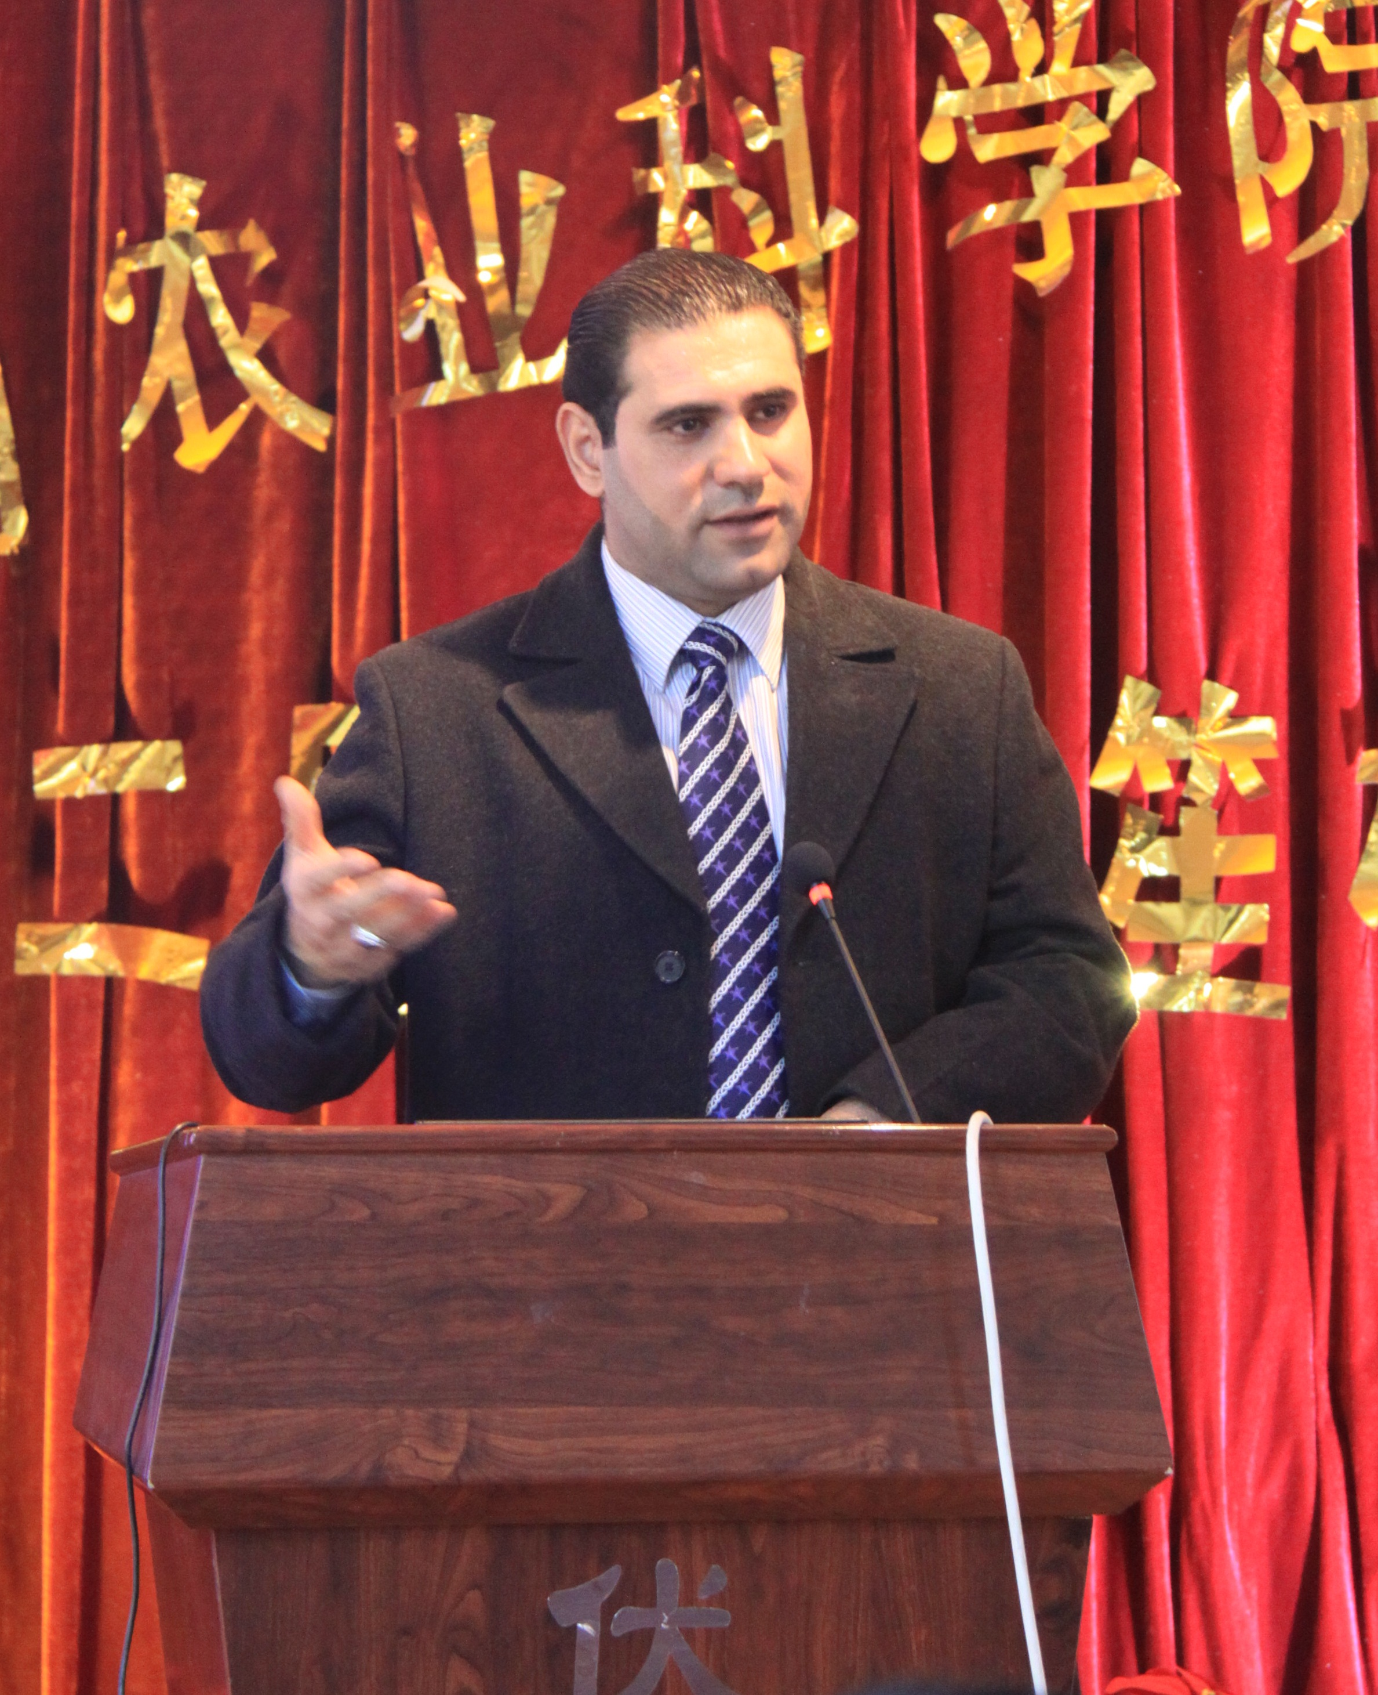

Email: amutlag@uowasit.edu.iq , alimahdi752@gmail.com

Presenting author details
Full name: Ali Mahdi Mutlag
Affiliation: Wasit University / College of Medicine
Contact number/Mobile Number: +9647723509925
Facebook Account: Ali Mahdi Mutlag
Category: (Oral presentation)

