

Title: HPTLC analysis and quantification of Genistein -an important isoflavonoid from in vitro and naturally grown Pueraria tuberosa (ROXB. Ex Willd.) DC.
Name: Illa C. Patel
E-mail: illa.botany@gmail.com
Hemchandracharya North Gujarat University, Patan – 384265, Gujarat, India

ABSTRACT

Pueraria tuberosa (ROXB. Ex Willd.) DC belongs to family Fabaceae, a large herbaceous perennial twiner with tuberous root. Pueraria used in indigenous system of Indian medicine as antirheumatic, aphrodisiac, tonic for strength, diuretic and galactogogue as the tuber is rich source of number of phytochemicals specially isoflavonoids. Tubers are consumed as supplementary food and for birth control by assured Indian tribes. It is also used for weight loss and for treatment of fertility. The present investigation was carried to develop simple, precise, and rapid HPTLC method for quantification of genistein from methanolic extract of in vitro tissues and natural plant parts of Pueraria. The method involves densitometric evaluation of genistein after their resolution on pre-coated silica gel 60F254 plates. Detection was at 254 nm. The method was validated for specificity, linearity, precision, accuracy, and repeatability. Quantification of genistein was done in in vitro developed tissues and in leaf, stem and tuber parts.
Phytochemical analysis was carried out by using series of solvents such as petroleum ether, chloroform, Methanol water and acetone by soxhlet extractor. Methanol extract showed presence of maximum phytochemicals in it. Although all the part of Pueraria tuberosa have some phytochemicals in it but the tuber pulp and tuber bark have maximum amount of carbohydrates, phenolic compound, flavonoids, alkaloids and glycosides. HPTLC analysis shows that both in vivo and in vitro parts are good source of Genistein. The present work may be helpful for new avenue for production of important phyto-constituents and reduces pressure on natural medicinal plant population.
Keywords: Pueraria tuberosa (ROXB. Ex Willd.) DC., Phytochemicals, genistein, quantification, HPTLC.
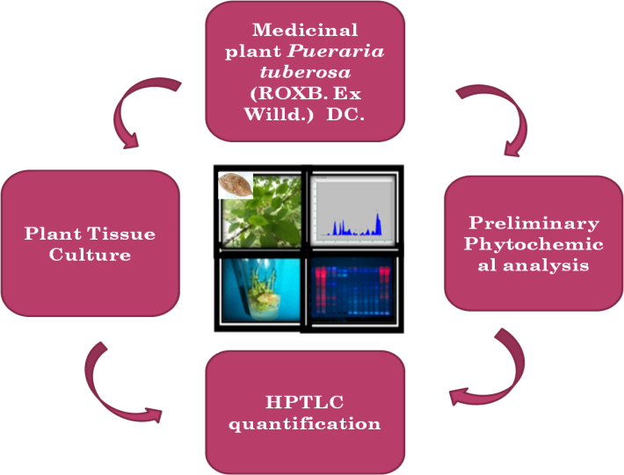
Fig. 1 Tissue Culture and Phytochemical study of Pueraria tuberosa (ROXB. Ex Willd.) DC

Recent five Publications
- Panigrahi J, Gantait S, Patel IC (2017) An efficient in vitro approach for direct regeneration and callogenesis of Adhatoda vasica Nees, a potential source of quinazoline alkaloids. National Academy Science Letters (Springer). Pp. 1-6. [IF 0.369].

- Panigrahi J, Gantait S*, Illa C Patel (2017). Concurrent production and relative quantification of vasicinone from in vivo and in vitro plant parts of Malabar nut (Adhatoda vasica Nees). 3 Biotech (Springer) [Pubmed] 7(5):280 [DOI: 10.1007/s13205-017-0882-7] [IF 1.361] (NAAS 6.99).

- Panigrahi J*, Gantait S, Patel I (2017). In vitro regeneration of Chlorophytum borivilianum Santapau & R.R. Fern. Medicinal plant International Journal of Phytomedicines and Related Industries, Vol.9, 76-79. [DOI: 10.5958/0975-6892.2017.00011.9]. [SCOPUS ] (NAAS 5.12).

- Rami Esha, Rami Saurabh and Patel Illa (2017). High Performance Liquid Chromatography method for quantification of Ellagic acid in in vivo and in vitro plant parts of Oroxylum indicum L. vent, Asian J Pharm Clin Res, Vol 10 (4), 2017, 56-58.

- Rathod Dipika and Patel Illa (2016). Comparative preliminary phytochemical studies of in vivo and in vitro extracts of Gloriosa superba L. International Journal of Pharma and Biosciences, 7(1): 20-23.

Biography

Dr. Illa Patel has completed her Ph. D in botany from Gujarat University, Gujarat, India. Presently she is Associate professor in botany at the Department of life sciences, Hemchandracharya North Gujarat University (Patan), Gujarat, India. She is M. phil. and Ph. D guide and has specialization in plant physiology, biochemistry, Tissue culture, medicinal plants and phytochemistry. She has more than 40 publications in the reputed journals and presented more than 35 papers in national and international conferences. She is also having some funded research projects and she is member of many specific and academic bodies and rendering her services to many scientific journals.

