Abstract: Wet Cupping Therapy
Healing through Suction
Discussion by Dr. Iftikhar Ahmad Saifi
Wet cupping is a form of bloodletting that involves first making superficial incisions on the skin, then applying the suction cups to suck out small amount of blood. It is the application performed to draw out stagnant, congested blood and Vital Force, as well as other stagnant or morbid humors.
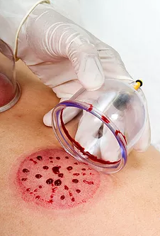
Cupping therapy is an incredibly ancient and universal practice that spans both East and West. In the East, the Chinese have been practicing the art of cupping for at least three thousand years. Cupping is applied to the acupuncture points to relieve the stagnation of Qi and blood, both locally and in the organ(s) activated by the point.
Traditional healers have long recognized the association between pain and conditions of congestion, stagnation and blockage. An old Chinese medical maxim states: Where there's stagnation, there will be pain. Remove the stagnation, and you remove the pain.
Not only pain, but the vast majority of all illness and disease including a number of psychiatric conditions come from stagnation, congestion and blockage - of energy, like the Vital Force, or of vital fluids or humors, like blood, phlegm or lymph. The suction applied by cupping sucks out and breaks up that congestion, stagnation, or blockage, restoring a free flow to the vital energies and humors of the organism.
After falling out of favor with medicine in the modern era, cupping therapy is enjoying resurgence in popularity, promoted by acupuncturists, Unani (Greek) medicine physicians and other holistic healthcare practitioners. New and exciting variations on this ancient technique, like cupping massage, are also being developed.
One secret of cupping's perennial popularity is its great ability to promote a state of deep pleasure and profound relaxation. Hopefully, cupping is here to stay.
About me
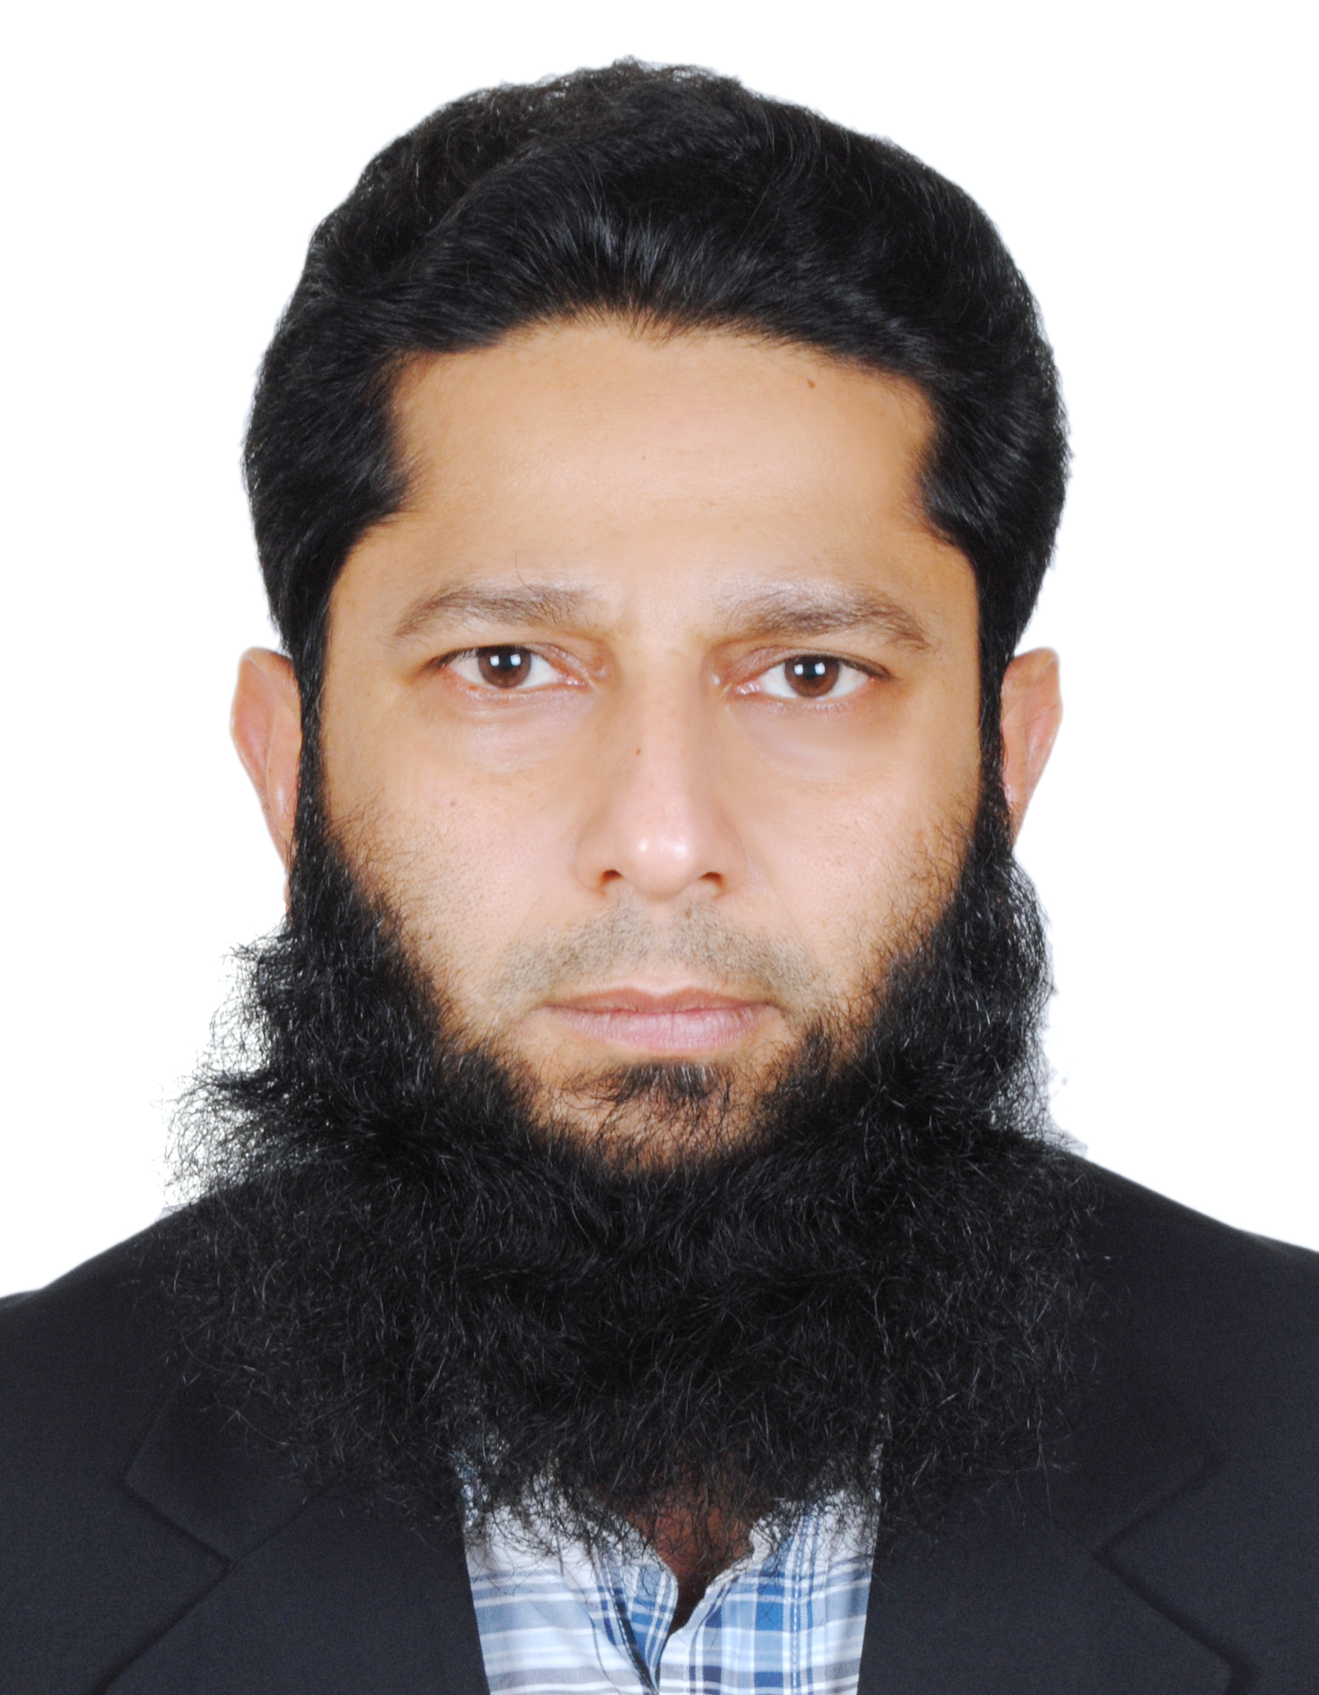
- Bachelor’s degree in Unani Medicine and Surgery (BUMS), India
- Registered Unani Medicine Doctor, AYUSH, Ministry of Health (MOH), India
- Doctor of Naturopathic Medicine (ND), USA
- American Naturopathic Medical Certification & Accreditation Board, USA
- Practiced Clinical Naturopathic medicine in Los Angeles, USA for good 10 years
- Licensed TCAM Doctor, Ministry of Health (MOH), UAE
- Licensed TCAM Doctor, Dubai Health Authority (DHA), UAE
- Member, Examination Board, Department of Licensure for TCAM, Ministry of Health (MOH), UAE for more than 8 years.
- Awarded with the highly prestigious “Ibn Sina (Avicenna) International Award for Excellence in Unani (Greek) Medicine”, India (2018)
- Presentations and lectures: Internationally including USA, South-East Asia, Middle-east and India
Number of clinical Wet Cupping cases performed : more than 5000
Email: driasaifi@gmail.com
Phone: 00971 50 266 9183

