Vactosertib, ALK5 inhibitor combinatorial treatment with radiation inhibits lung metastasis in syngeneic breast mouse models.
Ji Y. Park, Ji W.Choe,Yhun Y. Sheen, Ph.D. Ewha Womans University, College of Pharmacy, Seoul, Korea

Abstract

Radio-resistance and relapse after chemotherapy is a life-threatening problem for breast cancer patients. We identified the molecular signatures of the recurrent breast cancer patients after radiotherapy, which showed the up-regualtion of TGF-β signaling and the epithelial-to-mesenchymal transition (EMT). In order to find the potential therapeutic strategies to improve radiation therapy, we conducted gene set enrichment analysis, a computational method that determines whether an a priori defined gene set shows statistically significant between two phenotypes, using the breast cancer clinical data with Servant cohort (GSE30682). Since we have proved that EW-7197 showed the inhibitory effect in vivo in various breast cancer mouse models previously, we carried out experiments that might test if combinatorial treatment of EW-7197 improves radiation therapy using two syngeneic mouse models. Met 1 cells, which are derived from primary tumors of the FVB/N transgenic mouse with mammary tumor-polyoma virus middle T antigen (MMTV-PyVmt), were injected to fourth inguinal fat pads of FVB/N mice. 4T1 cells, which are derived from primary tumors of Balb/c mice, were injected as same way into Balb/c mice. Mice were treated with the fractionated-radiation (total dose 12 Gy, 4 Gy X3) with or without the combinatorial treatment of EW-7197 (2.5 mg/kg). Conclusion & Significance: Vactosertib (EW-7197), ALK5 inhibitor combinatorial treatment with radiation inhibits tumor growth and metastasis in syngeneic breast mouse models. This effect of Vactosertib (EW-7197), ALK5 inhibitor combinatorial treatment with radiation inhibits tumor growth and metastasis in syngeneic breast mouse models. Vactosertib (EW-7197) maybe related to the breast cancer stem-like phenotype, which is increased by 4Gy irradiation in vitro. We need to further study to conclude the therapeutic mechanisms of EW-7197 on improving radiation therapy. [This work was supported by the National Research Foundation of Korea grant funded by the Korea government (NRF-2015M2A2A7A01041499) and (NRF-2014R1A1A2005644).

Image

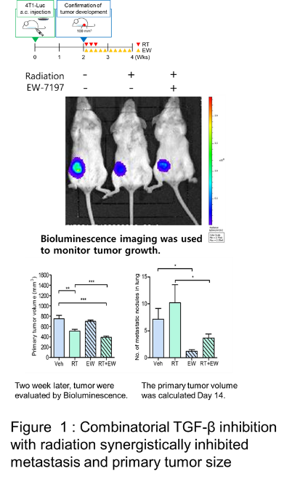

Recent Publications (minimum 5)
- Kim M (2016) TGF-beta Type I receptor kinase inhibitor, EW-7197 supresses cholestatic liver fibrosis by inhibiting HIF1 alpha-induced epithelial mesenchymal transition Cellular Physiology and Biochemistry 38:571-588.
- Park S (2015) EW-7197 inhibits hepatic, renal, and pulmonary fibrosis by blocking TGF-b/Smad and ROS signaling CMLS 72:2023-2039
- Park S (2015) TIMP mediates TGF-beta-dependent crosstalk between hepatic and cancer cells via FAK signalling. Sci. Reports 5:1038-1048.
- Park S (2015) Combinatorial TGF-β attenuation with paclitaxel inhibits the epithelial-to-mesenchymal transition and breast cancer stem-like cells. Oncotarget 6:37535-37552.
5. Son J (2014) EW-7197, a novel ALK-5 kinase inhibitor, potently inhibits breast to lung metastasis. MCT 13:1704-1716.

Biography (150 word limit)
Yhun Sheen has her research interest in developing new anti-cancer drug. She had participated in the development of TEW-7197 which is currently under clinical trial in USA (NCT02160106
Email: yysheen@ewha.ac.kr

