Correction of a scientific error in Lippincott Illustrated reviews Pharmacology 6th edition, 2015, chapter 46 (anticancer drugs, p 605, Mechanism of action of tamoxifen)

Name: Hussein Albarazanchi
Affiliation: Kurdistan institute for strategic studies and scientific research-cancer research Dept., Kurdistan of Iraq

Abstract

Tamoxifen is one of the selective estrogen receptor modulators (SERM) with tissue-specific activities for the treatment and prevention of estrogen receptor positive breast cancer. Tamoxifen acts as an anti-estrogen (inhibiting agent) in the mammary tissue, but as an estrogen (stimulating agent) in cholesterol metabolism, bone density, and cell proliferation in the endometrium.
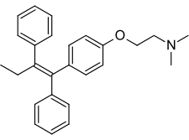

Chemical structure of tamoxifen

Mechanism of action
Tamoxifen is a nonsteroidal agent that binds to estrogen receptors (ER), inducing a conformational change in the receptor. This results in a blockage or change in the expression of estrogen dependent genes. The prolonged binding of tamoxifen to the nuclear chromatin of these results in reduced DNA polymerase activity, impaired thymidine utilization, blockade of estradiol uptake, and decreased estrogen response. It is likely that tamoxifen interacts with other coactivators or corepressors in the tissue and binds with different estrogen receptors, ER-alpha or ER-beta, producing both estrogenic and antiestrogenic effects.

The illustration on the mechanism of action of tamoxifen in the book as follow:
B. Tamoxifen
Tamoxifen [tah-MOX-ih-fen] is an estrogen antagonist with some
estrogenic activity, and it is classified as a selective estrogen receptor
modulator (SERM). It is used for first-line therapy in the treatment of
estrogen receptor–positive breast cancer. It also finds use prophylactically
in reducing breast cancer occurrence in women who are at
high risk. However, because of possible stimulation of premalignant
lesions due to its estrogenic properties, patients should be closely
monitored during therapy.
1. Mechanism of action: Tamoxifen binds to estrogen receptors in
the breast tissue, but the complex is unable to translocate into the
nucleus for its action of initiating transcriptions. That is, the complex
fails to induce estrogen-responsive genes, and RNA synthesis
does not ensue (Figure 46.26B). The result is a depletion
(down-regulation) of estrogen receptors, and the growth-promoting.

The error is highlighted with yellow color, the correction is as follow:
Tamoxifen binds to estrogen receptors in the breast tissue, but the complex not productive, the complex fails to induce estrogen-responsive genes and RNA synthesis does not ensue. That is mean, the complex enter the nucleus, while its action block on the gene and prevent the translation effects of estrogen.
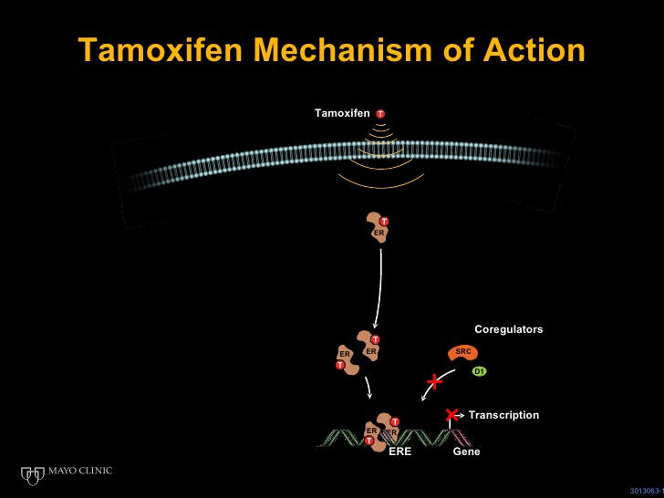

Biography
Hussein Albarazanchi born in Iraq, 1977, has M.Sc. cancer pharmacology from university of Bradford-institute of cancer therapeutics, and also has Bachelor degree in veterinary medicine and surgery from college of veterinary medicine-university of sulaimani-Kurdistan of Iraq. Currently he is working as a researcher in Kurdistan institute for strategic studies and scientific research-cancer research Dept., Kurdistan of Iraq; and as a lecturer of anticancer drugs in college of pharmacy university of sulaimani.

Email ID: Hussein.al-barazanchi@kissr.edu.krd

Presenter Name: Hussein Albarazanchi
Type of Presentation: Poster presentation
Contact Number:009647701988624
Right click on the image to change picture



