Demographic, imaging and histopathological findings of mucinous breast cancer: a retrospective study of 21 hospital-based series of cases
Eman Abbas, sr consultant radiologist Hamad Medical Corporation, Doha Qatar

Abstract
Objective To illustrate the demographic, imaging findings of mucinous breast carcinoma collected from Hamad General Hospital case series during 6 years from 2012 to 2017, with histopathological correlation.
Methods A retrospective review of our own database of patients in Hamad General Hospital diagnosed with breast cancer. The medical records of 21 patients with pathologically proven invasive mucinous cancer were reviewed. We evaluated the demographic, clinical data, imaging and pathological findings of these cases.
Results/ Discussion We identified 15 cases of pure and 6 cases of mixed mucinous breast carcinoma that constituted 1.7 % of all proven breast cancer. The age of the patients ranged from 27 to 73 years and were divided into 2 groups with 16 cases above 40 years and 5 below 40 years. Metastasis to the lymph nodes were found in 25% in group 1 and 80% in group 2, while distant metastases was 0% in group 1 and 60% in group 2. Radiologically 31% of group 1 and 40% of group 2 were categorized as BIRADS 3, with the remainder as BIRADS 4 and 5.
Mucinous carcinoma is a rare histological variant of invasive ductal breast cancer. It accounts for 1 to 7% of all breast cancers with increased prevalence in older women. The imaging appearance of mucinous breast carcinoma is challenging.
Conclusion This study showed apparent altered demographic results of mucinous breast carcinoma with most of patients presented in their forties and fifties and very aggressive behaviour in younger women < 40 years old. This may be attributed to the high proliferation marker Ki-67. The limitation of our work is that it is a retrospective single centre study with relatively small number of cases. Further studies on large scale is highly recommended.

Image
Table 1 illustrates the demographic, imaging and histopathological findings of mucinous breast cancer in patients > 40 years compared to patients < 40 years.

 | Number of patients | Age range and mean age | Imaging findings | Size of the lesion and mean size | Type | Grade | Lymph node metastases | Distant metastases | Hormonal receptor expression | +ve DCIS
Patients > 40 years old | 16cases  76% | 41- 73 years  Mean=  51 years 11 months | 5 cases  BIRADS3  31%  7 cases  BIRADS4  44%  4 cases  BIRADS5  25% | 1.2- 5.8 cm  Mean=  2.5 cm | 13pure  81%  3mixed  19% | 8cases gradeI  50%  7cases  grade II  40%  1case  grade III  6% | 4 cases  25% | 0  0% | 13 cases ER +ve, PR+ve and Her2/neu –ve 81%  2 cases ER +ve, PR +ve and Her2/neu +ve 13%  1 case ER +ve, PR -ve and Her2/ neu –ve 6%  Ki 67=1% to 40%  Mean= 11% | 10 cases  62.5%
Patients < 40 years old | 5 cases  24% | 27- 36 years  Mean=  31 years 7 months | 2 cases  BIRADS3  40%  1 case  BIRADS4  20%  2 cases  BIRADS5  40% | 1.7-6.7 cm  Mean=  3 cm | 2pure  40%  3mixed  60% | 3cases gradeI  60%  2cases grade II 40% | 4 cases  80% | 3 cases  60% | 4 cases ER +ve, PR+ve and Her2/neu –ve 80%  1 case ER +ve, PR +ve and Her2/neu +ve 20%  Ki67=10% to 50%  Mean= 32.5% | 3 cases  60%

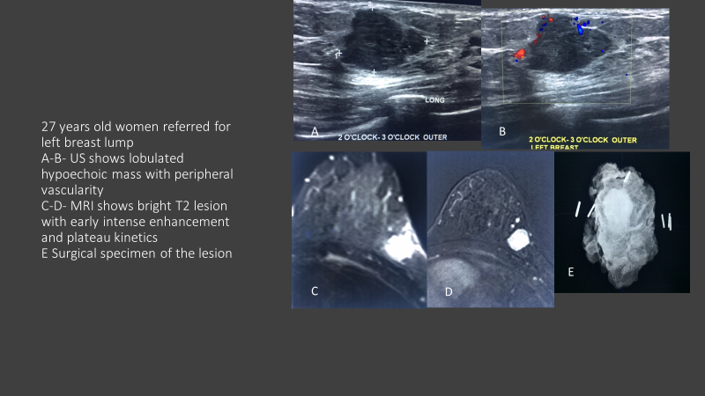
Fig 1. 27 years old woman referred for left breast lump. A-B- US shows lobulated hypoechoic mass with peripheral vascularity. C-D- MRI (T2 and subtracted dynamic) shows bright T2 lesion with early intense enhancement and type 2 kinetics. E- X ray of the surgical specimen.

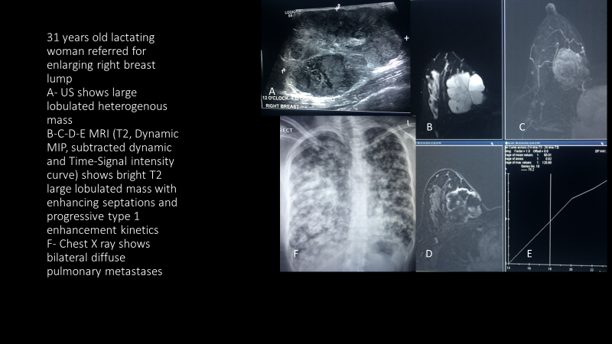
Fig 2. 31 years old lactating woman referred for enlarging right breast lump. US shows large lobulated heterogenous mass. B-C-D-E- MRI (T2, dynamic MIP, subtracted dynamic and time signal intensity curve) shows bright T2 large lobulated mass with enhancing septations and progressive type 1 enhancement kinetics. F- Chest X ray shows bilateral diffuse pulmonary metastases.
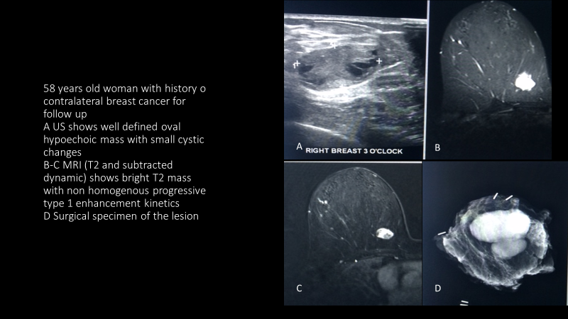
Fig 3. 58 years old woman with history of contralateral breast cancer for follow up. A- US shows well defined oval hypoechoic mass with small cystic changes. B-C- MRI (T2 and subtracted dynamic) shows well defined bright T2 mass with non homogenous progressive type 1 enhancement kinetics. D- X ray of the surgical specimen.
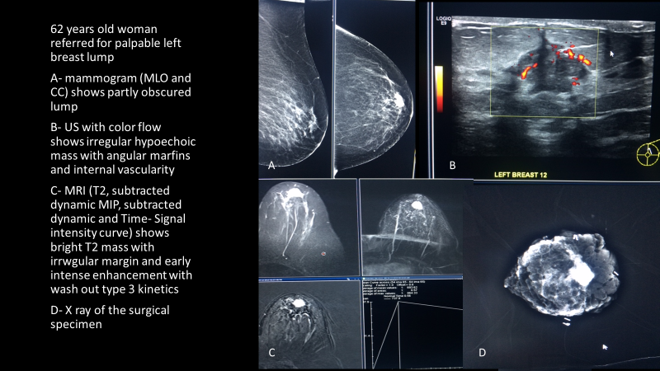
Fig 4. 62 years old woman referred for palpable left breast lump. A- mammogram (MLO and CC) shows partly obscured mass. B- US with color flow shows irregular hypoechoic mass with angular margins and internal vascularity. C- MRI (T2, subtracted dynamic MIP, subtracted dynamic and time signal intensity curve) shows bright T2 mass with irregular margins and type 3 curve. D- X ray of the surgical specimen.
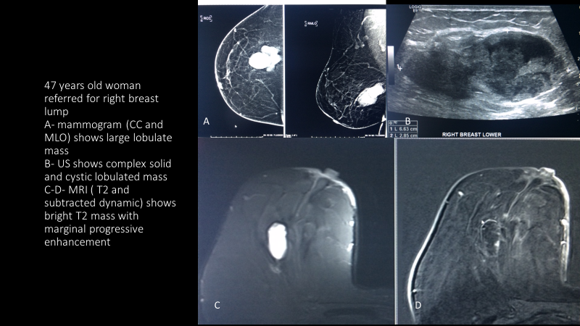
Fig 5. 47 years old woman referred for right breast lump. A- mammogram (CC and MLO) shows large lobulated mass. B- US shows large lobulated complex solid and cystic lesion. C- D- MRI (T2 and subtracted dynamic) shows bright T2 mass with marginal progressive type 1 enhancement.

Publications
- Ultrasound And Computed Tomography In Diagnosis Of Splenic Emergencies
Sanaa AE,Iman AH,Dalia ME. Medical Journal of Cairo University, vol. 70, No 1, March 2002.
- Clinical, tomographic and MRI evaluation of patients with internal derangement of the T.M.J. before and after T.M.J arthrocentesis .Ain Shams Dental Journal, vol. 5, No 1, March 2002.

- Assessment of maxillofacial lesions by computed tomography and direct digital radiography”..Iman AA,Iman AH. Egyptian Dental Journal, vol. 48, No 1, January 2002.

- Saline Infusion Sonohysterography and Transvaginal Ultrasound in the Diagnosis of Abnormal Uterine Bleeding; a Comparative Study with Operative Hysteroscopy. Rasha MK, Maha MM, Iman AH
The Egyptian Journal of Radiology and Nuclear Medicine, vol. 43, No 1, March 2003.
- Narrowed thoracic inlet causing esophageal pseudomass: A study by Digital barium Radiography and CT. Yehya AA, Sahar NS, Iman AH. The Egyptian Journal of Radiology and Nuclear Medicine, vol. 34, No 4, December 2003.

- Occurrence of occult spinal dysraphic lesions with overt spinal dysraphism
Iman AH. Kasr El-Aini Medical Journal, vol. 11, No 1,Sup.January 2005.

- The role of C.T in the assessment of air containing lung lesions in adults
Sanaa AE, Iman AH, Wael AG. The Egyptian Journal of Radiology and Nuclear Medicine, vol. 35, No 2, june 2004.

- The role of conventional and color Doppler sonography in evaluation of enlarged neck in pediatric patients. Mohamed KM, Iman AH, Ahmed SH. The Egyptian Journal of Radiology and Nuclear Medicine, vol. 35, No 2, June 2004.

- Pseudomyxoma peritonei :CT study. Iman A. Al-Azhar Assiut Medical Journal, vol. 6, No 3, october 2008.

- Fetal Split Cord Malformation associated with
Meningocele/ Chiari anomaly : Fetal US and MRI study. Iman AH . The Egyptian Journal of Radiology and Nuclear Medicine, vol.40, No 3, september 2009.

- The impact of recent advances in Multislice Computed Tomography for the diagnosis of orthopedic hardware Complications. Iman AH, Hamed SE. The Egyptian Journal of Radiology and Nuclear Medicine, vol.40, No 4, december 2009.

- The impact of Multi Slice Computed Tomography in the diagnosis of acute chest pain. Iman AH, Hames SE.The Egyptian Journal and Nuclear Medicine, vol.41, No 1, march 2010.

- Ultrasound assessment of acute non traumatic abdomen in children. Iman AH, Mohsen
E. The Egyptian Journal of Radiology and Nuclear Medicine, vol 41, march 2010.

- Cecal diverticulitis : US and CT. Iman AH. The Egyptian Journal of Radiology and
Nuclear Medicine, vol.41, No 2, june 2009.

15- Radiological evaluation of palpable breast masse during pregnancy and lactation
Iman AH, Lamia AS, Hamed SE. The Egyptian Journal of Radiology and Nuclear
Medicine, vol.40, No 3, september 2009.

- Ultrafast MRI of the fetus. An increasingly important tool in prenatal diagnosis of congenital anomalies. Iman AH, Hamed SE. Magnetic Resonance Imaging, vol. 28, No 10, december 2010.

- The impact of aerobic exercises on bone mineral density in obese premenopausal women under caloric restriction. Iman AH, Hamed SE,Wael GF, Adly AS, Mona AG.
Skeletal radiology, vol. 40, No 3, september 2009.

- Diffusion MRI of focal liver lesions. Iman AH, Hamed SE. South African Journal of Radiology, june 2011.

Biography
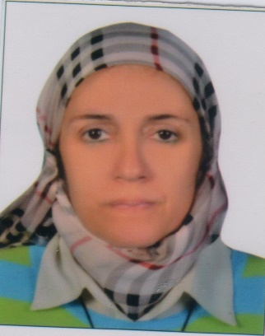
Dr Eman Abbas Hosny Mohamed Hosny Abbas graduated from Faculty of Medicine, Cairo University in 1986, has got master and Ph degrees of Diagnostic radiology in 1991 and 1999. She had appointed several posts in same university from house officer, resident, lecturer and professor starting from 1988 till now. Since more than 10 years, she has been working in the women imaging unit of Kasr AlAini hospital, also in the the Egyptian Women Health Outreach Program & National foundation for breast cancer elimination (EWHOPN). She had got the Diplome de français medical" in 2008 Chambre de commerce et d’industrie de Paris. She had a clinical fellowship in breast imaging from Mcgill University, Royal Vic hospital, Montreal Canada from 2011 to 2012. Lately she has joined HMC from September 2016 as Sr consultant.

