MRI radiogenomics for intelligent diagnosis of breast tumors and accurate prediction of neoadjuvant chemotherapy responses

Neoadjuvant Chemotherapy (NAC) in breast cancer regarding the prognostic and treatment response plays an important role in personal treatment and precision medicine. In this project, we review the concept, principle, techniques in using radiogeomics for the accurate NAC analysis and prediction. We also propose to solve a brand new problem in radiogenomics mining: How to combine structural radiomics information and non-structural genomics information for accurate NAC prediction.This requires to extract parameters from structural breast radiomics data quickly and automatically, and find non-structural feature vectors with diagnostic value, which then are combined with genomics data acquired from exocrine bodies in blood samples of breast cancer patients cohort for accurate NAC prediction. In this paper, we propose a self-attention-based deep learning approach along with an effective multi-channel tumour image reconstruction with high dimension. We aim at achieving diagnostic, non-structural feature vectors for accurate prediction of the VAC responses in combination with exocrine bodies related genomics analysis.

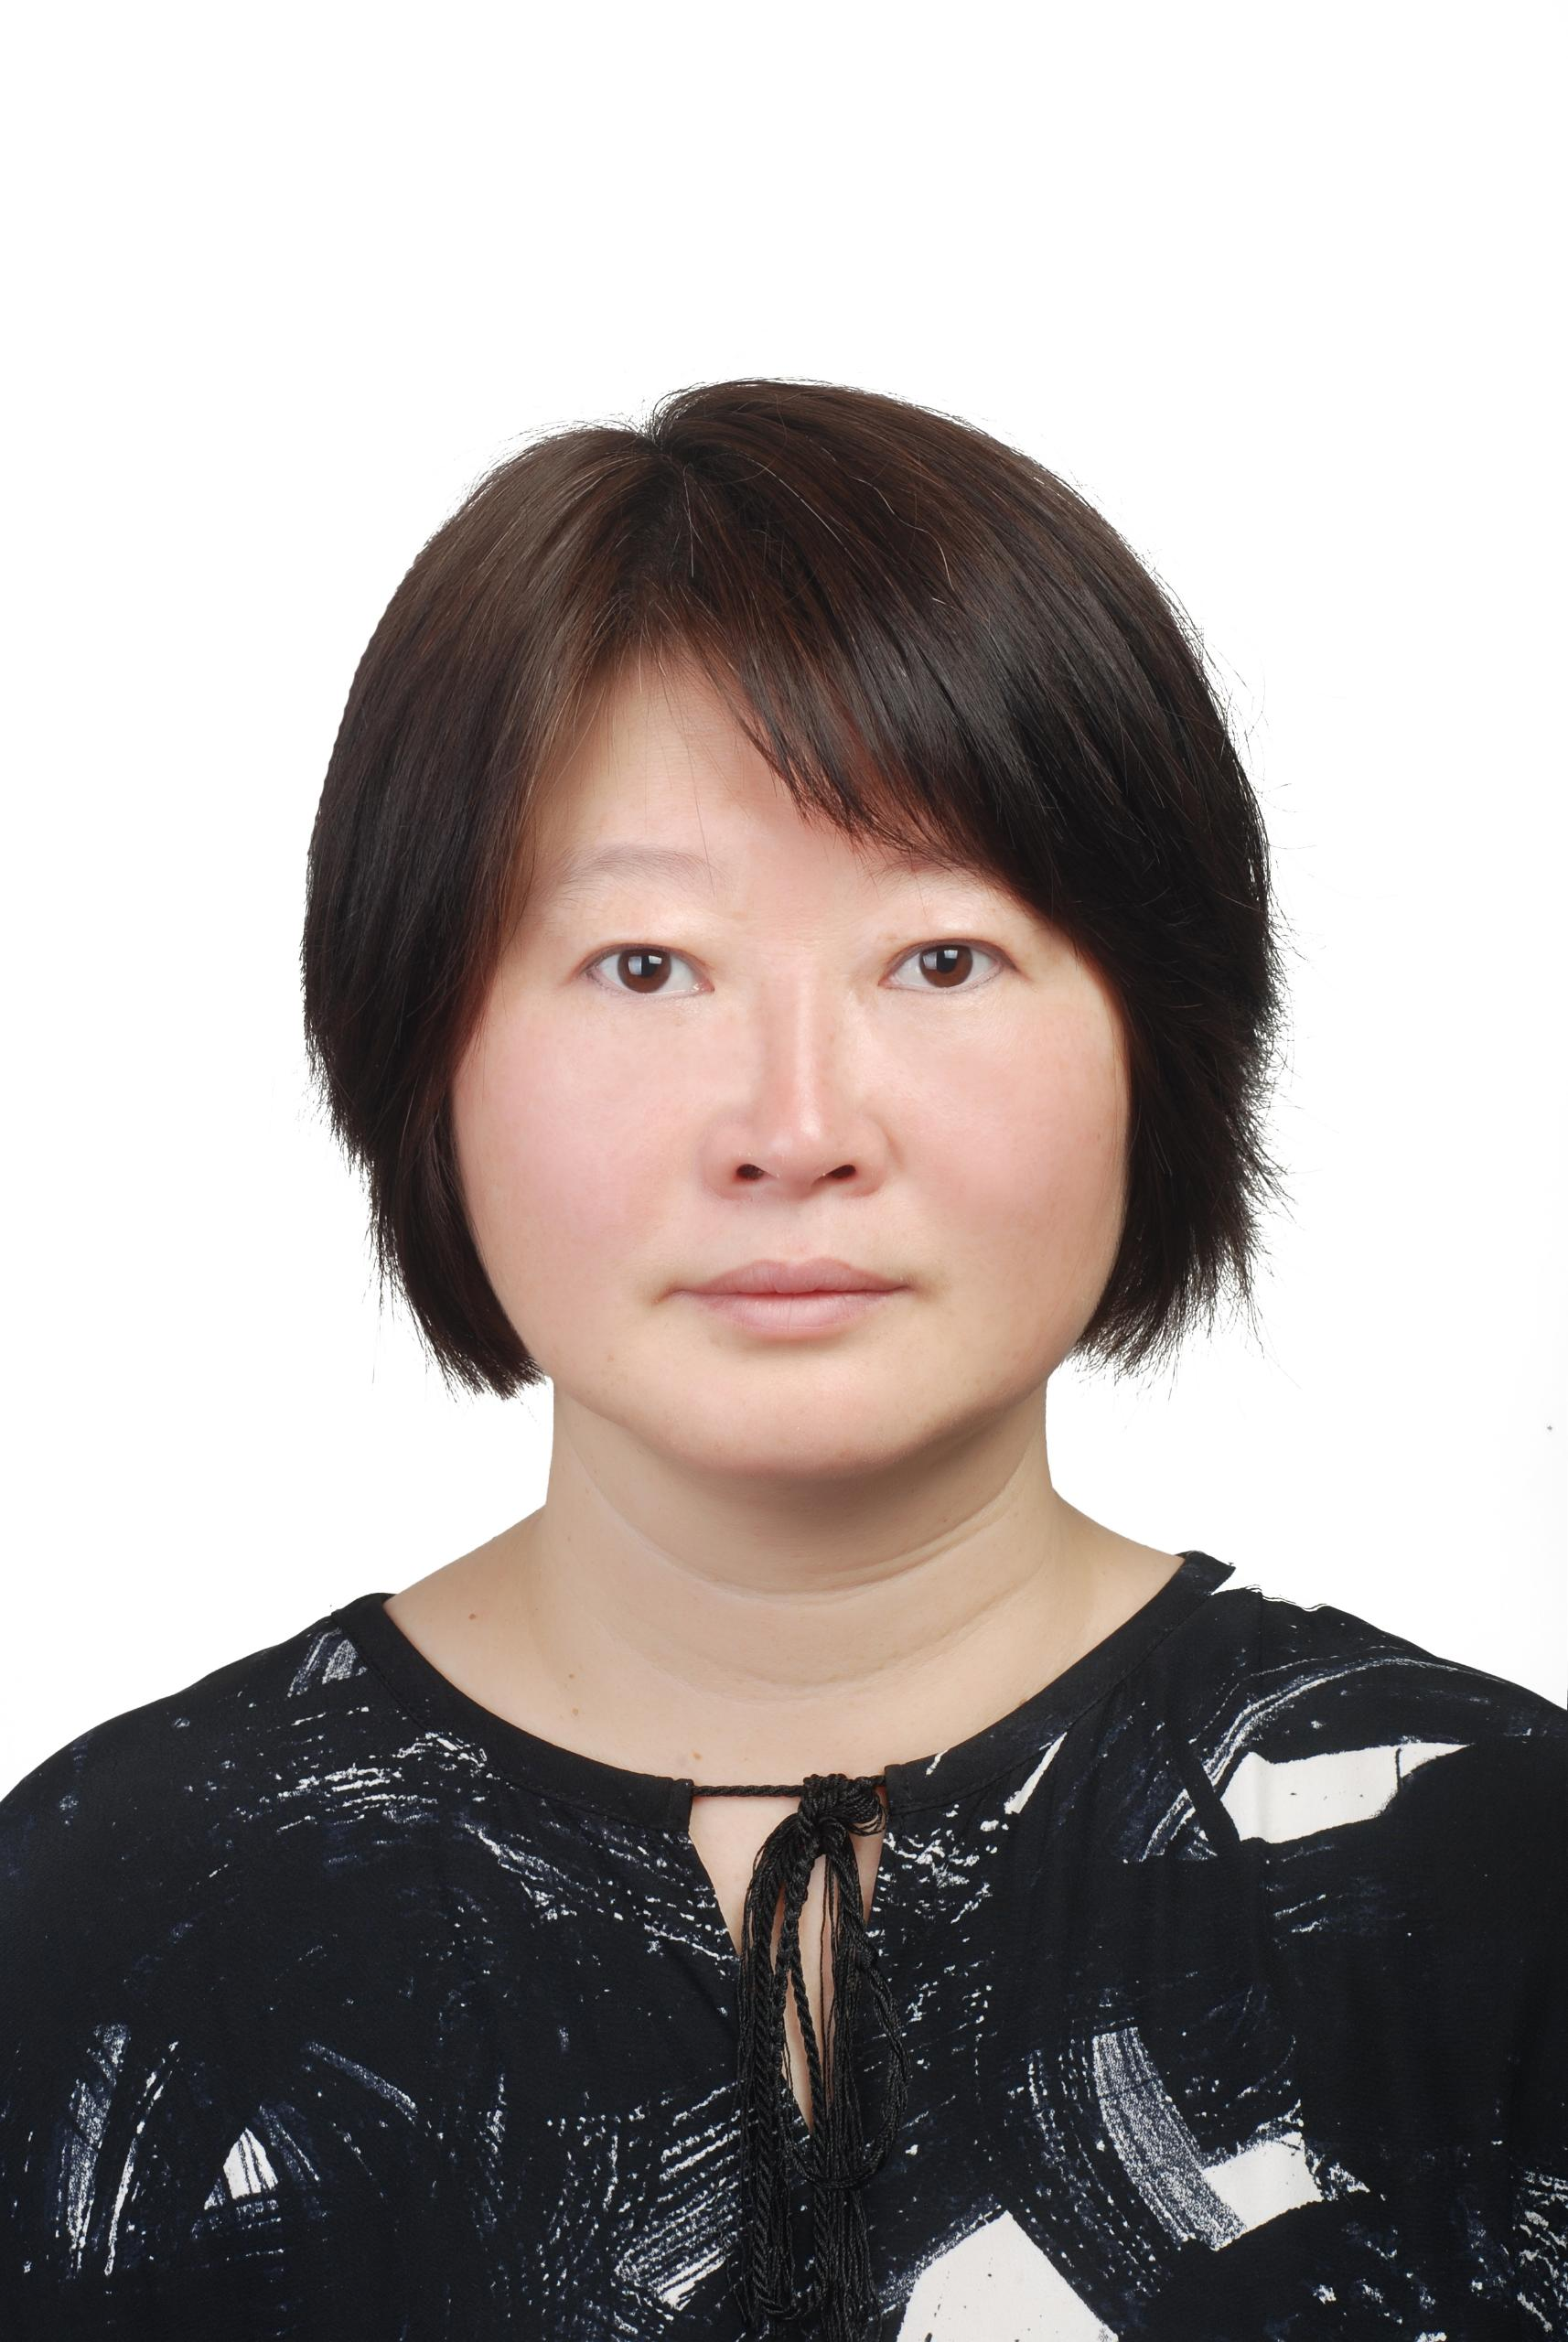XIAOXIA YIN received the Ph.D. degree in electronics engineering from The University of Adelaide, Australia. She was a Visiting Scholar with the University of Reading, Reading, U.K., under the supervision of S. Hadjiloucas, and with the University of Cambridge, Cambridge, U.K., under the supervision of L. F. Gladden. She involved in tumor detection via DCE-MRI with The University of Melbourne, Australia, under the supervision of Prof. Kotagiri. She has an existing collaboration with Prof. M.-Y. Su with the Center for Functional Onco Imaging, University of California at Irvine, USA, and with Prof. T. Kron with the Peter MacCallum Cancer Centre, Australia. She is currently a professor in University of Guangzhou, China and her major is in high-dimensional medical image analysis. Her research interests include multiresolution analysis, segmentation, image reconstruction and classifification, and their applications to high-dimensional medical imaging. She received the Postdoctoral Research Fellowship from the Australian Research Council, in 2009. She was a member of the Organizing Committee and the Publication Chairperson of the 3rd International Conference of Health Information Science, and a member of the Organizing Committee and the Program Co-Chairperson of the 4th and 5th International Conference of Health Information Science.

