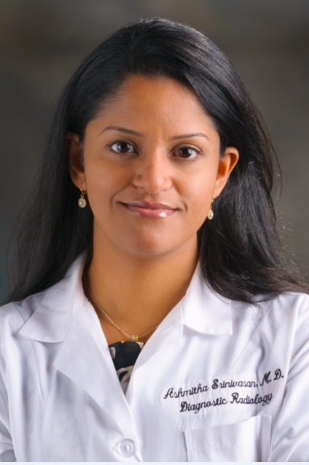

Title: Screening Breast Cancer: the Mammography War

Name: Ashmitha Srinivasan MD, MBA
The University of Texas, MD Anderson Cancer Center, Houston, Texas

Abstract

There is established consensus in breast health community that mammography is the mainstay imaging examination for screening breast cancer. However, there are varied national recommendations among stakeholders and major institutions in the topic of breast cancer screening. Lack of consensus in screening criteria includes risk stratification, age to initiate screening and the interval of screening. The differences in practice guidelines are mainly due to variation in design and interpretation of screening trials over the past decades. As debates for and against the use of screening mammography continue to escalate, both providers and patients are often confused and wrongly perceive the recommendations as directives. The purpose of this presentation is to review the current guidelines, analyze the reason for the controversies in screening mammography and shine light on the upcoming trends of future screening guidelines.

Biography

Dr. Srinivasan is currently the Assistant Professor in Diagnostic Radiology, Breast Imaging Section with University of Texas MD Anderson cancer center. Dr. Srinivasan has previously worked as a Medical Director of Ray Moody Breast Center at Orange Regional Medical Center in New York. Dr. Srinivasan has also earned her MBA in healthcare administration from George Washington University in Washington, DC. Dr. Srinivasan’s career focus has been in increasing community awareness on early detection mammography and patient education.

Presenting author details
Full name: Ashmitha Srinivasan MD
Contact number: 215-983-6221
Category: (Oral presentation)

