Targeting tumour-infiltrating myeloid cells for breast cancer therapy
Arianna Calcinotto, PhD, Institute of Oncology Research, Bellinzona, Switzerland

Abstract

The well-established dependency of cancer cells on the tumour microenvironment suggests that the non-cancer-cell component of the tumour may have an important role in controlling breast cancer progression and the emergence of therapy resistance. We are interested in understanding the liaison between tumor-infiltrating myeloid cells and cancer cells to identify new molecular mechanisms that regulate cancer progression, tumor evasion, and androgen insensitivity. Our research demonstrates that the breast tumor microenvironment is comprised of myeloid-derived suppressor cells (MDSCs) that favours tumour cell proliferation and therapy resistance in hormone-dependent cancers. These studies have helped provide significantly novel insights into designing novel immune therapies to target MDSCs that are now under clinical evaluation. Recent results will be presented on original and unexpected role of MDSCs in the neoplastic tissue, where they directly activate crucial pathways in the breast cancer cell. I will discuss that novel combination therapies tested in pre-clinical studies modulate the tumor microenvironment increasing the efficacy of currently available endocrine therapies.
Image
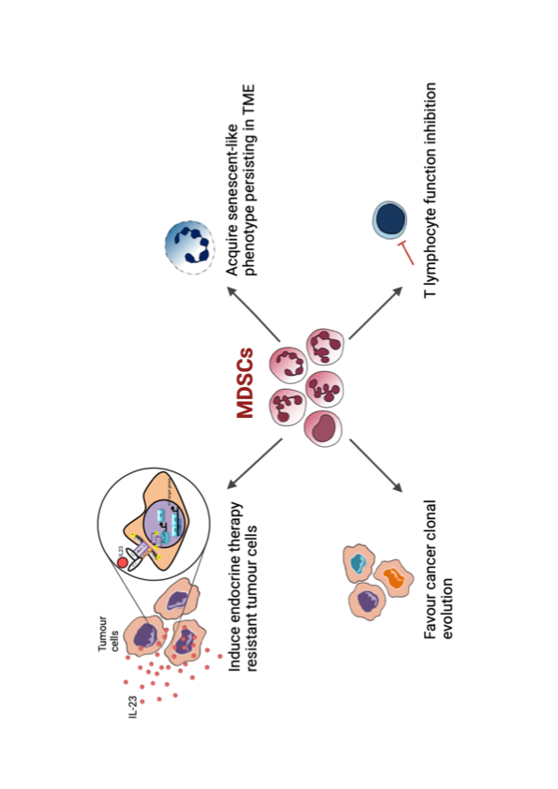
Recent Publications (minimum 5)
- Montopoli M, Zorzi M, Cocetta V, Prayer-Galetti T, Guzzinati S, Bovo E, Rugge M and Calcinotto A. Clinical outcome of SARS-CoV-2 infection in breast and ovarian cancer patients who underwent antiestrogenic therapy. Ann Oncol (2021) 32, 676-677.
- Calcinotto A, Pernigoni N, Zagato E, Troiani M, Mestre RP, Cali B, Attanasio G, Troisi J, Minini M, Mosole S, Revandkar A, Pasquini E, Elia AR, Bossi D, Rinaldi A, Rescigno P, Flohr P, Hunt J, Neeb A, Buroni L, Guo C, Welti J, Ferrari M, Grioni M, Gauthier J, Gharaibeh RZ, Palmisano A, Lucchini GM, D'Antonio E, Merler S, Bolis M, Grassi F, Esposito A, Bellone M, Briganti A, Rescigno M, Theurillat JP, Jobin C, Gillessen S, de Bono J and Alimonti A. Commensal bacteria promote endocrine resistance in prostate cancer through androgen biosynthesis. Science (2021) 374, 216-224.
- Mukherjee S, Elia AR and Calcinotto A. Role of myeloid-derived suppressor cells in hormone-dependent cancers. Swiss Med Wkly (2021) 151, w20483.
- Calcinotto A, Kohli J, Zagato E, Pellegrini L, Demaria M and Alimonti A. Cellular Senescence: Aging, Cancer, and Injury. Physiol Rev (2019) 99, 1047-1078.
- Calcinotto A, Spataro C, Zagato E, Di Mitri D, Gil V, Crespo M, De Bernardis G, Losa M, Mirenda M, Pasquini E, Rinaldi A, Sumanasuriya S, Lambros MB, Neeb A, Luciano R, Bravi CA, Nava-Rodrigues D, Dolling D, Prayer-Galetti T, Ferreira A, Briganti A, Esposito A, Barry S, Yuan W, Sharp A, de Bono J and Alimonti A. IL-23 secreted by myeloid cells drives castration-resistant prostate cancer. Nature (2018) 559, 363-369.
5. Calcinotto A, Brevi A, Chesi M, Ferrarese R, Garcia Perez L, Grioni M, Kumar S, Garbitt VM, Sharik ME, Henderson KJ, Tonon G, Tomura M, Miwa Y, Esplugues E, Flavell RA, Huber S, Canducci F, Rajkumar VS, Bergsagel PL and Bellone M. Microbiota-driven interleukin-17-producing cells and eosinophils synergize to accelerate multiple myeloma progression. Nat Commun (2018) 9, 4832.
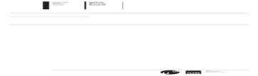


Biography (150 word limit)
Dr. Arianna Calcinotto is Group Leader of the Cancer Immunotherapy group at the Institute of Oncology Research in Switzerland. She received her PhD in Molecular Medicine with honors from Università Vita-Salute San Raffaele, Milan in 2015. She completed her PostDoc training before at San Raffaele Institute in Milan, then in the lab of Prof. Bergsagel at Mayo Clinic (Arizona, USA) and then in the lab of Prof. Alimonti in Switzerland. She has studied cancer cell-immune cell interactions in the tumor microenvironment during different phases of cancer development and progression in both solid tumors and hematological malignancies developing novel immunotherapies for cancer. Her major scientific contributions have been the identification of an unexpected link between the presence of specific bugs in the gut microbiota in patients affected by multiple myeloma and prostate cancer and the identification of the role played by IL23 producing myeloid cells promoting therapy-resistance in castration resistance prostate cancer patients.
Email: arianna.calcinotto@ior.usi.ch

Presenting author details
Full name: Arianna Calcinotto
Contact number: +41 58 6667 204
Mail id: arianna.calcinotto@ior.usi.ch
Category: Oral presentation

