Recommendations on Nursing and Follow Up of Breast Cancer Patients During COVID-19 Pandemic
Yuzhi Yao, Guangzhou Women and Children Medical Center, Bachelor of Nursing, CHINA
Xiaobin Lin, M.D., Guangzhou Women and Children Medical Center, CHINA

Abstract (300 word limit)
Patients with cancer are under a higher risk of contracting COVID-19 and a higher mortality rate after infection due to the immunosuppression of chemotherapy. Systematic scientific nursing follow-up and standardized adjuvant treatment are important to breast cancer patients during the COVID-19. We established a personalized follow-up nursing system for breast cancer patients during the COVID-19 according to Chinese experts’ recommendations. A structured questionnaire about anxiety, online consultation, therapy schedule and side effects. There were 58 and 60 breast cancer patients from February to April in 2020 and 2019. We found that the anxiety rates of patients were significantly increased from 21.67% (2019) to 48.28% (2020) during COVID-19 (P=0.027). Due to the vigorous promotion of online consultation system, the online consultation rate has significantly increased from 30% to 60.34% (P=0.012). Further analysis showed that there was no significant difference in the delay rate of chemotherapy, targeted HER2 therapy and endocrine therapy compared with patients in 2019 (P=0.222). As for side effects, there was no difference in the incidences of fever, diarrhea, constipation and et al in two groups (P>0.05). It is worth mentioning that none of patients were infected with COVID-19 during treatment. These demonstrated that the anxiety level of breast cancer patients increased significantly during the COVID-19, but the needed regular and standardized adjuvant therapy has not changed. Therefore, based on the special situation and the treatment needs of patients during COVID-19, we constructed a personalized follow-up nursing system to conduct rigorous follow-up of all patients. This system is safe and effective, which can provide a systematic and effective suggestion for cancer patients’ treatment and nursing around COVID-19.

Image
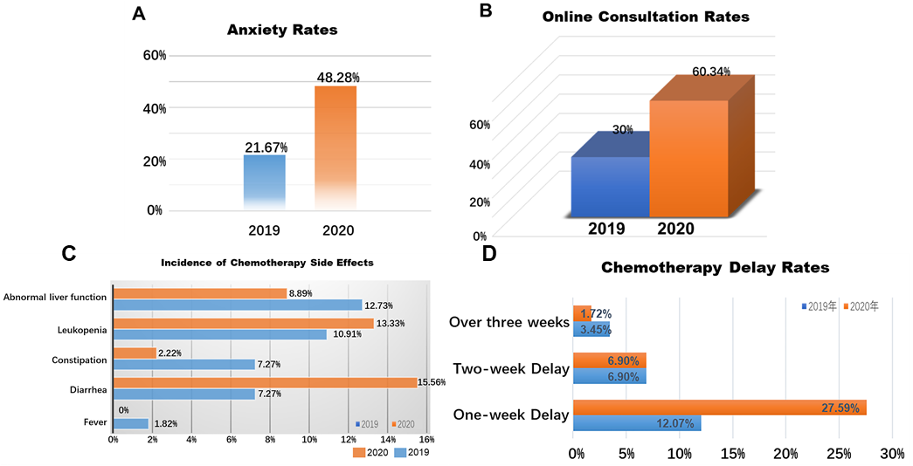
Recent Publications (minimum 5)
- Lin X, Wang S, Sun M, Zhang C, Wei C, Yang C, Dou R, Liu Q, Xiong B. Correction to: miR-195-5p/NOTCH2-mediated EMT modulates IL-4 secretion in colorectal cancer to affect M2-like TAM polarization. J Hematol Oncol. 2019 Nov 22;12(1):122. J Hematol Oncol.
- Li C, Yao Y, Long D, Lin X. KDELC1 and TRMT1 Serve as Prognosis-Related SARS-CoV-2 Proteins Binding Human mRNAs and Promising Biomarkers in Clear Cell Renal Cell Carcinoma. Int J Gen Med. 2021 Jun 14;14:2475-2490.
- Yao Y, Long T, Pan Y, Li Y, Wu L, Fu B, Ma H. A Five-step Systematic Therapy for Treating Plugged Ducts and Mastitis in Breastfeeding Women: A Case-Control Study. Asian Nurs Res (Korean Soc Nurs Sci). 2021 Aug;15(3):197-202.
- Wei C, Yang C, Wang S, Shi D, Zhang C, Lin X, Liu Q, Dou R, Xiong B. Crosstalk between cancer cells and tumor associated macrophages is required for mesenchymal circulating tumor cell-mediated colorectal cancer metastasis. Mol Cancer. 2019 Mar 30;18(1):64.
5. Wei C, Yang C, Wang S, Shi D, Zhang C, Lin X, Liu Q, Dou R, Xiong B. Crosstalk between cancer cells and tumor associated macrophages is required for mesenchymal circulating tumor cell-mediated colorectal cancer metastasis. Mol Cancer. 2019 Mar 30;18(1):64.


Biography (150 word limit)
Ms. Yao Yuzhi is the head nurse of the surgical department of Guangzhou Women and Children's Medical Center. He is also an educational nurse in Guangdong Province. She has been engaged in breast specialist work for nearly ten years, and has rich theoretical knowledge and practical foundation of breast cancer nursing. She has studied at Cincinnati Children's Hospital and Denver Magnetics Annual Meeting.
Email: nikko.yyz@163.com

Notes/Comments:

Presenting author details
Full name:
Contact number:
Mail id:
Category: (Oral presentation/ Poster presentation)

