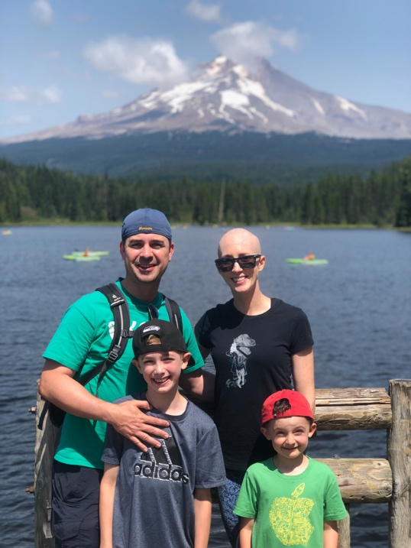
Title: Seeing the Silver Linings, a Survivor’s Story
Name: Melissa Wilmot, breast cancer patient at age 37 (stage 2)

Excerpt from possible speech:

I battled hard through breast cancer. I lost my hair, bruised my arms during botched chemo IVs, couldn’t taste my food, couldn’t dry myself after showers, and missed my sons’ soccer games, but I am on the other side of that experience and grateful and happy. Truthfully, I remained happy and grateful throughout the months of tests, doctor appointments, chemotherapy, surgeries and rehabilitation. I know this may be hard to believe, but it’s true. I went through the wringer and felt happy that my spirit was strong and could get me through it. With a cancer diagnosis, as with many other difficult circumstances, you can easily go down a deep, dark hole, or you can grab firmly onto silver linings. I chose the latter.

One of the first realities I learned after my diagnosis was that every breast cancer diagnosis is different. OK, maybe there are a few that have the exact same variables in play, but it’s rare to find someone having the same experience. I had previously thought if you have breast cancer, it’s the same from one person to the next. Modern medicine tells us so much these days and now we know how different tumors and treatments can be.

How’d I get here? Did I do monthly breast self exams for the past decade? No, I definitely did not. One, I have super dense and bumpy breasts and everything felt like a little tumor if you asked me. And two, I got conflicting information about self exams from doctors, articles, friends. And finally, I have two elementary-aged kids involved in ALL the sports and activities. Breast self exams? I barely had time to wash my hair!

But, I did feel a slightly larger, out-of-place bump while showering in the summer of 2017 and then fixated on it for weeks. Every time I changed, I checked to see if it was still there. It was. It didn’t hurt at all, but was close to the surface of my skin and felt like a pea that moved a bit under my finger pressure. I finally pointed it out to my husband, Matt, and then kept bringing it up, to the point where he finally said, “No, I do not want to feel your bump again! Go to your doctor!” So, I did. My primary care physician couldn’t feel it, but ordered a mammogram and ultrasound in the fall of 2017. Being 36 at the time, I had never had a mammogram. And it’s true what they say – not exactly a spa day. I can’t wait until more comfortable and accurate scanning tools are broadly available to women. Turns out the mammogram didn’t see anything, whew. But then the ultrasound identified my bump. “Most likely a benign tumor called a fibroadenoma,” they told me. “Nothing to worry about and very common in women your age. Come back in six months and let’s see if it’s changed.” I put it out of my head at that point. Worrying wasn’t going to help anything for the next six months. Life went on. We went to Mexico for spring break; both Grady, then nine, and Nolan, then six, played basketball, soccer and baseball; fall turned to winter and then to spring. I went back in May 2018, had a second mammogram that once again didn’t find the bump, and then had a second ultrasound. Before I go into those results, can we just take a moment to acknowledge that in total, I had four mammograms and not one of them saw anything suspicious in my breast tissue? If you are concerned about something, trust your instincts, ask for second opinions, advocate for yourself! Some of these tests and medical equipment are not 100% accurate and women should know that. So, the second ultrasound once again saw the bump and it turns out that it had grown two millimeters (a tiny amount) during the six months. While the immediate response was that fibroadenomas can grow and shrink in size, it warranted a biopsy just to be sure. I vividly remember lying on the bed about to get my biopsy and the doctor telling me, “you know we are almost positive this is a benign fibroadenoma, right?” and I replied in the affirmative, just happy that I would finally know and be able to cross that off my list…

Biography

Melissa Wilmot is the founder and CEO of wedding start-up, WedBrilliant. Not in the medical field, Melissa’s background and presentation proposal comes solely from her experiences as a patient. The medical community should look for opportunities to hear from those it seeks to support, so this presentation helps meet that goal. With a background in public affairs and communications, Melissa worked for an Oregon State Senator, headed up communications for the Portland Japanese Garden and worked with clients on the west coast of the US before launching WedBrilliant. Melissa is married with two young sons and lives in Portland, Oregon. (Up to 100 words)
Presenting author details
Full name: Melissa Wilmot
Contact number: (503) 747-8816
Twitter account:
Linked In account: https://www.linkedin.com/in/melissawilmot/
Session name/ number:
Category: (Oral presentation)

