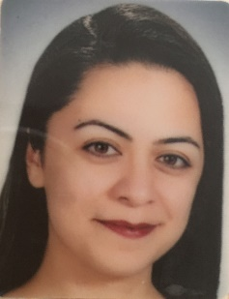
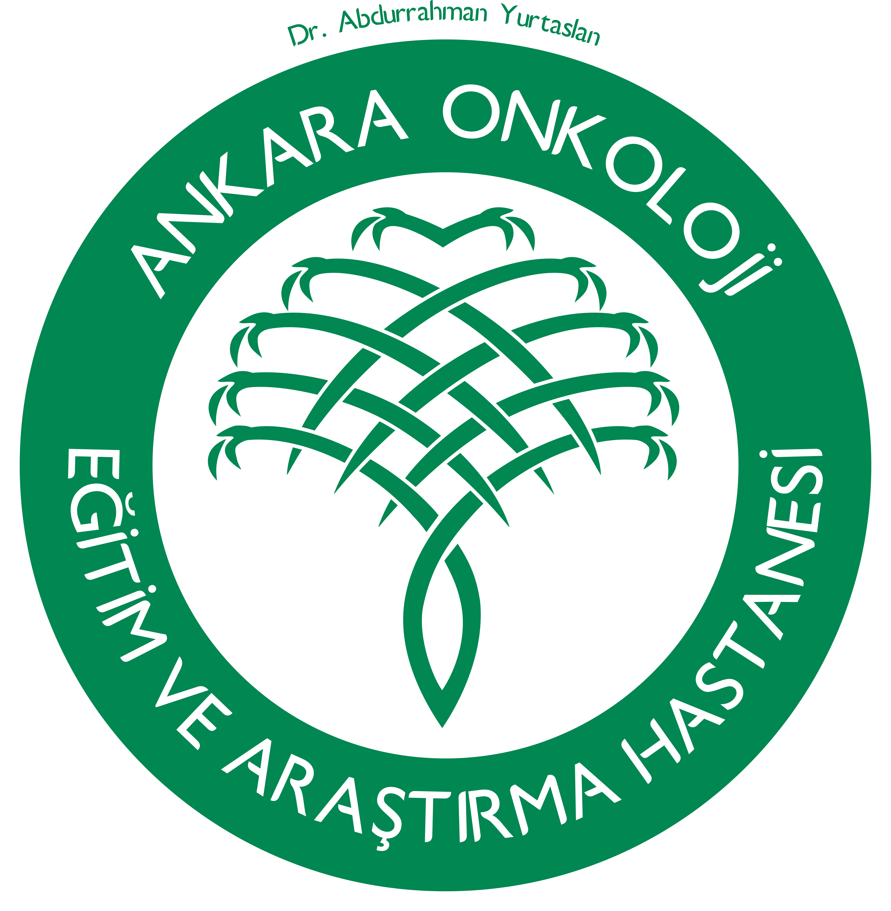Logo here

Title: E-MPBC-Imaging Findings of a Rare Aggressive Breast Cancer Subtype: Metaplastic Carcinoma of the Breast.
Name: Hale AYDIN, MD

Dr Abdurrahman Yurtaslan Ankara Oncology Training and Research Hospital, Ankara 06200, TURKEY

Imaging Findings of a Rare Aggressive Breast Cancer Subtype: Metaplastic Carcinoma of the Breast (E-MPBC): Metaplastic breast carcinoma (MPBC) is one of the rarest and generally poorly differentiated invasive breast carcinomas. According to our knowledge MPBC tend to show more benign imaging features, such as round, lobular, oval shape with a predominantly circumscribed contour. We analyzed 65 patients with pathologically proven MPBC between 2004 and 2016. We reviewed patients’ medical files and breast imaging records of the all patients. Patients ranged in age from 25 to 88 years (median, 53 years) and 16 patients were younger than 40 years-old. The most common mammographic findings were round shape, microlobulated margin and high density masses. The most frequent sonographic presentations of MPBC were round shape, angular margin which partially indistinct, hypoechoic and heterogeneous echo pattern and no posterior feature masses. MRI was performed in 7 patients, and all lesions were presented as masses rather than non-mass enhancements. Six of the lesions showed irregular or spiculated margins. Signal intensity-time curves were type-II or type-III. DWI were obtained in 3 patients and the lesions showed diffusion restriction in 2 patients. In conclusion, well-recognizing the findings of MPBC is very important. Because, according to previously reported series this aggressive, high grade tumour can display more benign imaging feature. This appearance can cause misdiagnosis as benign breast lesion especially in young women. Although the lesions demonstrate benign or moderately malign feature, MPBC should be keep in mind in differential diagnosis for large palpable breast masses.

Biography

Hale AYDIN has graduated from Ankara University School of Medicine, Ankara and completed residency from Baskent University School of Medicine Ankara (TURKEY). She is a radiologist with sub-specialty expertise in breast imaging, and she serve as breast radiologist at Dr Abdurrahman Yurtaslan Ankara Oncology Training and Research Hospital, Ankara. Her research interests have been focused on the use of imaging methods on breast cancers.

