Long term clinical evaluation after microdiscectomy for a single level lumbar disc herniation.

Evangelos I. Papanastasiou M.D., Ph.D.
Orthopaedic surgeon, Larissa, Greece, EU.

Abstract

The purpose of this study is to evaluate the effect of lumbar microdiscectomy in pain, disability and quality of life in a 5-year period and to identify potential demographic and clinical risk factors. One hundred patients who underwent lumbar microdiscectomy by the same surgeon participated in this prospective study. Clinical assessment was made with validated questionnaires (VAS, Oswestry Disability Index, Roland Morris Disability Questionnaire and the SF – 36) preoperatively and up to 5 years postoperatively. Subsequently, associations between clinical outcomes and demographic data were recorded. In every assessment questionnaire, there was a significant improvement in the first postoperative month, which lasted up to 1 year post-discectomy. After that, improvement was statistically significant (p < 0.05) but without clinical importance. Women reported more pain preoperatively and 1 month after surgery. Urban residents also presented more pain preoperatively. Older patients had more pain, disability and worse quality of life 1 to 5 years postoperatively. Similarly, patients with lower education presented the worst scores in every questionnaire at the same time. Smokers reported less pain 1.5 to 4 years after lumbar microdiscectomy. Higher alcohol consumption and obesity were associated with lower levels of preoperative pain. However, obese patients had worse SF-36 and ODI scores after the 6th postoperative month. Patients with heavy jobs presented the worst preoperative ODI scores. Significant clinical improvement was recorded from the first postoperative month to the first postoperative year; stabilization was noticed later on. Feminine gender, urban residency, older age, low level of education, obesity and heavy physical occupation were negative prognostic factors. Oddly smoking and alcohol were correlated with less pain.
Image
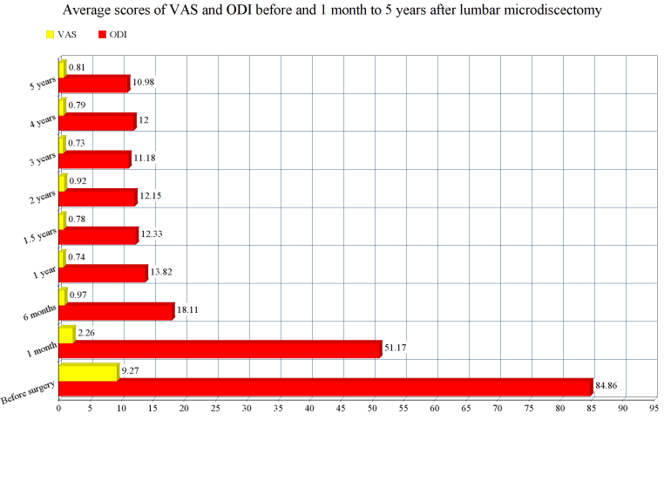
Recent Publications
- Gelalis, I.D., Papanastasiou, E.I., et al. Clinical outcomes after lumbar spine microdiscectomy. A 5 year follow up prospective study in 100 patients. Eur J Orthop Surg Traumatol. 2018. – DOI: 10.1007/s00590-018-2359-8
- Gelalis, I.D., Papanastasiou, E.I., Theodorou, D.J. et al. Postoperative MRI findings 5 years after lumbar microdiscectomy. Eur J Orthop Surg Traumatol (2018). https://doi.org/10.1007/s00590-018-2338-0
- Ahmadi SA, Burkert IP, Steiger HJ et al (2018) Multidimensional long-term outcome analysis after single-level lumbar microdiscectomy: a retrospective single-centre study. Eur J Orthop Surg Traumatol 28:189. https ://doi.org/10.1007/s0059 0-017-2043-4
- Koerner JD, Glaser J, Radcliff K (2015) Which variables are associated with patient-reported outcomes after discectomy? review of SPORT disc herniation studies. Clin Orthop Relat Res 473(6):2000–2006. https ://doi.org/10.1007/s1199 9-014-3671-1
- Huang W, Han Z, Liu J, Yu L, Yu X (2016) Risk factors for recurrent lumbar disc herniation. A systematic review and meta-analysis. Medicine 95(2):e2378. https ://doi.org/10.1097/MD.0000000000 002378

 Biography
Evangelos I. Papanastasiou MD, PhD is an orthopaedic surgeon whose research interests cover a range of issues, especially surgical procedures for cervical and lumbar surgery, microsurgery and surgery of the hand and upper extremity. In addition to orthopaedic surgery and traumatology Dr Papanastasiou is also trained in Medical Acupuncture with an emphasis on musculoskeletal disorders and injuries and on the treatment of myofascial pain and chronic pain syndromes.

Email: vangelispapanastasiou@yahoo.gr

