Perspectives of pharmaceutical stakeholders on determinants of medicines accessibility at the primary care level
Shaimaa A. M. Abd El Fatah, PhD, Kasr Al-Aini Faculty of Medicine , Cairo University, Cairo, Egypt.

Abstract (300 word limit)
Statement of the Problem: Equitable access to essential medicines of maintained efficacy, and cost-effectiveness must be ensured by a well-functioning health system. Egypt, like many developing health systems, cannot simply measure their constraints. Issues preventing “access to medicines for all” need to be explored and addressed. The purpose of this study is to identify the determinants of patients’ access to medicines at the primary health care (PHC) level from the perspectives of various (internal and external) stakeholders of the pharmaceutical system. Methodology & Theoretical Orientation: The study employed both quantitative and qualitative components. Quantitative component applied a descriptive cross-sectional design and qualitative component applied an in-depth interview design. It was conducted at two (PHC) facilities (one urban and the other rural). It inquired upon political, economic, and managerial aspects of the pharmaceutical system utilizing the “Health System Assessment Approach: a How-To Manual” and the “WHO operational package for assessing, monitoring and evaluating country pharmaceutical situations.” Findings: Analysis of the quantitative data extracted from the external stakeholders (patients) revealed that about one-third of patients in both facilities were unable to pay for the medicine. Patients in both settings took less than an hour to reach the PHC facility. The Percent of patients who believe that the private pharmacies’ medicine is better than the PHC one was significantly higher in rural than urban group (24% and 10% respectively) and the percent of medicines dispensed was 50% and 66.7% in rural and urban groups respectively. Analysis of the qualitative data with internal stakeholders (key informants from regulatory agencies, pharmaceutical industry, academia, pharmacists, and physicians) were summarized utilizing Strengths-Weaknesses-Opportunities-Challenges (SWOC) analysis approach. Conclusion & Significance: There is a need to invest in building trust in generic medicine quality in the government health facilities focusing on improving medicine availability and ensuring enough amounts of high-quality drugs. Although there are drug committees in the two studied PHC facilities for demonstrating the prescribing and dispensing policies, yet the system required to enforce these policies is still deficient.

Image
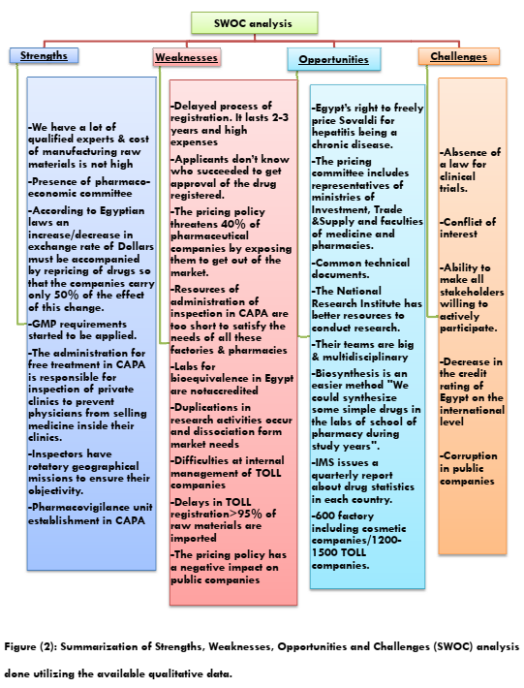
Recent Publications (minimum 5)
- The relationship between health care providers' perceived work climate, organizational commitment, and caring efficacy at pediatric intensive care units, Cairo University. [Original article] Int J Health Plann Mgmt. 2020;35: 469–481. https://doi.org/10.1002/hpm.2920
- Knowledge, Attitude, and Behavior of Egyptian Medical Students Toward the Novel Coronavirus Disease-19: A Cross Sectional Study. [Original article] Open Access Macedonian Journal of Medical Sciences. 2020 Nov 07; 8(T1):443-450.
https://doi.org/10.3889/oamjms.2020.5279
- Perspectives of pharmaceutical stakeholders on determinants of medicines accessibility at the primary care level. [Original article] Journal of the Egyptian Public Health Association, (2021) 96:1 https://doi.org/10.1186/s42506-020-00062-x
- Multifarious experiences of women drivers post-car accidents: An urban community experience. [Original article] Women’s Studies International Forum, 85 (2021) 102449. https://doi.org/10.1016/j.wsif.2021.102449
- Vitamin D supplementation and improvement of pneumonic children at a tertiary pediatric hospital in Egypt. [Original article] Medicine.2021;100:13(e25011). http://dx.doi.org/10.1097/MD.0000000000025011
Paste your Logo here

Biography (150 word limit)
Dr. Shaimaa A. M. Abd El Fatah has her expertise and passion in Public Health and Community Medicine research expressly health system research. Her open and persistent research manner is based on contributing to the work reported, whether that’s in the research conception or design, acquisition of data, analysis and interpretation, or in all these areas.
Her enduring approach in research is always to find out new pathways for improving health care. She has built this conviction after years of experience in research, evaluation, teaching and administration both in hospital and education institutions. This approach is responsive to all stakeholders and has various ways of focusing.

Email: drshaimaali595@hotmail.com

Notes/Comments:
Presenting author details
Full name: Shaimaa A. M. Abd El Fatah
Contact number: 01003062047
Mail id: drshaimaali595@hotmail.com
Category: (Oral presentation/ Poster presentation): Speaker

