Fabrication of Layer-by-Layer Bio-Composite Scaffold for In-vitro Skin Regeneration after Chronic Burns

¹Department of Chemistry, School of Sciences and Engineering, The American University in Cairo (AUC), AUC Avenue, P.O. Box 74, New Cairo 11835, Egypt
*Corresponding author. E-mail address: wael_mamdouh@aucegypt.edu
Abstract:
Skin burn wounds is a definitive issue that can affect patient’s life quality and may drive to Disability-Adjusted Life-Years (DALYs) and cause of death in chronic cases. WHO reported annual global death of 265,000 due to skin burns that often take place in low and middle-income countries. This study aims to fabricate novel tri-layered asymmetric porous bio-composite that can mimic the natural skin layers. The upper layer is composed of nano-fibrous mat and imitative the skin epidermal layer and protects against wide range of pathogens strains. While, the lower layer is in the form of xerogel and mimics the skin dermal layer and provides physical support. Both layers are stick together using effective natural adhesive material that can keep the whole fabricated scaffold intact and stable. A consistent characterization was performed for each layer individually using specific standard techniques. Structural morphology was analyzed using scanning electron microscopy and image j that revealed existence of significant pore distribution among the electrospun and xerogel layers confirmed by the method of Brunauer-Emmett-Teller. Chemical and functional groups of the utilized components were confirmed using fourier transform infrared spectroscopy. The innovated scaffold exhibited promising swelling capacity that appropriate for absorbing wound exudates, followed by constant biodegradability over time (P<0.0001). Nearly 98% of the in-vitro induced gap was healed in the presence of the three scaffold asymmetrical layers using mouse embryonic fibroblasts. The innovated asymmetric scaffold reveals promising biological features for skin regeneration after chronic burns with potential for clinical applications.
Keywords: skin burns, third-degree burns, wound healing, nanofibers, xerogels, biocomposite, scaffold, tissue-engineered skin, tissue culture, biomedical applications.

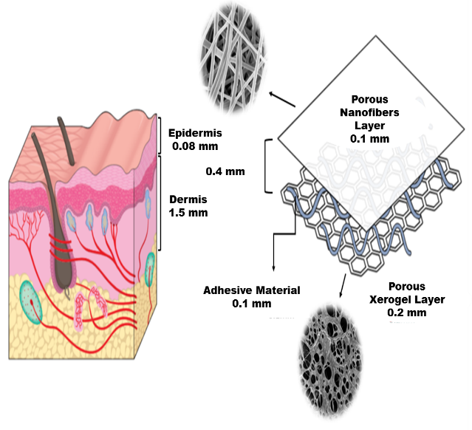Figure 1: Figure illustrating the engineered design of tri-layered asymmetric porous bio-composite scaffold. The upper layer consists of porous nanofibrous sheet with average thickness of 0.1mm. The lower layer constitutes of xerogel mat with average thickness of 0.2 mm. The middle layer is composed of fibrin glue (0.1mm). The whole scaffold was engineered to a thickness of 0.4 mm to facilitate the taken by the normal skin.
References:
- Dias, J. R., Granja, P. L., & Bártolo, P. J. (2016). Advances in electrospun skin substitutes. Progress in Materials Science, 84, 314-334.
- Kheiri, A., Amini, S., Javidan, A. N., Saghafi, M. M., & Khorasani, G. (2017). The effects of Alkanna tinctoria Tausch on split-thickness skin graft donor site management: a randomized, blinded placebo-controlled trial. BMC complementary and alternative medicine., 17(1), 253.

