Isolation and Screening of Protease producing bacteria from soil and characterization of Enzyme
Farheen Aslam^{1*,}Department of Biotechnology, Lahore College for Women University, Lahore; farheenpu@gmail.com, farheenpu@gmail.com, Tel.: +92-42-99203801-9 Ext-277, Fax: +92-42-99203077.
Nargis Khatoon: Department of Biotechnology, Lahore College for Women University, Lahore

Abstract (300 word limit)
Enzymes are biocatalysts produced by living cell, usually take part in the metabolic process of the cell and speed up the biochemical reaction (Suganthi et al., 2013). Application of enzymes in industrial and food processes have experienced significant developments in numerous areas in the last 10-20 years. These include detergent, textile, grain wet milling, pulp and paper, food, monogastric animal feed, organic chemical synthesis, natural polymer modifications and diagnostic etc.
Proteases also play important role in silk degumming and final elegant texture finishing in textile industry(Srilakshmi et al., 2015). Alkaline protease from Bacillus subtilis have been reported for the processing of waste feathers from poultry abattoir(Jisha et al., 2013). A combination of proteases from bacillus subtilis, Bacillus amyloliquefacines and Streptomyces species with thioglycolate is used commercially to clean clogged with hair containing deposits(Rani et al., 2012). Soil samples were required to be collected. For screening of protease producing microorganisms skim milk agar medium was used(Hamza and Azmach. 2018). Isolated culture with a prominent zone of clearance was identified based on both the physiological and morphological characteristics. 1% inoculum of bacteria was added in 10 ml of LB broth media and incubates at shaking condition at 37°C for 24 hour. Centrifuge it at 6000 rpm, remove the pallet. Now check the OD at 660 nm

Image
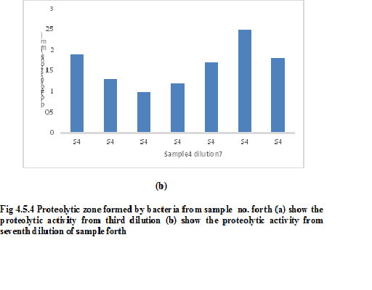
Recent Publications (minimum 5)

- Bashir R1, Afroze B1, Zulfiqar HF1, Saleem R1, Altaf I2, Saleem F1, Aslam F1, Naz S1. Microbiological Load of Ethylene Oxide Sterilized Medical Devices and its Elimination by Cobalt 60 Source. J Coll Physicians Surg Pak. 2016 Jun;26(6):486-9. doi: 2347. 0.4

- Farheen Aslam, Kunza Latif, Faiza Saleem and Shagufta Naz. A general insight into G-protein Coupled receptors. J. innov. Sci. 2(1); 71-74.

- Hina Qaiser, Farheen Aslam, Saima Iftikhar, Adeen Farooq. Construction and recombinant expression of Pseudomonas aeruginosa truncated exotoxin A in Escherichia coli. Cellular and Molecular Biology. 2018 | Volume 64 | Issue 1, 64-69.
Impact factor 1.37

- Khadija Gilani, Shagufta Naz, Farheen Aslam and William Gurley. A Comparison of Zinc, Phosphorous and Potassium Levels in Leaves and Fruit Pulp of Healthy and Huanglongbing Affected Citrus Cultivars. Journal of Plant Physiology & Pathology. 2018. 7:1. Impact factor 0.9.

- Farheen Aslam 1*, Hooria Younas 2, Saima Iftikhar Bajwa. Genomic sequencing and Recombinant Expression of Proinsulin isolated from Cow and Buffalo in Pakistan. 16 May 2019

Photograph

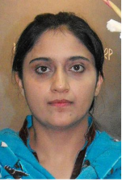

Dr. Farheen Aslam done her Ph.D. from School of Biological Sciences, University of the Punjab. Lahore Pakistan. My Ph.D. research topic was "Cloning, expression and physico- chemical analysis of proinsulin and its derivatives". I have expertise in PCR, Cloning, Expression of recombinant proteins, refolding of recombinant protein, purification of protein, HPLC (High performance liquid chromatography) and MALDI- TOF (matrix assisted laser desorptin ionization-Time of flight.
I am working as Assistant Professor, I exercise a calculated and methodical approach to problem solving. I am competent in teaching and administrative work and research.

.
Email: farheenpu@gmail.com

Notes/Comments:

