Ultrasensitive and Ultrafast Optical Biosensors Based on Two-dimensional Materials

Dr. Shivananju Bannur Nanjunda
Department of Electrical Engineering
Centre of Excellence in Biochemical Sensing and Imaging Technologies (Cen-Bio-SIM)
Indian Institute of Technology Madras, India

Abstract
In the last few decades nanomaterials such as nanoparticles, nanowires, quantum dots, carbon nanotubes have been explored for biosensing applications [1]. In recent years two-dimensional (2D) nanomaterials have attracted significant attention for electronics, photonics, and biosensors applications [2]. Graphene and related 2D materials have exceptional biochemical optical sensing properties such as large surface-to-volume ratio, excellent biocompatibility, fluorescence-quenching ability, broadband light absorption, ultrafast carrier mobility, high chemical stability, outstanding robustness and flexibility. The most striking features of optical biosensors based on 2D materials are ultra-sensitivity, ultrafast response time, and increasing the specificity of label-free biosensing, thereby posing the potential to replace some of the existing electrical and mechanical sensors used for biosensing applications [1, 3].
This presentation covers the emerging optical biosensors based on 2D materials. First discuss on their optical sensing properties, followed by fabrication of 2D materials coated optical sensors, and finally recent biosensing applications such as single cell detection, RNA sensing, and DNA sensing [1, 3]. We have recently demonstrated a surface plasmon resonance sensor based on 2D nanomaterial of antimonene for the specific label-free detection of clinically relevant cancer bio-markers such as miRNA-21 and miRNA-155. The detection limit can reach 10 aM, which is 2.3–10,000 times higher than those of existing miRNA sensors [4]. We have also demonstrated a novel photonic integrated graphene-optofluidic device to monitor DNA structural changes with the ultrafast response time as schematically shown in Figure 1. Our innovative technique for the first time allows us to perform ultrafast monitoring of the conformational changes of special DNA molecules structures, including G-quadruplex formation by K+ ions and i-motif formation by the low pH stimulus [5]. The 2D materials based optical biosensors as demonstrated provides a new class of label-free, ultrafast, ultrasensitive, compact, and cost-effective optical biosensors for medical and healthcare applications.

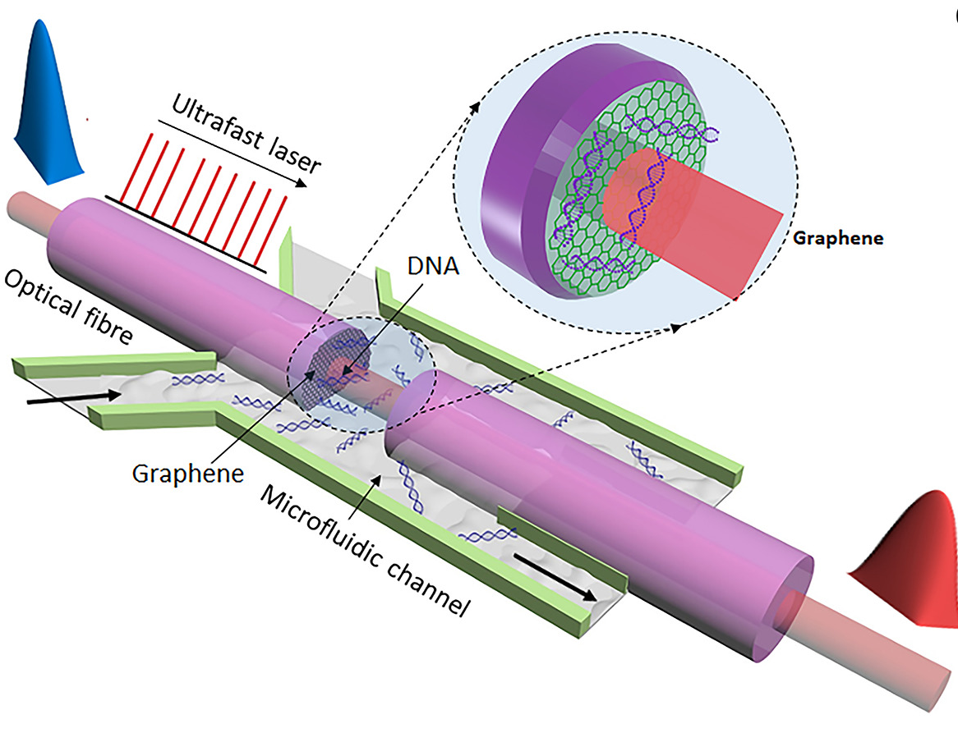
Figure 1: Schematic diagram of ultrafast graphene-optofluidic device for probing interaction of DNA structures on two-dimensional graphene [5].
Recent publications
- Shivananju Bannur Nanjunda, et al., (2019), “Optical Biochemical Sensors Based on 2D Materials,” Book chapter, doi.org/10.1016/B978-0-08-102577-2.00010-5.
- Hui Ying Hoh, et al., (2019) “Bio-photonic applications,” Book chapter, doi.org/10.1016/B978-0-08-102637-3.00009-7.
- Shivananju Bannur Nanjunda, et al., (2017) “The roadmap of graphene-based optical biochemical sensors,” Advanced Functional Materials, 27, 1603918.
- Tianyu Xue, et al. (2019), “Ultrasensitive detection of miRNA with an antimonene-based surface plasmon resonance sensor,” Nature Communications, 10 (1), 28.
- Shivananju Bannur Nanjunda, et al. (2020) “Probing the dynamic structural changes of DNA using ultrafast laser pulse in graphene‐based optofluidic device,” InfoMat, 3 (3), 316-326.


Biography
Dr. Shivananju Bannur Nanjunda received his PhD degree (2014) from Indian Institute of Science, India. He worked as a research fellow at the ARC Centre of Excellence in Future Low-Energy Electronics Technologies (FLEET), Department of Materials Science and Engineering, Monash University, Australia. He is currently working as an Assistant Professor in the Department of Electrical Engineering, Indian Institute of Technology (IIT) Madras, India. He is one of the 10 lead Chief Investigators of Centre of Excellence in Biochemical Sensing and Imaging Technologies (Cen-Bio-SIM). He has authored or co-authored more than 40 international journals and conferences articles with more than 1,200 total citations and an H-index of 17 (Google Scholar). His research involves the investigation of two-dimensional materials based biochemical optical sensors, photonics & optoelectronics devices, polaritons & Nano-FTIR, optogenetics & neural imaging applications. Shivananju serves as a Guest Editor of international Sensors (MDPI) journal.
Email: shivananju@ee.iitm.ac.in
Presenting author details
Full name: Shivananju Bannur Nanjunda
Contact number/Mobile Number: +91-9880928566
Session name/ number: Biosensing Technologies
Category: (Oral presentation/ Poster presentation): Oral presentation

