Exploring the Opportunity for Organic Household Waste (OHW) Management Technology Options: An Empirical Investigation for Muharraq City
Sumaya Yusuf Abbas, MSc,MPhil, PhD Candidate, WMG, University of Warwick, UK

Abstract (300 word limit)
Statement of the Problem: Waste management is currently considered one of Bahrain’s most important challenges, thus, exploring the opportunity for OHW through selecting the most preferred management solution for the Bahraini context seems to be necessary, especially with the appearance of the harmful effects of dumping it into the landfill. Moreover, exploring the socio-economic and environmental gains of the technology implementation helps the decision makers to have a clear vision for future waste management strategy adoption and policy making. This research aims to explore the opportunity for the OHW management options using the "Case Study" methodology on Muharraq City, via developing a profile/technology matrix from literature review. Empirical OHW samples chemical characterization, and exploring the most preferable OHW Management technology solutions based on Bahraini OHW characteristics criteria. Sustainability gains of the selected technology environmentally, economically and socially, and exploring the enablers and barriers to the technology adoption will be explored. Research methods are quantitative and qualitative approaches. Research provide sufficient information to future adoption of preferred OHW management technology in Bahrain and explore the barriers and enablers to its adoption which help in decision making, and give a full understanding of OHW characterization in Bahrain and suggest solutions to overcome barriers. Public awareness will be measured among public as an important key factor to succeed any waste management practices in the country. As a conclusion, the research may provide sufficient information to future adoption of specific OHW management technology in Bahrain and explore the barriers and enablers to its adoption which helps in decision making and gives a full understanding of the OHW characterization in Bahrain. The case study might be the first of its kind in the region and be a model to be applied to any country that share similar characteristics and waste composition.

Image
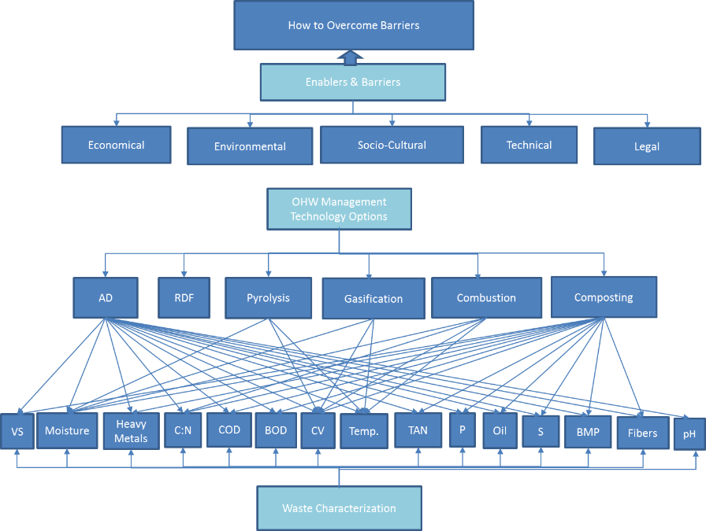
Figure 1: The Parameters and Technologies interrelation to be considered in this research, with the possible enablers and barriers.

Recent Publications (minimum 5)
- Sumaya Abbas (2015), Exploring the Opportunity for Household Organic Waste Valorisation: An Empirical Investigation for Case Study Muharraq City, WMG Doctoral Research and Innovation Conference International Manufacturing Centre, University of Warwick.(Poster)
- Sumaya Abbas (2017), Exploring the Opportunity for Household Organic Waste Valorisation: An Empirical Investigation for Case Study Muharraq City, WMG Doctoral Research and Innovation Conference International Manufacturing Centre, University of Warwick.(Oral presentation)
- Sumaya Hasan (2015), Waste Heat Recovery as a Potential CDM Project: Case Study of a Refinery in Bahrain. Bahrain Society of Engineers, June, 60 :14-16
- Sumaya Yousif (2012), Waste Heat Recovery as Potential CDM Project: Case Study of a Refinery in Bahrain, Women as global Leaders conference, Zayed University, UAE. (oral presentation)
- Sumaya Yousif (2013), Waste Heat Recovery as Potential CDM Project: Case Study of a Refinery in Bahrain, 1st Energy Management Conference & Exhibition 2013, MOE, Society of Engineers, Manama, Bahrain. (Oral Presentation)

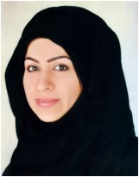
Biography (150 word limit)
Sumaya Yusuf Abbas is a L'OREAL-UNESCO Pan Arab Regional Fellowship Award Winner in 2012-2013 as the First Bahraini Woman winner. Venus International Women Award for outstanding women achiever, 2016. In February 2015, she earned MPhil in Environmental Engineering from the University of Warwick-. Member in EUROMA since 2014. In March 2011, she earned an M.Sc in Environmental Management from the Arabian Gulf University, Bahrain. Sumaya is a lecturer and researcher in the Arabian Gulf University. In 2006, she won a Scholarship provided by the Japanese Government to pursue her higher studies and in 2007 obtained a Postgraduate Researcher Certificate and High Diploma in Bio-systems Sustainability-Nutritional Biochemistry from the Graduate School of Agriculture, Hokkaido University, Sapporo Japan; and was a Master student in their Special Postgraduate Program. She has participated in many local and international conferences; she has 13 years of experience in the field of Environmental Management.
Email: Sumaya.Abbas@warwick.ac.uk

Notes/Comments:

This paper is under completion by getting the results ready soon. Many statistical interactions and comparisons are to be built.
This is part of the PhD thesis

