Role of pharmacist in correction of inappropriate medication in hospitalized geriatrics
¹Akhtar Tavana Ghamsari, pharmacy student, Shahid Beheshti University of medical Sciences, Tehran, Iran
²Mohammad Abbasinazari, Shahid Beheshti University of medical Sciences, Tehran, Iran

Abstract
Statement of the Problem :Elderly people with frailty and urgent care needs are major users of health and social care services. The Beers Criteria for the use of prescription inappropriate medication (PIM) in geriatrics are one of the most frequently consulted sources regarding the safety of prescribing medications for older adults. The present study aims to evaluate the rate of PIM and effect of the consultation provided by the clinical pharmacist for alteration of prescription errors.

Methodology & Theoretical Orientation: In all, 240 elderly patients have been evaluated during eight months in the internal and surgery wards of a Taleghani hospital in Tehran, Iran. Mean age of evaluated geriatrics was 71.2$±7.9$. In case of any deviation from the Beers Criteria, the clinical pharmacist did an intervention by writing progress notes and talking with physicians for modification in geriatric medication.

Findings: High prevalence of PIM has been shown by Pethidine, Alprazolam and Metoclopramide respectively. As much as 33.3% of the elderly patients had at least one PIM. Moreover, 91.5% of consultations provided by clinical pharmacists have been accepted, resulting in modifications of inappropriate medication. The acceptance for the correction of non-psychotropic medication was better than the psychotropic kind.

Conclusion: Clinical pharmacists play an important role in the modification of the pharmacotherapy of hospitalized elderly patients through consultation with physicians.

Image
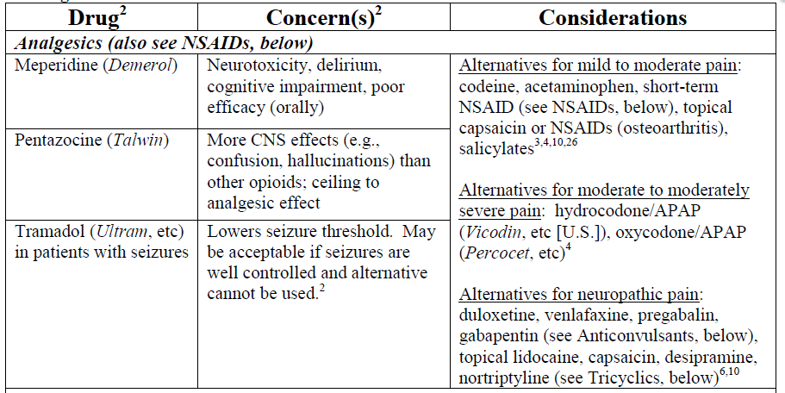
Recent Publications
- Azoulay L, Zargarzadeh A, Salahshouri Z, Oraichi D, Bérard A. Inappropriate medication prescribing in community-dwelling elderly people living in Iran. European journal of clinical, pharmacology. 2005 Dec 1;61(12):913-9.
- Lucchetti G, Lucchetti AL. Inappropriate prescribing in older persons: A systematic review of medications available in different criteria. Archives of gerontology and geriatrics. 2017 Feb 28;68:55-61.
- Nadai M, Katoh M. Changes in pharmacokinetics in elderly patients. Nihon rinsho. Japanese journal of clinical medicine. 2013 Jun;71(6):999-1003.Zullo AR, Gray SL, Holmes HM, Marcum ZA. Screening for Medication Appropriateness in Older Adults. Clinics in geriatric medicine. 2017 Oct 14.
- Pesante-Pinto JL. Clinical Pharmacology and the Risks of Polypharmacy in the Geriatric Patient. Physical Medicine and Rehabilitation Clinics of North America. 2017 Nov 30;28(4):739-46.
- Fulone I, Lopes LC. Potentially inappropriate prescriptions for elderly people taking antidepressant: comparative tools. BMC geriatrics. 2017 Dec;17(1):278


Akhtar Tavana Ghamsari is a pharmacy student. She has always been a very conscientious student and performed her duties with utmost indulgence. Her grades were all excellent. She is highly motivated and she was always ardent to help other students. She has the talent and dedication needed for pursuing her graduate studies at best schools.
.
Email: akhtar_tavana@yahoo.com

