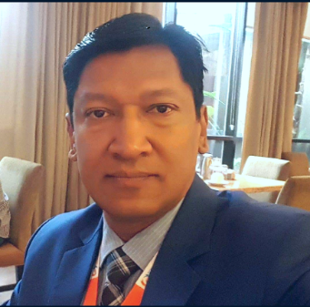
Title: Biomedical Equipment Maintenance Services: a challenge to implement in remote area
Bikash B. Shrestha, Advanced College of Engineering & Management, Nepal
Abstract
Importance of biomedical engineering field is ever growing with the focus of health quality demands and its safe practices in Nepal. One side, the remoteness gives challenges to this industry whereas the other side; have to consider the health care seekers choice of right of treatment near to their home. However, the trends of recent day practices have been growing and improved, dramatically both in private and government hospitals; the best practice and performance of biomedical equipment is needed to ensure safety, accuracy and expected results on time. Recently, Ministry of Health successfully outsourced the “Nationwide Maintenance Services of Biomedical Equipment” (IFB No: DoHS/MC-2016/Lot-1/Lot-2/Lot-3) program which is supported under the technical collaboration and assistance from the management4health (m4h) GmbH, Germany and KFW Development Bank, Germany. Implementation of this program is one of the big challenges due to use of the sophisticated equipment in remote part of country and its regular management. Program comprises the PLAMAHS (Planning and Management of Assets in Health Service) unique database system that has been designed for the specific purpose for Nepal first time in the South Asia. A major contractor like Medilux Systems has involved in Lot-3 program ensuring the set up plan of actions like Planned Preventive Maintenance (PPM) and Curative Maintenance (CM) of the regular safety inspections that will cut down the chances of failure. The contractor also established three respective workshops covering 30 districts of far-western remote place of Nepal and a head office incorporating a strong team of management that is responsible for HR mobilization and strategic planning. Finally, the efficacy of this expected program is to improve overall public health status in remote place of Nepal within 4 years of stipulated time period.
Biography:
Bikash B. Shrestha, PEng is Associated Professor, Head of the Department of Electrical Engineering and Academic Adviser for Department of Computer and Electronics Engineering at Advanced Engineering College & Management, Tribhuvan University, where he has been since 2016. He also currently serves as President of Biomedical Engineering Foundation Nepal (BEFON). From 2008-Till now he is a Visiting Associate Professor at the College of Biomedical Engineering and Applied Sciences, Purbanchal University and from 2001-Till now he is a Visiting Associate Professor at the Institute of Technology, Tribhuvan University. He received a B.Sc. Engineering from Bangladesh University of Engineering & Technology in 1993. He received his M.Tech. in Biomedical Engineering from the Indian Institute of Technology (IIT) of Banaras Hindu University at Varanasi, India in 2001. From 1994 to 2016 he worked at Shree Birendra Hospital, Nepal Army in Kathmandu Nepal, eventually as a Senior Biomedical Engineer. He is First PEng (Professional Engineer) Title holder in Biomedical Engineering in Nepal. He was awarded with “Distinguished Entrepreneur Award” for 2019 on 57th Engineer Day organized by Nepal Engineers’ Association.

Presenting author details
Full name: Er. Bikash Bahadur Shrestha, PEng
Contact number: +977 9851038698
Twitter account:
Linked In account: Bikash Shrestha, PEng
Session name/ number: Track 1: Biomedical Engineering & Biomedical Device Engineering
Category: Keynote Presentation

