Hybrid smart nanocrystals and the shielding effect of phospholipic bilayer for biomedical application
Valentina Cauda, Professor, Bianca Dumontel, MD, Francesca Susa, MD, Marta Canta, MD, Luisa Racca, MD, Andrea Ancona, PhD, Nadia Garino, PhD, Tania Limongi, PhD, Giancarlo Canavese, PhD, Marco Laurenti, PhD
Politecnico di Torino, Department of Applied Science and Technology, Turin, Italy

Abstract (300 word limit)
Statement of the Problem: Zinc oxide nanocrystals (ZnO NCs), thanks to their unique properties, are receiving much attention for their use in nanomedicine, in particular for therapy against cancer [1]. To be efficiently employed as diagnostic and therapeutic (yet theranostic) tools [2], highly dispersed, stable and non-toxic nanoparticles are required. In the case of ZnO NCs, there is still a lack of knowledge about cytotoxicity mechanisms and stability in the biological context, as well as immunological response and haemocompatible features. We thus propose a novel approach to render stable, immune and hemocompatible these ZnO NCs in various biological media using artificial and natural phospholipidic bilayers.
Methodology: We synthesized amino-functionalized ZnO NCs, then shielded with phospholipid bilayers either from synthetic origin or natural biovesicles. We characterized their structural, morphological, physico-chemical properties, focusing on the coupling mechanism between ZnO NCs and the lipid vesicles. The stability behavior of different hybrid nanocrystals was evaluated, comparing their biodegradation profiles in different inorganic and biological media. The studies aim to investigate how the particle surface chemistry and charge could influence their aggregation/ degradation in the different media and interaction with cells. We actually proved their haemocompatibility in human plasma and their internalization into cancer cells and related cytotoxicity mechanisms. A stimuli responsive activation by UV-light was investigated for inducing high mortality of cancer cells based on the hybrid NCs.
Findings: We demonstrated that pristine ZnO NCs strongly aggregate when suspended in both simulated and biological media, showing small dissolution into potentially cytotoxic Zn-cations, also slightly affecting their crystalline structure. In contrast, high colloidal stability and integrity was retained for hybrid lipid-shielded ZnO NCs in all media [3,4], accompanied by high biocompatibility, efficient cell internalization and effective killing ability only upon stimuli-activation. These features render these hybrid ZnO NCs ideal “Trojan horses” for further theranostic applications.

Image
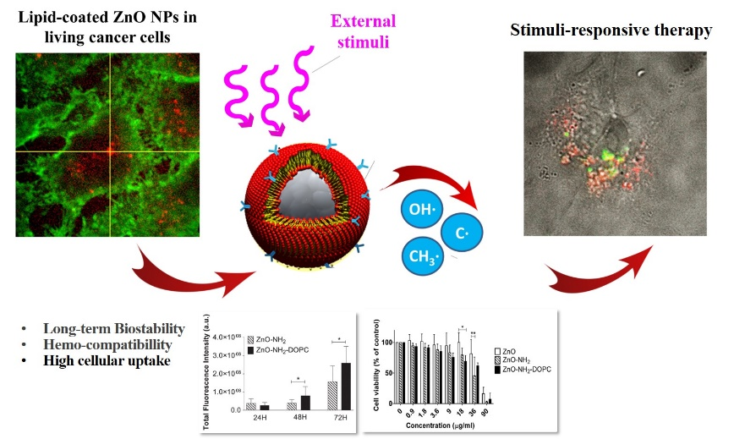

Figure 1. Scheme of the hybrid nanocrystal, as a Trojan horse showing higher bio- and haemocompatibility, long-term stability in various biological and inorganic fluids, improved cell internalization with respect to pristine ZnO NCs. A stimuli responsive behavior, guided by UV-light is also reported.

Recent Publications (minimum 5)
1. Racca L, Canta M, Dumontel B, Ancona A, Limongi T, Garino N, Laurenti M, Canavese G, Cauda V (2018) “Zinc oxide nanostructures in biomedicine” in Ciofani G Ed. “Smart Nanoparticles for Biomedicine”, Elsevier Inc, 171-187, doi: 10.1016/B978-0-12-814156-4.00012-4.
2. Lim E, Kim T, Paik S, Haam S, Huh Y, Lee K (2015), Chem. Rev. 115:327−394.
3. Dumontel B, Canta M, Engelke H, Chiodoni A, Racca L, Ancona A, Limongi T, Canavese G, Cauda V (2017) Enhanced Biostability and Cellular Uptake of Zinc Oxide Nanocrystals Shielded with Phospholipid Bilayer. Journal of Materials Chemistry B, 5:8799-8813.
4. Ancona A, Dumontel B, Garino N, Demarco B, Chatzitheodoridou D, Fazzini W, Engelke H, Cauda V, (2018) Lipid-Coated Zinc Oxide Nanoparticles as Innovative ROS-Generators for Photodynamic Therapy in Cancer Cells. Nanomaterials 8 (143):1-15

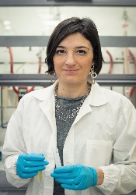
Biography (150 word limit)
Valentina Cauda is Associate Professor at the Politecnico di Torino, Italy. She received her Ph.D. in Material Science and Technology in 2008 from the same university and graduated in Chemical Engineering in 2004. In 2006 she worked as visiting PhD student at the Universidad Complutense (Madrid, Spain). From 2008 to 2010, she worked as Post-Doc at the University of Munich, Germany. From 2010 to 2015 she was Senior Post-Doc at the Istituto Italiano di Tecnologia (Italy). For her research results she received in 2010 the prize for young researchers at the University of Munich, in 2013 she got the Italian “Giovedì Scienza” award, in 2015 the Zonta Prize for Chemistry, and in 2017 the USERN Prize for Biological Sciences. In 2016 she was awarded by the European Research Council with an ERC Starting Grant. She is author of 84 papers on peer-reviewed international journals with H-index of 28 (Source: Scopus accessed on September 2018).
Email: valentina.cauda@polito.it

Notes/Comments:

This work has received funding from the European Research Council (ERC) under the European Union’s Horizon 2020 research and innovation programme (grant agreement No 678151 – Project Acronym “TROJANANOHORSE” – ERC starting Grant) and from Compagnia di Sanpaolo.

