Carbonate apatite: Next generation artificial bone replacement
Kunio Ishikawa, PhD, Kyushu University, Japan

Abstract
Although bone apatite is the carbonate apatite (CO₃Ap) that contains 6-9wt% carbonate in apatitic structure, hydroxyapatite (HAp) has been used as one of typical artificial bone substitute since CO₃Ap powder start to decompose at 400°C, thus cannot be sintered. We have found that CO₃Ap block can be fabricated by compositional transformation though a dissolution–precipitation reaction using precursors such as calcium carbonate and tricalcium phosphate.
Although HAp is not resorbed by osteoblasts, CO₃Ap thus fabricated was resorbed by osteoclasts similar to bone (figure 1). As a result of osteoclastic resorption, CO₃Ap is replaced by bone whereas HAp remained as it is at the bone defects (Figure 2). CO₃Ap up-regulate differentiation of osteoblasts even when compared to HAp. 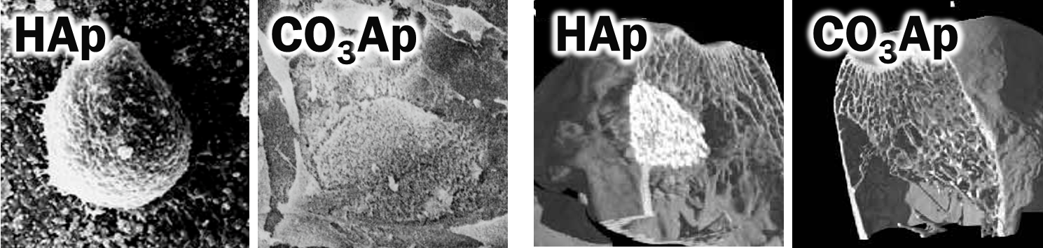
Figure1 SEM images of HAp and CO₃Ap when osteoclastic cells were incubated on their surfaces.

Figure 2 Micro-CT images of HAp and CO3Ap when used for the reconstruction of rabbit femur bone defect. 24months after implantation.

Figure 3 show the typical Villanueva Goldner staining of HAp and CO₃Ap when used for the reconstruction of bone defect made at the beagle dog mandible. Both HAp and CO₃Ap demonstrated excellent tissue response. However, amount of the bone formed at the bone defect was much larger in the case of CO₃Ap when compared to HAp.

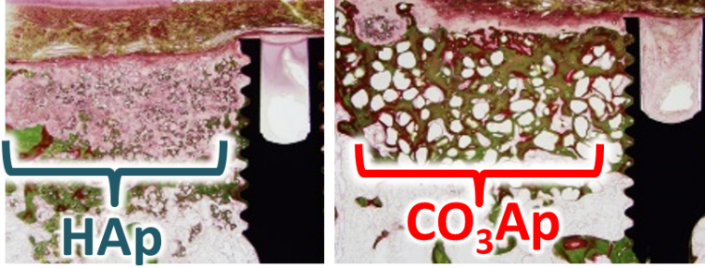
Figure3 Villanueva Goldner staining of HAp and CO₃Ap when used for the reconstruction of bone defect at the beagle dog mandible. 3months after implantation
Recent Publications
1. Ishikawa K, Kawachi G, Tsuru K, Yoshimoto A (2017) Fabrication of calcite blocks from gypsum blocks by compositional transformation based on dissolution–precipitation reactions in sodium carbonate solution. Mater Sci & Eng C, 51, 389–393.
2. Shariff KA, Tsuru K, Ishikawa K (2017) Fabrication of dicalcium phosphate dihydrate-coated β-TCP granules and evaluation of their osteoconductivity using experimental rats. Materials Science and Engineering C. 75, 1411-1389–393.
3. Fukuda N, Tsuru K, Mori Y, Ishikawa K (2017) Effect of citric acid on setting reaction and tissue response to β-TCP granular cement. Biomed Mater, 12(1), 15027.
4. Arifta TI, Munar ML, Tsuru K, Ishikawa K (2017) Fabrication of interconnected porous calcium-deficient hydroxyapatite using the setting reaction of α tricalcium phosphate spherical granules. Cerams Int, 43,11149-11155.
5. Sugiura Y, Tsuru K, Ishikawa K (2017) Fabrication of arbitrarily shaped carbonate apatite foam based on the interlocking process of dicalcium hydrogen phosphate dihydrate. J Mater Sci: Mater Med, 28, 122.

Biography
Kunio Ishikawa graduated Osaka University, Japan in 1985 and got a PhD in 1990. After he worked at Tokushima University as Assistant Professor, he moved to Okayama University as Associate Professor. In 2001, he became Chairman and Professor of the Department of Biomaterials, Faculty of Dental Science, Kyushu University, Japan. He is also working as a Senior special advisor, National Institute of Science and Technology Policy, Ministry of Education, Culture, Sports, Science and Technology, Japan His interest is biomaterials aimed for hard tissue regeneration and reconstruction. He was awarded “The Award of Japanese Society for Biomaterials”.
Email: ishikawa@dent.kyushu-u.ac.jp

Notes/Comments:

