Preparation of PVDF-g-PNIPAAm thermo-sensitive fiber membranes by electrostatic spinning and application in cultivation and harvest of cells
Tianqing Liu, Kedong Song, Dan Ge, Shui Guan, PhD, Dalian University of Technology, China


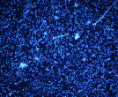
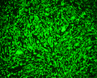

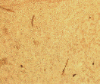
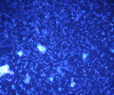
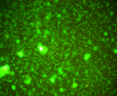


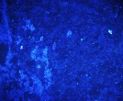
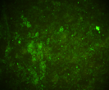

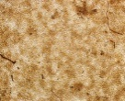

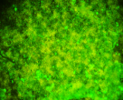

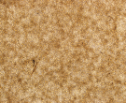
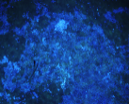
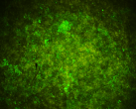

Bright field
Hoechst
Calcein-AM
PI
Control
M_{PVDF}
M21
M43
M11
Figure 1: Images of PC12 cells fluorescent stain on different material surfaces.

Abstract
Trypsin digestion has long been the main way to harvest anchorage-dependent cells. But trypsin will damage the proteins of extracellular matrix, leading to the degradation of the structure and function of cells. Cultivating cells on thermo-sensitive material, then harvesting cells by lowering temperature, can make the extracellular matrix maintain integrity.
In this study, a series of PVDF-g-PNIPAAm thermo-sensitive fiber membranes, M21, M43, M11, and M45 were prepared by electrospinning. Fourier transform infrared spectroscopy and NMR-H spectrum were used to characterize that the PNIPAAm was grafted successfully. The morphology of each fiber membrane was observed by scanning electron microscope, indicating that the grafting percentage of PNIPAAm influenced the spinnability of PVDF. Fourier transform infrared spectroscopy of PVDF and PVDF-g-PNIPAAm fiber membranes showed that electrostatic spinning would not change the structure of thermo-sensitive polymer.
PC12 cells were seeded on the surfaces of M21, M43 and M11 for cell experiments. The cell adhesion, proliferation and growth on different fiber membranes were examined. Then the harvested cells on different fiber membranes with temperature reduction was compared with those harvested by trypsin digestion method. The images of cell live/dead fluorescence staining showed that cells in different fiber membranes all had a high viability and the prepared thermo-sensitive fiber membranes had good biocompatibility. The MTT results showed that the nanometer fiber structure was conducive to the proliferation and growth of cells. The cells grown on the surface of M21 were the best and relatively poor on the M11, which indicated that higher grafting ratio is not suitable for the adhesion and growth of cells. Finally the cells cultivated on the three thermo-sensitive fiber membranes after three days were harvested with temperature reduction, showing that high grafting ratio is advantageous to the detachment of cells. Compared with trypsin digestion method, the temperature reduction method has significant advantages.

Recent Publications (minimum 5)
- Kato A, Kan K, Ajiro H, et al (2017) Development of a rapid in vitro tissue deadhesion system using the thermoresponsive sol-gel transition of hydroxybutyl chitosan. Journal of biomaterials science polymer edition 1:16.
- Nagase K, Sakurada Y, Onizuka S, et al (2017) Thermoresponsive polymer-modified microfibers for cell separations Acta biomaterialia 53:81-92.
- Sudo Y, Sakai H, Nabae Y, et al (2016) Role of hyperbranched polystyrene on thermo-responsive cell culture dishes prepared by hyperbranched polystyrene-g-poly (N-isopropylacrylamide) Polymer 100:77-85.
- Mellati A, Kiamahalleh MV, Madani SH, et al (2016) Poly(N-isopropylacrylamide) hydrogel/chitosan scaffold hybrid for three-dimensional stem cell culture and cartilage tissue engineering Journal of Biomedical Materials Research Part A 104(11):2764-2774.
- Sudo Y, Sakai H, Nabae Y, et al (2015) Preparation of hyperbranched polystyrene-g-poly(N-isopropylacrylamide) copolymers and its application to novel thermo-responsive cell culture dishes Polymer 70:307-314.

Biography (150 word limit)
Prof. Liu, Ph.D. in Chemical Engineering, is the director of R&D center for stem cell and tissue engineering, Dalian university of technology, China. His main research interests include novel bioreactor and stem cells 3D culture; stem cell expansion and differentiation control; scaffolds and tissue construction; transport phenomena in micro/nano scale and enhancement; bioprocessing of bio-fuel etc. He has published more than 200 journal papers and more than 100 papers in proceedings of international conferences; edited 2 scientific books and as author in other 3 chapters of international books on tissue engineering; 11 patents. Prof. Liu has been responsible for various national and international projects on transport phenomena and stem cell study.

Email: liutq@dlut.edu.cn

Notes/Comments:

