Production of bone tissue support materials based on bioactive glass-polymer composites
Ali Can ÖZARSLAN¹, Sevil YÜCEL¹, Oguzhan GÜNDÜZ²
¹Yildiz Technical University, TURKEY
²Marmara University, TURKEY

Abstract
Bone tissue support materials have biocompatibility, biodegradability and bioactivity properties that are made of various ceramics, polymers or both of ceramics and polymers which is called composites. The most interesting of them is bioactive glasses due to their excellent features. Bioactive glasses are osteoconductive and osteoinductive materials and when they implanted on bone, they connect to the bone tissue. They are generally used in order to fill bone defect and promote new bone formation because of their osteogenic cell stimulator and bioactivity properties. In recent years, bioactive glass materials which are used as bone in the form of block, granules, injectable or paste has increased significantly. These forms which are called support material make easier patient healing and surgical operation.
In this study, injectable bone tissue support materials based on bioactive glass-polymer composites were produced for bone tissue engineering applications. At different ratios of bioactive glass and alginate composites were prepared such as 1:1, 1:2; g/ml, respectively. All samples were characterized by Fourier Transform Infrared Spectroscopy (FT-IR) and X-Ray Diffraction (XRD) analysis before simulated body fluid (SBF) to understand structure of composites and after SBF to understand bioactivity properties of composites.

Image

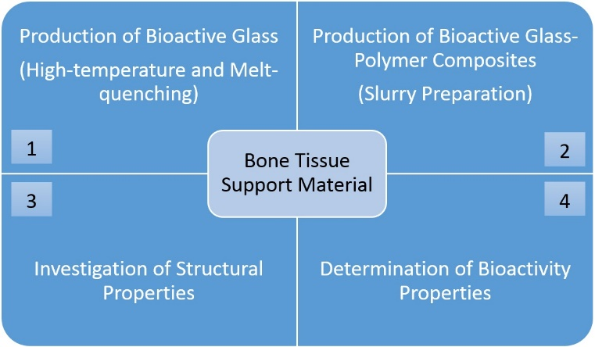

Recent Publications
- Borhan, S., Hesaraki, S., Behanamghader, A.A., Ghasemi, E., (2015). Injectable bone paste biocomposite based on melt-derived bioactive glass and sodium alginate natural polymer, Journal of The Australian Ceramic Society, 51(2):99-108.
- Sohrabi, M., Hesaraki,S., Kazemzadeh, A., Alizadeh, M., (2013). Development of injectable biocomposites from hyaluronic acid and bioactive glass nano-paticles obtained from different sol-gel routes, Materials Science and Engineering, 33:3730-3744.
- Combes, C., Tadier, S., Galliard, H., Girodfullana, S., Charvillat, C., Rey, C., Auzely-velt, R., El Kissi, N., (2010). Rheological properties of calcium carbonate self-setting injectable paste, Acta Biomater., 6:920-927.
- Gerhardt L.C. and Boccaccini, A.R., (2010). Bioactive glass and glass-ceramic scaffolds for bone tissue engineering, Materials, 3, 3867–3910.
- Özarslan, A.C., Yücel, S., (2016). Fabrication and characterization of strontium incorporated 3-D bioactive glass scaffolds for bone tissue from biosilica, Materials Science and Engineering: C, 68, 350-357.

 Biography
Ali Can Özarslan completed bachelor degree at Yildiz Technical University, department of bioengineering in 2015. He continues his education as a graduate student at Yildiz Technical University, department of bioengineering. He has 2 research paper published by the international refereed journals and 5 papers published by the international scientific meetings. Topics of his interest are bone tissue engineering, biomaterials, bone tissue support materials.
Email: alicanozarslan@gmail.com

