How to meet the needs of bees? – Diversification of industrial crops cultivation for a more environmentally benign bioeconomy
Moritz von Cossel, University of Hohenheim, Germany

Abstract
Statement of the Problem: Today, agriculture is facing fundamental ecosystemic crisis such as pollinator losses and land degradation mainly driven by both climate change and declining landscape heterogeneity. Consequently, industrial crops cultivation (ICC) – key element of a growing bioeconomy - should both avoid competition with food crops cultivation (FCC) and take environmental aspects into account. In Germany however, ICC for biogas production is still characterized by only a few biogas substrates such as maize or whole crop cereal silage prevalently using non-marginal areas strongly competing with FCC. This study reassesses agricultural diversification of ICC to support agrobiodiversity especially considering low-input practices on marginal lands.
Methodology & Theoretical Orientation: Several field trials with amaranth (Amaranthus hypochondriacus L.) and perennial wild plant mixtures (WPM) were conducted at three sites in southwest Germany from years 2014 to 2017. Lab-scale biogas yield assessments were conducted with milled dry matter samples.
Findings: The diversification of biogas crop rotation systems with amaranth was found promising for increasing ecosystemic functioning of ICC for biogas production. Amaranth provides high amounts of nectar, an essential ecosystemic service towards biodiversity conservation. Additionally, amaranth showed comparable suitability for legume intercropping to maize. However, both better agronomic knowledge and genotypes are required to improve its performance. WPM cultivation showed highest potential for biodiversity conservation due to its high species diversity and long-term soil cover. High biomass yields (> 20 t ha⁻¹) were observed under marginal growth conditions. The long term performance of WPM could be improved using maize as nurse crop in the establishment year. However, low yield stability and variable biogas substrate quality render crucial challenges for practical implementations of WPM.
Conclusion & Significance: This study reports promising temporal and spatial agricultural diversification measures for a more environmentally benign industrial crop cultivation and derives basic recommendations for further investigations.

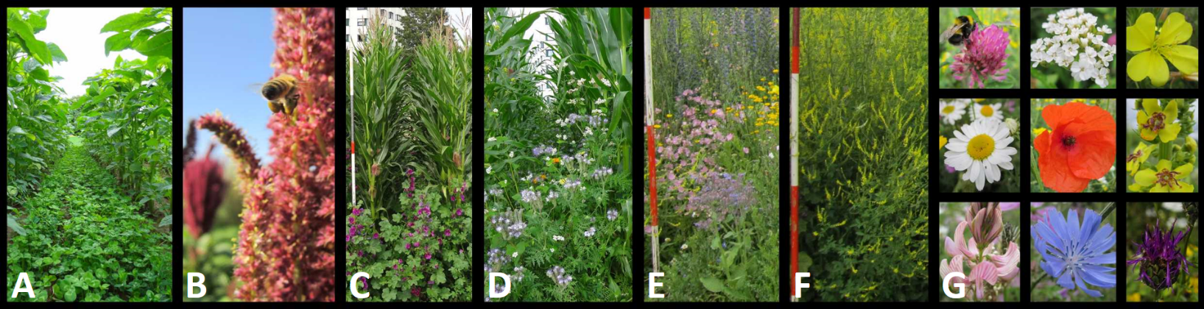
Image
Figure 1: Impressions of the treatments tested in field trials 2014-2017: Amaranth with undersown white clover (A); a bee approaching an amaranth flower (B); under-maize establishment of wild plant mixtures (WPM) S2 (C, Saaten-Zeller, Germany) and WPM S1(D, Rieger-Hofmann, Germany) in 2014; sole cultivation of WPM S1 (E) and S2 (F); and some of the numerous flowers observed during the WPM cultivation period 2014 until 2017 (G, from top left: Trifolium pratense L., Achillea millefolium L., Oenothera biennis L., Leucanthemum vulgare LAM., Papaver L., Verbascum thapsus L., Onobrychis MILL., Cichorium intybus L., Centaurea jacea L.).

Recent Publications
- Altieri MA, Nicholls CI, Montalba R (2017) Technological Approaches to Sustainable Agriculture at a Crossroads: An Agroecological Perspective. Sustainability 9, 349.
- Blumenstein B, Siegmeier T, Selsam F, Möller D (2018) A case of sustainable intensification: Stochastic farm budget optimization considering internal economic benefits of biogas production in organic agriculture. Agricultural Systems 159: 78-92.
- Folke C (2006) Resilience: The emergence of a perspective for social–ecological systems analyses. Global Environmental Change 16: 253-267.
- Hallmann CA, Sorg M, Jongejans E, Siepe H, Hofland N, Schwan H, Stenmans W, Müller A, Sumser H, Hörren T (2017) More than 75 percent decline over 27 years in total flying insect biomass in protected areas. PLoS ONE 12(10): e0185809.
- Lewandowski I, Lippe M, Castro-Montoya J, Dickhöfer U, Langenberger G, Pucher J, Schließmann U, Derwenskus F, Schmid-Staiger U, Lippert C (2018) Primary Production, in: Bioeconomy. Springer, Cham, pp. 95–175.
- Von Cossel M, Iqbal Y, Scordia D, Cosentino SL, Elbersen B, Staritsky I, Van Eupen M, Mantel S, Prysiazhniuk O, Maliarenko O, Lewandowski I (EU-deliverable, unpublished yet) Deliverable 4.1: Low-input agricultural practices for industrial crops on marginal land.
- Von Cossel M, Lewandowski I (2016) Perennial wild plant mixtures for biomass production: Impact of species composition dynamics on yield performance over a five-year cultivation period in southwest Germany. European Journal of Agronomy 79: 74–89.
- Von Cossel M, Möhring J, Kiesel A, Lewandowski I (2017) Methane yield performance of amaranth (Amaranthus hypochondriacus L.) and its suitability for legume intercropping in comparison to maize (Zea mays L.). Industrial Crops & Products 103: 107-121.

 Biography
Moritz von Cossel is a research associate (doctoral candidate) at the Department of Biobased Products and Energy Crops at Hohenheim University. Before studying, he trained to become a vegetable grower at Germany’s largest vegetable farm (Behr AG) where he gained first knowledge on basic agricultural practices and both chances and challenges of diverse cropping systems. After receiving his master degree in crop science from Kiel University, he moved to southern Germany and started his research on both temporal and spatial diversification measures in biogas cropping systems at Hohenheim University. Over the past four years, he has participated in the GOBI project (General Optimization of Biogas Processes) and revealed valuable insights to the cultivation of amaranth and perennial wild plant mixtures for biogas production. Currently, he is working on low-input agricultural practices for industrial crops cultivation on marginal lands across Europe (EU-28 and Ukraine) as part of the MAGIC project.
Email: moritz.cossel@uni-hohenheim.de

Notes/Comments:

