Development of a Novel Liquid-Inerted Microwave Pyrolysis System
Benjamin Shepherd, University of Nottingham
Dr. John P. Robinson, University of Nottingham
Department of Chemical and Environmental Engineering, United Kingdom

Abstract
Pyrolysis is the thermochemical decomposition of biomass under inert conditions, into gas, oil and char. Microwave-pyrolysis, which offers direct inherent heating advantages not provided by conventional heating, is an expanding area of research. However, concerns exist with current state-of-the-art of microwave-pyrolysis systems used by researchers, as they typically have low intensity microwave-fields, are arcing-prone and require a significant amount of inert gas. As such, currently there is limited energy mass-balance information available due to the nature of these microwave reactors, which is fundamentally needed to support the scalability potential of microwave-pyrolysis.
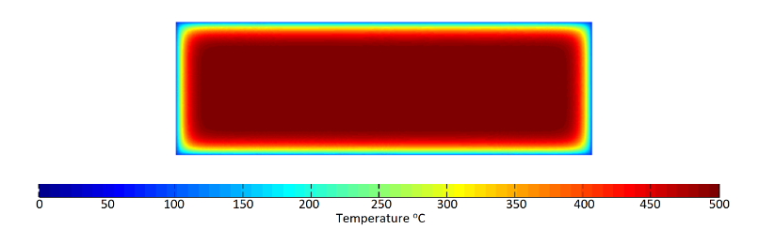
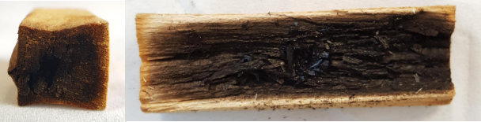
In an effort to overcome the aforementioned issues, a solvent inerted microwave-pyrolysis process has been developed and is presented here, offering benefits over gas microwave-pyrolysis. These include: prevention of thermal-runaway as the solvent maintains the biomass between 300-500°C due to increased thermal transfer, prevention of volatile secondary degradation reactions, provides heterogeneous heating-profiles enabling larger samples to be processed. An inerting gas is not needed as volatiles are quenched directly into the solvent, yielding bio-oil, reducing gas capture requirements and lowering process unit-costs.
Figure 2 – A) Example of a pyrolysed block of sycamore (45 x 15 x 15 mm) with a power density of 4.5×10⁷ W/m³ (455 W absorbed power) at 16 seconds. B) Temperature gradient simulation of the same pyrolysed block of sycamore with the same processing conditions.
A
B
This presentation will focus on the screening of nine solvents used to inert the pyrolysis of sycamore feedstock in a microwave-system, based on microwave transparency/absorbency, boiling points, cost, environmental safety. Preliminary findings suggested that energy requirements for pyrolysis are not significantly increased, selective depolymerisation of cellulose and hemicellulose is possible, pyrolysis liquid yields can be as high as 70% of the bulk mass loss from the sample, and results fall in line with mathematic models. This allows for potential of scale-up, and different pyrolysis liquid compositions to be compared to conventional and gas-inerted microwave-pyrolysis.
Future research and development, including: establishing how the solvent choice affects phase separation, identification of key components in the oil and further processing scale-up, mass and energy balances and mathematical models will also be discussed in this presentation.

Images
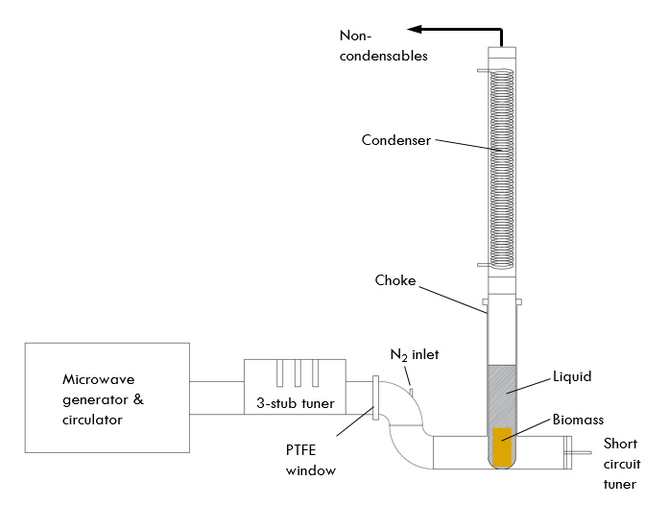
Figure 1 – Schematic representation of the liquid pyrolysis system used in these trials

Biography
Benjamin Shepherd is a 2nd year PhD researcher at the University of Nottingham working under the supervision of Dr John Robinson and Dr Liam Ball. After obtaining a MEng degree in Chemical Engineering in 2015 from the University of Nottingham, he decided to pursue research. His current research focuses on the development of a novel microwave pyrolysis system that employs superior temperature control using inert liquid instead of gas. He performs a combination of theoretical and empirical research in order to help underpin the process envelope for this new system.
Email: Benjamin.shepherd@nottingham.ac.uk

