Biomarkers in Covid-19 disease progression
Ramachandran Muthiah
Morning star hospital, Marthandam, Kanyakumari District, Tamil nadu state, India
The heterogeneous disease course of COVID-19 is unpredictable and up to 17% need intensive care support for acute respiratory distress syndrome (ARDS), hyperinflammation and multiorgan failure. An immune dysfunction with a hyperactivity of T lymphocytes and the release of pro-inflammatory cytokines including IL-2, IL-6, IL-7, MCP1, and TNF alpha, which contributes to increase in classical inflammatory biomarkers such as PCT and CRP. A cut-off of 3.27 pg/ml for IL-6 and a 37 mg/l for CRP indicate requirement of intubation. The binding of COVID-19 to the Toll Like Receptor (TLR) and production of active IL-1β which is a mediator of lung inflammation, fever and fibrosis. Initial trials of the IL-1β antagonist Anakinra appear to reduce the need for mechanical ventilation and mortality in severe cases. Elevated levels of biomarkers of cardiomyocytes injury such as Troponin I, CK-MB, CK, myoglobin and hematological changes such as lymphopenia, thrombocytopenia, anemia, increased neutrophil-to-lymphocyte ratio (> 8), platelet-to-lymphocyte ratio (> 192), and D-dimer level (> 0.9 mg\L) are predictors for severe COVID-19 infection. Treatment with low molecular weight heparin (LMWH) is associated with reduction in levels of D-dimer, fibrin degradation products and also in IL-6 levels suggesting a potential anti-inflammatory effect. Tocilizumab has been considered in extensive lung disease with elevated IL-6 level, COVID-19 severity is associated with lower serum concentrations of sodium, potassium and calcium. Ferritin is a key mediator of immune dysregulation and many individuals with diabetes exhibit elevated levels. Liver biomarkers (ASAT/ALAT, γ-GT, LDH) and. higher levels of urea nitrogen and creatinine occur in severe cases. Immunodominance shift could be detected by measuring five immune response markers: IgG1, IgM and IgA1 responses to S protein and antibody-dependent complement deposit, IgM and IgA2 response to N protein. Future studies should explore novel biomarkers, such as non-coding RNAs or proteomics, for disease progression and severity..
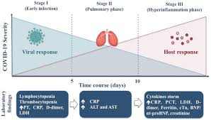

Publications
- Muthiah, R. (2017) “End-Stage” Constrictive Pericarditis—A Case Report. Case Reports in Clinical Medicine, 6, 255-273
- Muthiah, R. (2021) Isolated Acute Rheumatic Pancreatitis—A Case Report. Case Reports in Clinical Medicine, 10, 52-77
- Muthiah, R. (2019) Infective Endocarditis in Tetralogy of Fallot Complicating Brain Abscess—A Case Report. Case Reports in Clinical Medicine, 8, 105-126.
- Muthiah, R. (2018) Native Aortic Valve Endocarditis—A Case Report. Case Reports in Clinical Medicine, 7, 483-504.
- Muthiah, R. (2018) Tropical Coronary Artery Disease and Arrhythmogenic Potentials—The Changing Pattern towards Endomyocardial Fibrosis—An Analysis. Case Reports in Clinical Medicine, 7, 397-429.

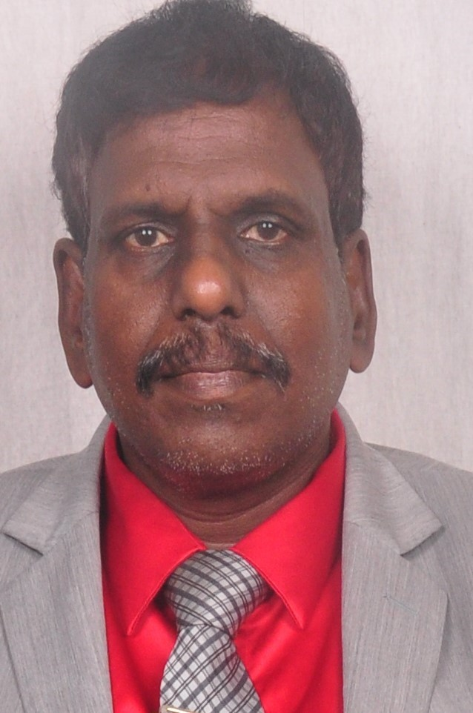

Biography
Ramachandran Muthiah, Consultant Physician & Cardiologist, Zion hospital, Azhagiamandapam and Morning star hospital, Marthandam, Kanyakumari District, India. Completed MBBS in 1989 under Madurai Kamaraj University, M.D. in General Medicine in 1996, D.M. in cardiology in 2003 under Tamil Nadu Dr.MGR Medical University, Chennai, India. Worked as medical officer in Rural health services for 5 years and in teaching category as Assistant Professor at Madras medical college, Coimbatore medical college, Thoothukudi medical college. Published many papers in Cardiosource, American College of Cardiology Foundation, Case Reports in Clinical Medicine (SCIRP) and Journal of Saudi Heart Association. Special research on Rheumatic fever and Endomyocardial fibrosis in tropical belts, Myxomas, Ineffective endocarditis, apical hypertrophic cardiomyopathy, Ebstein’s anomaly, Rheumatic Taussig-Bing Heart, Costello syndrome and Tetralogy of Fallot.

Presenting author details
Full name: Ramachandran Muthiah
Contact number: +91 7598755201
Landline +91 4651 203014, Palaninta vilai, keezhkulam- 629193, kanyakumari
District, Tamil nadu state, India
Whatsapp +91 6374494194
E-mail : cardioramachandran@yahoo.co.uk
Category: (Oral presentation/
Passport No:P8925619

