Title: Salivary biomarkers of oxidative stress and inflammation for screening of inflammatory gastrointestinal diseases
Katarína Janšáková, MSc PhD^{1,2}, Michael Escudier, MD. PhD ³, Ľubomíra Tóthová Dr. Rer. Nat., PhD^{1,2}, Gordon Proctor, Prof. PhD ⁴
¹ Institute of Molecular Biomedicine, Faculty of Medicine, Comenius University, Bratislava, Slovakia
² Institute of Physiology, Faculty of Medicine, Comenius University, Bratislava, Slovakia
³ Oral Medicine, Dental Institute, King's College London, United Kingdom
⁴ Mucosal and Salivary Division, Dental Institute, King’s College London, United Kingdom

Abstract (300 word limit)
Statement of the Problem: Crohn’s disease and orofacial granulomatosis are autoimmune lifelong gradually worsening diseases. Diagnostics is a long-lasting process requiring colonoscopy and related biopsy. New screening biomarkers might assist early diagnosis and facilitate monitoring of disease activity. The aim of this study was to analyse markers of oxidative stress and antioxidative status and inflammation in saliva of patients with Crohn’s disease (CD) orofacial granulomatosis (OFG) and concurrent orofacial granulomatosis and Crohn’s disease (OFG+CD) and compare them with healthy controls (CTRL).
Methodology: Ninety-three patients were divided into individual groups according to their clinical diagnosis and healthy controls. Unstimulated whole mouth saliva was collected and markers of oxidative stress and antioxidant status were measured. Markers of inflammation, immunoglobulin A, lactoferrin and myeloperoxidase, were assessed as well.
Findings: The concentration of total salivary proteins was higher in all patients in comparison with control group. There was observed higher level of immunoglobulin A in all experimental groups compare to the control group. Salivary lactoferrin was higher in the OFG+CD group compared to the CTRL and CD groups. Analysis of antioxidant status represented by ferric reducing antioxidant power showed lower concertation in all experimental groups. On the other hand, carbonyl stress was higher in saliva of CD and OFG+CD patients. Marker of protein oxidation was higher in CD and OFG group compare to control group.
Conclusion & Significance: The results indicate that the composition of saliva is altered in CD and OFG with increased oxidative stress. The increased concentrations of immunoglobulin A and lactoferrin may be of salivary gland origin since levels of inflammatory cell derived myeloperoxidase were not significantly increased. This study suggests that saliva could have a role in monitoring CD and OFG but there is a need for further longitudinal studies focused on analysing a panel of markers in saliva of these patients.

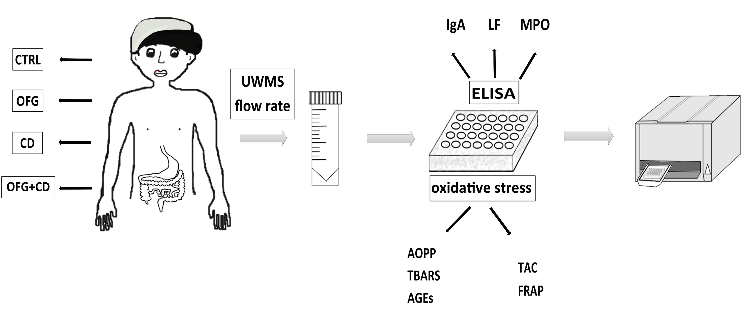
Recent Publications (minimum 5)
- Aguirre A, Nugent C A (2015) Images in Clinical Medicine: Oral Manifestation of Crohn's Disease, The New England journal of medicine 373: 1250.
- Campbell H, Escudier M, Patel P, Nunes C, Elliott T R, Barnard K, Shirlaw P, Poate T, Cook R, Milligan P, Brostoff J, Mentzer A, Lomer M C, Challacombe S J, Sanderson J D (2011) Distinguishing orofacial granulomatosis from crohn's disease: two separate disease entities?, Inflammatory bowel diseases 17: 2109-2115.
- Tothova L, Kamodyova N, Cervenka T, Celec P (2015) Salivary markers of oxidative stress in oral diseases, Frontiers in cellular and infection microbiology 5: 73.
- Tuzun A, Erdil A, Inal V, Aydin A, Bagci S, Yesilova Z, Sayal A, Karaeren N, Dagalp K (2002) Oxidative stress and antioxidant capacity in patients with inflammatory bowel disease, Clinical biochemistry 35: 569-572.
- Said H S, Suda W, Nakagome S, Chinen H, Oshima K, Kim S, Kimura R, Iraha A, Ishida H, Fujita J, Mano S, Morita H, Dohi T, Oota H, Hattori M (2014) Dysbiosis of salivary microbiota in inflammatory bowel disease and its association with oral immunological biomarkers, DNA research : an international journal for rapid publication of reports on genes and genomes 21: 15-25.

Biography (150 word limit)
Katarína Janšáková has her expertise in molecular biology. Her PhD study was focused on oxidative stress markers in relation to various inflammatory diseases and salivary markers. Currently, she works as a post doc at Institute of Physiology, Faculty of Medicine, Comenius University in Slovakia where she participates in many projects with the team of Academic Research Center for Autism. Her primary interest is in salivary research and problems that meet using a saliva in the clinical practice.
Email:katarina.jansakova@gmail.com
- Full Name: Katarína Janšáková
- Personal Email: jansakova.katarina@gmail.com
- Mobile Number: +421 0910 212 671
- Linked In: Katarína Janšáková
- Facebook: Katarina Jansakova
- Session Name/ number: Biomarkers and Diseases
- Category: Oral presentation
- Date of Birth: 26.03.1990
- Postal Address: Sasinkova 2, 813 72 Bratislava

Notes or Comments:

