Title: The effect of stimulation of salivation on the secretion of cortisol
Katarína Janšáková, MSc PhD¹, Klaudia Kyselicová, MSc PhD¹, Hana Celušáková, MSc¹, Jolana Laznibatová Dr. PhD², Gabriela Repiská, MSc PhD¹, prof. Daniela Ostatníková, MD PhD¹
¹Institute of Physiology, Faculty of medicine, Comenius University, Bratislava, Slovakia,
²Research Institute for Child Psychology and Pathopsychology, Bratislava, Slovakia

Abstract (300 word limit)
Statement of the Problem: Cortisol is generally used as a stress marker. Its assessment is possible in various biological materials including saliva. Many studies use stimulated saliva, however, it is not yet clearly known how stimulation affects the flow of specific markers. The purpose of this study was to assess if stimulation of salivation affects the physiological flow of cortisol during a stressing day compared to control day without stress strain. The next aim was to show how the normalising factor affects the outcome of the study.
Methodology: Stimulated saliva was taken from 42 healthy children twice a day in the morning at 8:30 and at 11:30 in two separate days a month apart. First day, children were exposed to stress situation represented by the scholar testing. The second day was considered a control day to the stress day. Saliva samples were used for assessment of cortisol and total protein concentration.
Findings: The highest level of cortisol was observed in saliva taken in the morning of stress day compare to all other collections (p < 0.001). There was no difference between morning and afternoon salivary cortisol collected on the control day (p = 0.93). The concentration of salivary proteins did not differ between stress and control day (p = 0.83). After correction of the results to the protein concentration, no significant differences were observed between morning and afternoon cortisol levels both in the testing (p = 0.87) and control days (p > 0.99).
Conclusion & Significance: Stimulation of salivation led to high interindividual variability in all saliva samples. Based on our results, examination of cortisol diurnal rhythm is not reliable using stimulated saliva. Further studies focusing on the effect of saliva stimulation on specific biomarkers concentrations should be conducted.
This study was supported by grant APVV 15-0045 and APVV 15-0085.
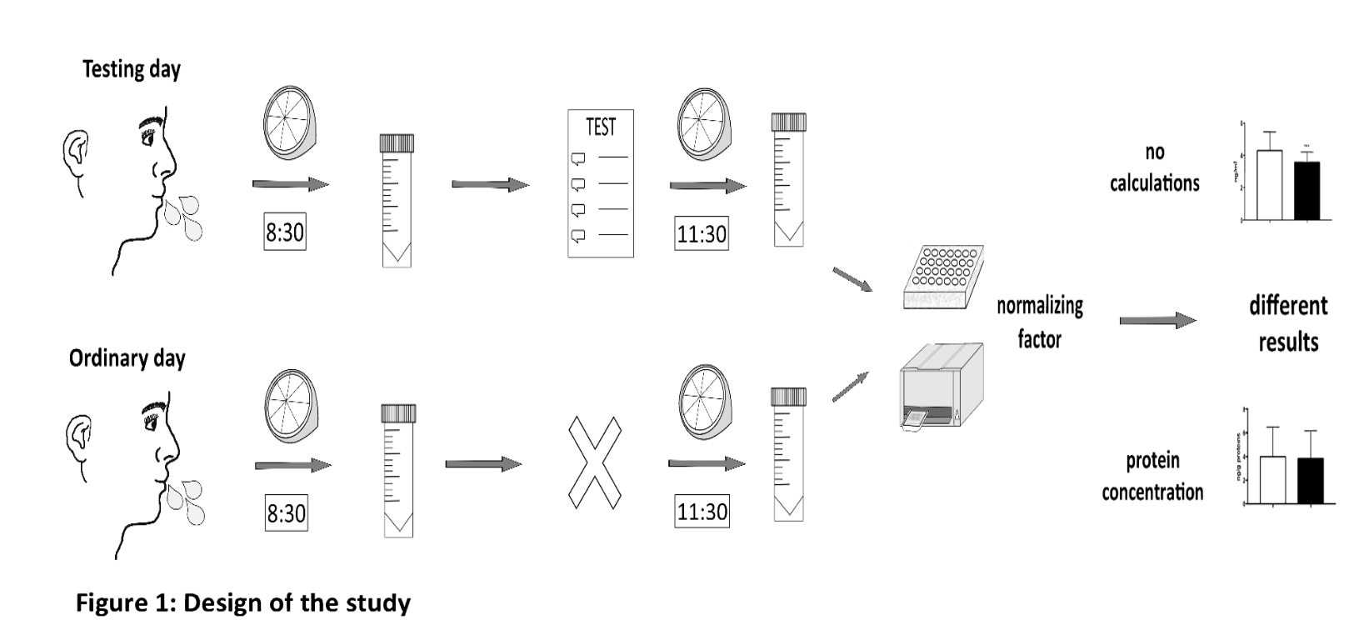
Recent Publications (minimum 5)
- Kobayashi H, Miyazaki Y (2015) Distribution characteristics of salivary cortisol measurements in a healthy young male population, Journal of physiological anthropology 34: 30.
- Banasova L, Kamodyova N, Jansakova K, Tothova L, Stanko P, Turna J, Celec P (2015) Salivary DNA and markers of oxidative stress in patients with chronic periodontitis, Clin Oral Investig 19: 201-207.
- Granger D A, Kivlighan K T, Fortunato C, Harmon A G, Hibel L C, Schwartz E B, Whembolua G L (2007) Integration of salivary biomarkers into developmental and behaviorally-oriented research: problems and solutions for collecting specimens, Physiol Behav 92: 583-590.
- Nagamine M, Noguchi H, Takahashi N, Kim Y, Matsuoka Y (2017) Effect of cortisol diurnal rhythm on emotional memory in healthy young adults, Scientific reports 7: 10158.
- Nunes L A, Mussavira S, Bindhu O S (2015) Clinical and diagnostic utility of saliva as a non-invasive diagnostic fluid: a systematic review, Biochemia medica 25: 177-192.

Biography (150 word limit)
Katarína Janšáková has her expertise in molecular biology. Her PhD study was focused on oxidative stress markers in relation to various inflammatory diseases and salivary markers. Currently, she works as a post doc at Institute of Physiology, Faculty of Medicine, Comenius University in Slovakia where she participates in many projects with the team of Academic Research Center for Autism. Her primary interest is in salivary research and problems that meet using a saliva in the clinical practice.
Email:katarina.jansakova@gmail.com
- Full Name: Katarína Janšáková
- Personal Email: jansakova.katarina@gmail.com
- Mobile Number: +421 0910 212 671
- Linked In: Katarína Janšáková
- Facebook: Katarina Jansakova
- Session Name/ number: Biomarkers Research
- Category: Poster presentation
- Date of Birth: 26.03.1990
- Postal Address: Sasinkova 2, 813 72 Bratislava

Notes or Comments:

