ABSTRACT
Enzymatic Degradation of Sugarcane Bagasse: Biotechnology route to renewable biofuels
Sadia Fida Ullah, Eliane Ferreira Noronha
Department of Molecular Biology, University of Brasilia
Brasilia, Brazil
Sadia.fida@ymail.com
Cellulosic ethanol has gain the attention as a potential option of renewable transportation fuel. One of the most favorable routes for the conversion of cellulosic materials into ethanol is the enzymatic hydrolysis followed by fermentation. Hydrolysis of lignocellulosic materials by cellulases and hemicellulases are the efficient method for the release of fermentable sugars. Xylanases (1,4-β-xylanohydrolase; EC3.2.1.8) are valuable enzymes that degrade xylan, the most abundant hemicellulose present in both hardwoods and Pulp. Most industrial enzymes are produced by bacteria, yeasts and fungi that are able to ferment specific substrates.
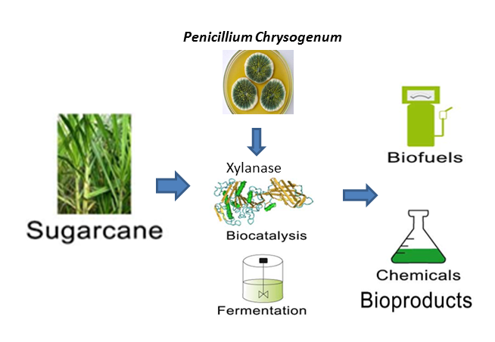
A number of fungi from the genus Penicillium are effective decomposers of lignocellulosic biomass and efficient producers of xylanases. The present study deals with the evaluation of xylanase production using different agro biomasses. Three extracellular xylanase was observed to be the major protein in the culture filtrate of Penicillium chrysogenum when grown in 1% agriculture biomass (sugarcane bagasse and straw and orange peel off). One xylanase of 38kDa completely and another (20kDa) was partially purified after three purification steps: Ultrafiltration, molecular exclusion and anion-exchange chromatography. The physical characteristics of purified enzyme represent its optimal pH.5.0 ad 40ºC temperature best suited conditions for the fermentation. The enzyme retained 85%activity in the presence of Tannic acid and Gallic acid two main aromatic phenolic compounds mainly produced in lignin degradation, making it desirable for application in second generation bioethanol industries. With its low temperature activity the enzyme can also be used in baking industry. The study assesses the route could enhance performance on inexpensive biomass like bagasse and reduce the cost of enzyme production using cellulolytic strains, Penicillium chrysogenum.
Keywords: Bioethanol, Penicillium Chrysogenum, Sugarcane bagasse, Xylanase

