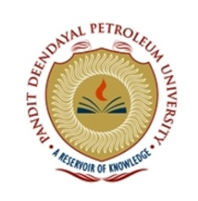


Title: Biogas based Adsorption Refrigeration System: A Parametric Study of Adsorption Based Heat Transfer
Name: Kinger Yash J.

Pandit Deendayal Petroleum University, Raisan, Gandhinagar, India

The high prices of fossil fuel and environmental concerns have again drawn attention to the need for reliable, pollution free and low energy cost refrigeration. Bioenergy driven adsorption refrigeration system seems to be a promising alternative to achieve, effectively both energy conservation and environmental protection.
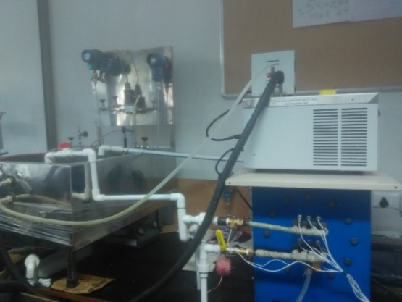
Cooling effect is produced by the evaporation of a refrigerant. Heat is used in different ways to operate a refrigerator system for evaporating the refrigerant in the cycle. Bio-chilling denotes that heat is produced through any conversion process of biomass such as biogas, producer gas, etc. to operate a refrigeration cycle. A test rig is designed and fabricated consisting of an adsorbent bed based on silica gel/ water as a working pair which uses electricity as a heating source. The experimental setup is used to understand the effect of various operating conditions on heat transfer performance.
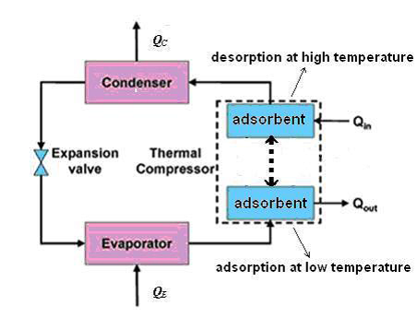
Fig.1 Adsorption Refrigeration Cycle Fig.2 Pictorial Representation of Test Rig
The efficiency of the system is defined by COP (Coefficient of Performance) and SCP (Specific Cooling Power) which came out to be 0.419 and 166.67 W/kg adsorbent respectively. The study aims to improve the heat transfer performance of the adsorbent bed which enhances the efficiency of the system. Hence, plots of COP and Capacity with respect to cycle time, temperature, etc. will be useful to determine optimum parameters. Exhaustive experimental data collection is under progress and the same will be shared with final conclusion.

Biography

Mr. Kinger Yash J. is pursuing Bachelor of Technology in chemical engineering from Pandit Deendayal Petroleum University, Gandhinagar, India. He has worked in the field of biodiesel and presented poster on the same at CHEMCON-2015. He has also worked on simulation of a plant for production of pipeline gas from shale gas using Aspen Plus. He is currently working on adsorption refrigeration.

Presenting author details
Full name: Kinger Yash Jayesh
Contact number: (+91) 8128993882
Twitter account: @KingerYash
Session name/ number: 28th April, 2017; Poster Presentation
Category: Poster presentation

