ASSESSMENT OF ENVIRONMENTAL EFFECT OF DOMESTIC WASTE-WATER IN MINNA, NIGER STATE, NIGERIA

By
Kudu Dangana¹ and Idris Aliyu Auna²

Department of Geography,
- Faculty of Natural Sciences , Ibrahim Badamasi Babangida University, Lapai ,
Niger State, Nigeria.
- Niger State Ministry of Land and Survey, Minna, Niger State, Nigeria.

This study assessed the environmental effect of the current practise of domestic waste-water disposal in Minna, Niger State, it identifies the current practice of domestic waste-water disposal; it examines the environment effect of the current practice of domestic waste-water disposal and determine the effect of domestic wastewater practice on surrounding ground water quality. Explanatory research design was adopted, Structural questionnaire was used and water samples were analysed in the laboratory where results are presented in tables, chart and diagrams. The findings established that waste water itself is not a problem, it is the way this waste water is being managed that is the major problem and attributed the problem to lack of good sewage construction and negligence of the residents of the study areas to generation, collection, storage and disposal of the waste water. It also shows that mean pH of the available water was found to be 7.68, with a maximum value of 8, minimum of 7.30 and a standard deviation 0.12. EC and TDS which signifies that groundwater sources within the sample area is not safe. The study concludes that the problems of domestic waste water, collection, disposal and management have underscored the need for re-evaluation the basis for delivering modern services efficiently in urban centres. Thereby recommends that domestic wastewater re-use be adopted as a disaster risk reduction strategy for urbanized areas like Minna in developing countries.
Key words: waste water, disposal,
Introduction
Urban areas are facing daunting environmental challenges which have increased in scope over recent years. At the same time, cities provide exciting opportunities for growth and revitalization (Gale et al.,, 2012). The interplay of these challenges and opportunities create important tasks for policymakers and researchers. Urban centres throughout the world exhibit an incredible diversity of characteristics, economic structure, levels of infrastructure, historical origins, patterns of growth and degree of formal planning, also many of the problems they face are strikingly familiar. But in developing countries, particularly Africa, urban residents suffer to a great extent from severe environmental and health challenges associated with weak urban planning and waste management facilities. The situation is even worse in countries of Africa, especially in Nigeria (Izueke and Eme, 2013).

Statement of Research Problem
Poor urban planning in the face of rapid urbanization and improper wastewater management is regarded as one of the major problems many urban areas in Nigeria are facing(Nabegu, 2014, Mustapha, 2013, Idris-Nda et al.,, 2013,Musa, 2012) with special reference to Minna area in Niger State. Human beings generate waste while carrying out their daily activities so as to maintain means of livelihood also to enhance and make life comfortable. Wastewater generated has serious adverse effect on man himself and subsequently the environment (Izueke et al.,,2013)..
Observation in the study area shows that, the current practices of residents in domestic wastewater are based on their individual knowledge and capacity which have impact on health and environment of the residents.
Studies carried out in this area such as that of (Nabegu, 2014, Mustapha, 2013, Idris-Nda et al.,, 2013,Musa, 2012) could not address this problem. That situation left a gap that seems to be generating a vicious circle on poverty-environment-health-poverty as improper waste water management have been undergoing for years and worsened by irreconcilable natural environment that makes poor people powerless to bring the environment works for them. In addition, the condition is augmented with the absence of proper development control, guidance and enforcement from the authority. If no intervention is made to cut the circle, the local people will suffer from prolonged poverty and health problems. As a preliminary step towards comprehensive solution, a research will be necessary. So far, no single research has been done in the area on this theme.
1.3 Research Questions
  - What is the practice of domestic waste-water disposal in Minna, Niger State?
  - Does the practice of domestic waste-water disposal have effect on the environment?
  - What is the health effect of wastewater practice on ground water quality of the study area?
Aim and objectives of the study
The aim of the study is to assess the environmental effect of the current practise of domestic waste-water disposal in Minna, Niger State, Nigeria. The following objectives will be achieved:
  - To identify the current practice of domestic waste-water disposal in Minna, Niger State
  - To examine the environment effect of the current practice of domestic waste-water disposal in Minna.
  - To determine the effect of domestic wastewater practice on surrounding ground water quality.

- Study Area
- Minna is the capital of Niger State. The study area lies between Latitude 9° 33¹ and 9° 40¹ North, and Longitude 6° 29¹ and 6° 35¹ East. At the North –east corridor of the town lies continuous steep outcrop of granite, which form a limitation towards physical development in that axis. In the present political zoning system, the town is within the North Central Zone, and occupies an area of about 884 hectares. It is about 145 kilometers by road from Abuja, the Federal Capital of Nigeria. Since 1999, the city has experienced change in both pace of growth and types of space occupied for development. It has a total area of 74,344 km2 wide, (Sanusi 2011).Minna has estimated projected population of 400,639 (NPC, 2016) as one of the 25 Local Government Areas in Niger State, se

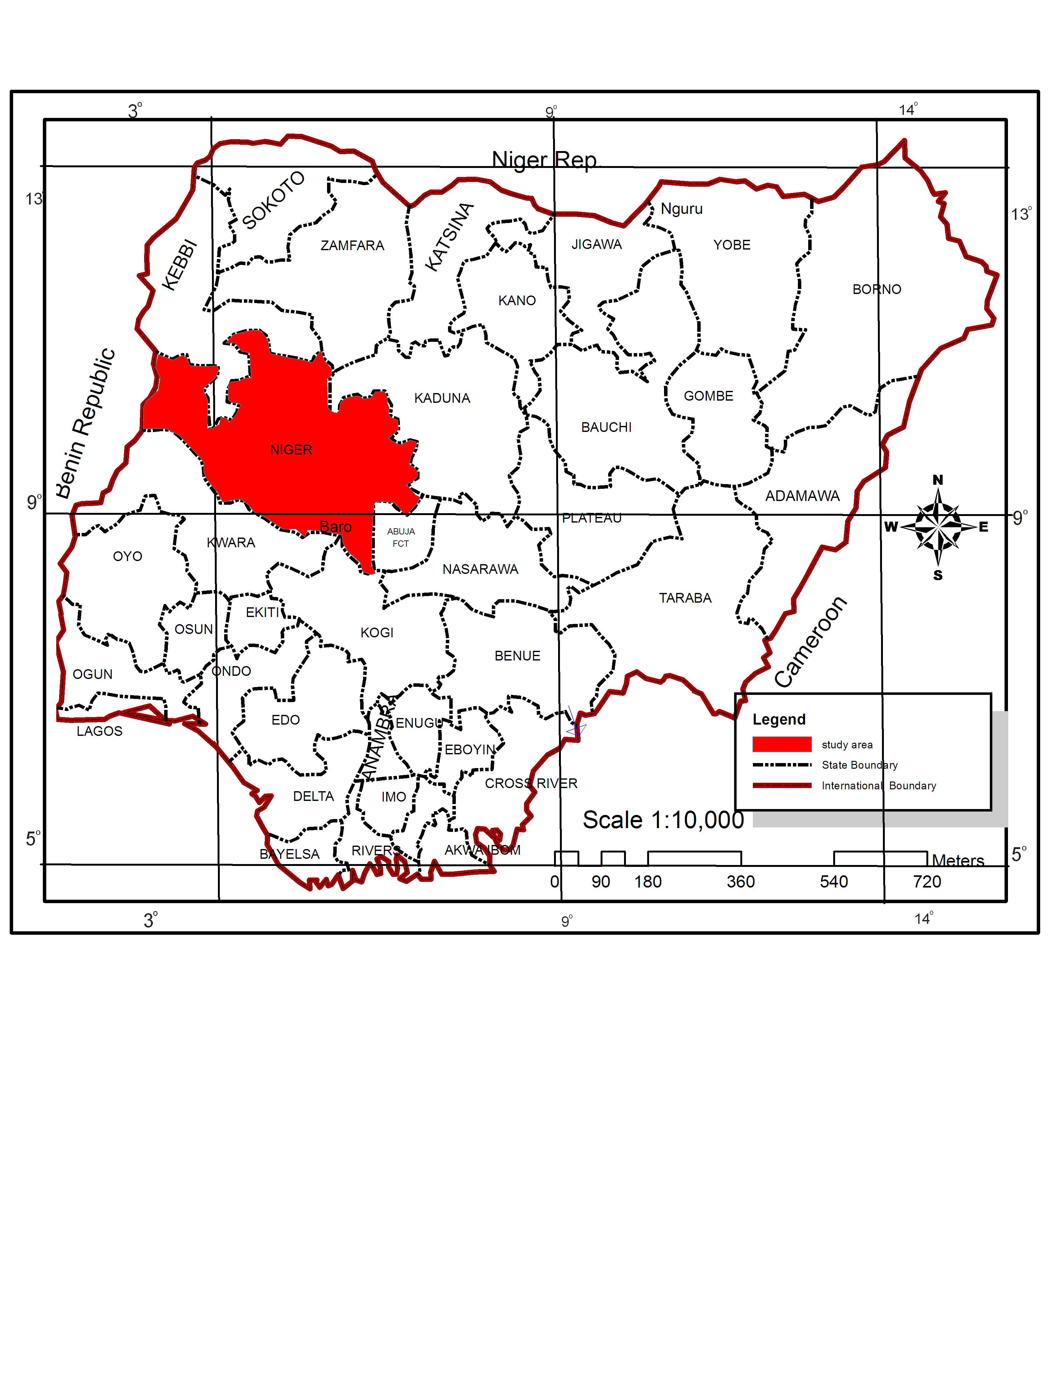
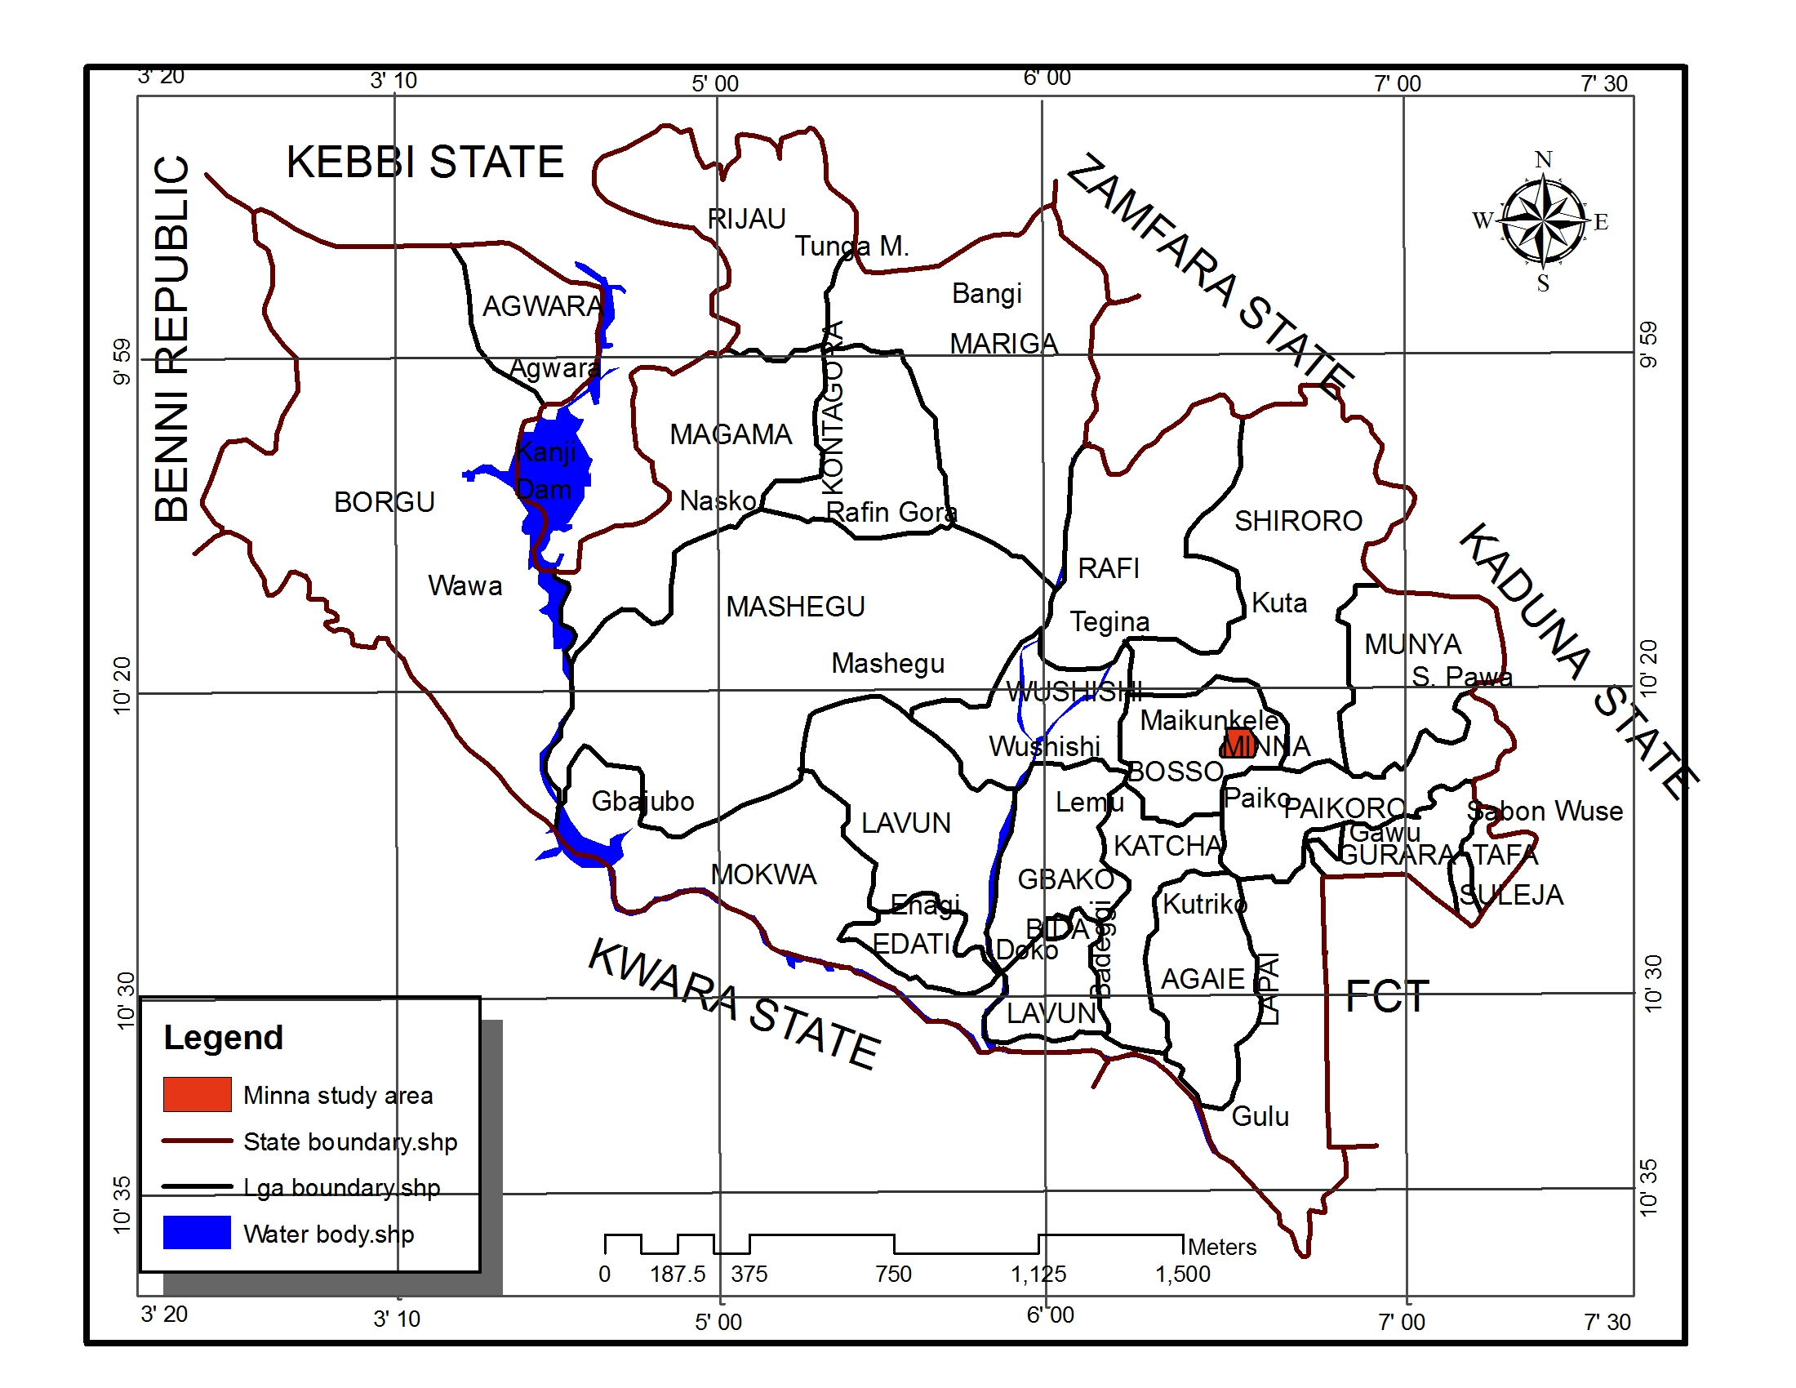

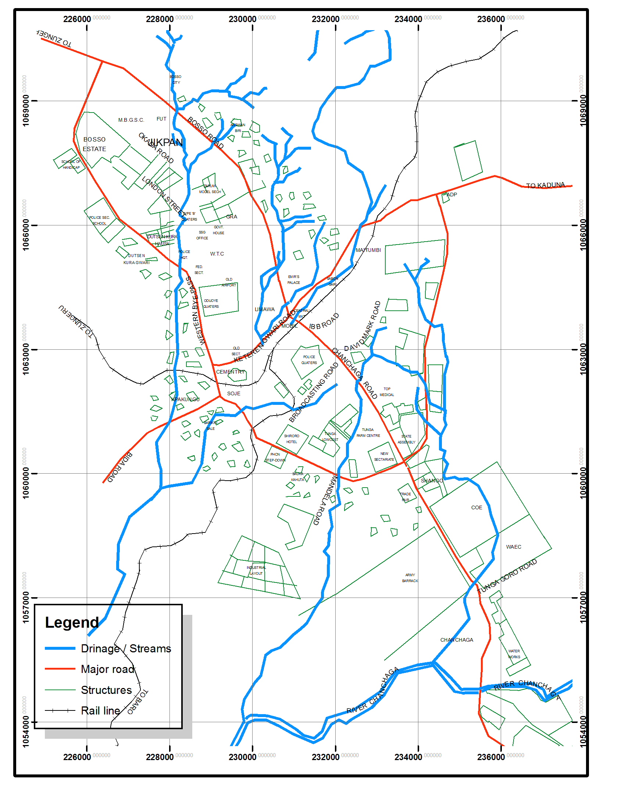

Figure 1.1: Minna in Niger State,
Source: Niger State Ministry of Land and Housing, (2018

Conceptual framework
Pla
RESEARCH METHODOLOGY

3.1 Introduction
This study was carried out in Minna, Niger State, Nigeria. It assesses the environmental effect of the current practise of domestic waste-water disposal in Minna. For the purpose of this study, two sets of data were gathered; that is qualitative and quantitative data type which is also called mixed method or the multi method because according to Creswell. (2012), research problems can better be understood through the use of both methods in a complementary approach.
Data Required
The required data are base map of Minna showing neighbourhood, field data such as types of domestic water generated, disposal method of domestic waste water, available waste water management facility, and causes of poor domestic waste management, frequency of sanitations and source of domestic waster. Also, geographical coordinates of available domestic water source samples with the areas and water sample within the locations.

Water Sampled bottle

The procedure for preparation of the dilution of underground water, water quality sampled are as follow; seven (6) plastic bottle of water was used for near and far well water close to the waste water source or storage, each at interval of 25meters, 45meters, 55meters and 100meters from four cardinal corners of the study area.
To examine the effect of domestic wastewater practice on surrounding ground water quality. | Water sample and Geographical coordinates | Qualitative quantitative | Laboratory analysis of Water quality test, and geospatial locations of groundwater source

Water quality parameters was tested in Federal Regional Water Quality Control Agency, Minna, Niger State following the practical guide to the design and implementation of fresh water quality studies and monitoring programmes edited by Jamie Bartram and Richard Balance, published on behalf of United Nations Environment Programme and World Health Organization (UNEP/WHO) 2006. This study adopts thematic analysis method to condense the raw data obtained from the field into categories based on the conclusion and interpretation validity (Elo et al.,, 2014). Content analysis was conducted based on the respondent’s perception. The interview results were analysed using SPSS.The mean, standard Deviation, t- test and ANOVA statistics was used to test for the significance of the difference in the stated null-hypothesis. T-test statistic was used for the analysis. The acceptance or rejection of the null-hypotheses was determined at the probability level of 0 .05.
DATA ANALYSIS AND DISCUSSION OF RESULTS
  - Effect of domestic wastewater practice on surrounding ground water quality.
The mean pH of the available water was found to be 7.68, with a maximum value of 8, minimum of 7.30 and a standard deviation 0.12 (Table 4.8). EC and TDS showed a similar trend across the three sample location, increasing from concentrations of 1000 to 1049 and 500 mg/L in Tunga and Saukakahuta, respectively and then decreasing steadily in Barikin Sale. The mean EC was 816.20μS/cm with a standard Error of 134.71μS/cm while a mean of 409.80mg/L was recorded for TDS with a Standard Error of 134.71mg/L (Table 4.8).

Dissolved Oxygen decreased from station 1 (0.85mg/L) Saukakahuta (0.25mg/L) and then increased steadily in Barikin sale (0.3mg/L). Biochemical Oxygen Demand declined from Tunga (0.4mg/L), Saukakahuta (0.25mg/L), and then a slight increase in Barikin sale (0.1mg/L). Table 4.8 shows mean and standard errors for DO and BOD of 0.53,013 and 0.17, 0.07 respectively. NO3-N increased from Tunga to Saukakahuta, decreased in Barikin sale in a zigzag manner giving a similar trend with PO4-P concentration in the three sample locations. The maximum NO3-N concentration observed was 3.80mg/L and a lowest of 0.90mg/L. PO4-P mean concentration observed in the water was 0.44mg/L with a standard error of 0.17.Surface Water Temperature had the highest value of 31°C and lowest of 27°C, Cu and Cr had concentrations below detectable limits (Table 4.8). Zn, Ni and Cd showed a similar concentration gradient from Tunga, Saukakahuta and Barikin sale while Fe showed an opposite trend with the othermetals, decreasing in concentration were the others increase and increasing where they decrease. Among the four (4) metals, only Zn concentration was within the acceptable limits (Table 4.8).

Table 4.8. Summary Statistic of water quality characteristics of the sample locations and standard values for water quality.
Parameter | Mean | Standard  Error | Minimum | Maximum | Standard | Recommending  Agency
pH | 7.68 | 0.12 | 7.30 | 8.00 | < 8 | WHO
EC (µS/cm) | 816.20 | 134.71 | 298.00 | 1049.00 | 1000.00 | WHO
TDS (mg/L) | 409.80 | 67.55 | 149.00 | 525.00 | 500.00 | WHO
DO (mg/L) | 0.53 | 0.13 | 0.25 | 0.85 | 5.00 | WHO
BOD (mg/L) | 0.17 | 0.07 | 0.05 | 0.40 | 5.00 | WHO
NO₃-N (mg/L) | 2.58 | 0.55 | 0.90 | 3.80 | 10.00 | WHO
PO₄-P (mg/L) | 0.44 | 0.17 | 0.02 | 1.00 | 5.00 | WHO
Temp. (ºC) | 29.20 | 0.66 | 27.00 | 31.00 | NA | NA
Fe (mg/L) | 0.47 | 0.12 | 0.29 | 0.89 | 0.30 | SON
Cu (mg/L) | BDL | BDL | BDL | BDL | 1.00 | SON
Cr (mg/L) | BDL | BDL | BDL | BDL | 0.05 | SON
Zn (mg/L) | 0.39 | 0.05 | 0.25 | 0.56 | 3.00 | SON
Ni (mg/L) | 0.40 | 0.04 | 0.33 | 0.50 | 0.02 | SON
Cd (mg/L) | 0.09 | 0.02 | 0.06 | 0.16 | 0.003 | SON
EC= Electrical Conductivity, TDS= Total Dissolved Solids, DO= Dissolved Oxygen, BOD= NO3-N= Nitrate-
Nitrogen, PO4-P= Phosphate-Phosphorus, Temp.= Temperature, BDL= Below Detectable Limit, SON= Standard Organisation of Nigeria, NA= not available

The Water quality index and Metal Index showed a similar pattern of distribution in Tunga, Saukakahuta and Barikin Sale, increasing from 52.45 and 38.1 to 58.95, the lowest water quality index (WQI) of 45.03 was observed while in contrast Barikin sale recorded the highest MI value of 79.38 (Table 4.9).

Table 4.9 Water Quality and Metal indices of the three sampling locations

Station | Water Quality Index | Metal Index
TUNGA | 52.45 | 38.5
SAUKA KAHUTA | 58.95 | 56.11
BARIKIN SALE | 55.25 | 49.51

Significant positive correlation was observed between Fe concentration and pH (r=0.76(P<0.01); Electrical Conductivity and BOD (r=0.46)(P<0.05), NO3-N (r=0.83)(P<0.01), Surface Water Temperature (0.68)(P<0.05) and Zn (0.57)(P<0.05); TDS with BOD (r=0.45)(P<0.05) and N03-N (r=0.83)(p<0.01), Surface Water Temperature (0.69)(P<0.01) and Zn (r=0.58)(P<0.01); DO with BOD (r=0.40)(p<0.05); N03-N with P04-P (r=0.56), Temperature (r=0.69)(P<0.01) and Zn (r=0.82)(P<0.01); PO4-P with Zn (r=0.62)(P<0.01) and Ni (r=0.50)(P<0.05); Temperature with Zn (r=0.86)(P<0.01); and Ni with Cd (r=0.74)(p<0.01)(Table 4.9).
Significant negative correlation was observed between EC and DO (r=-0.53)(P<0.05), Ni(r=-0.43)(P<0.05) and Cd (r=0.89)(P<0.01); TDS with DO (r=-0.53)(P<0.05), NI (r=0.44)(P<0.05)and Cd (r=-0.89)(0.01); DO with NO3-N (r=-0.50)(P<0.05), PO4-P (r=-73)(0.01), Surface WaterTemperature (r=-0.64)(P<0.01) and Zn (r=-0.73)(P<0.01); NO3-N with Cd (r=-0.80)(P<0.01);PO4-P and Fe (r=-0.52)(P<0.05); Surface Water Temperature with Ni (r=-0.74)(P<0.01) and Cd(r=-0.83)(P<0.01); Fe with Ni (r=-0.60)(P<0.01); and Zn with Cd (r=-0.64)(P<0.01)(Table 4.9).

Table 4.9 Pearson Correlation Coefficient of physicochemical characteristics of sample water.

 | pH | EC | TDS | DO | BOD | N0₃-N | PO₄-P | Temp. | Fe |  | Zn | NI | Cd
pH | 1.00
EC | 0.37 | 1.00
TDS | 0.36 | 1.00 | 1.00
DO | -0.23 | -0.53* | -0.53* | 1.00
BOD | 0.34 | 0.46* | 0.45* | 0.40* | 1.00
N0₃-N | -0.19 | 0.83** | 0.83** | -0.50* | 0.26 | 1.00
PO₄-P | -0.15 | 0.30 | 0.30 | -0.73** | -0.20 | 0.56* | 1.00
Temp. | -0.05 | 0.68* | 0.69** | -0.64** | -0.24 | 0.69** | 0.21 | 1.00
Fe | 0.76** | 0.21 | 0.21 | -0.15 | -0.05 | -0.31 | -0.52* | 0.27 | 1.00
Zn | -0.35 | 0.57* | 0.58* | -0.73** | -0.33 | 0.82** | 0.62** | 0.86** | -0.21 |  | 1.00
NI | -0.10 | -0.43* | -0.44* | 0.06 | 0.03 | -0.25 | 0.50* | -0.74** -0.60** |  |  | -0.33 | 1.00
Cd | -0.11 | -0.89** -0.90** |  | 0.34 | -0.33 | -0.80** | -0.03 | -0.83** -0.23 |  | -0.64** 0.74** |  |  | 1.00
EC= Electrical Conductivity, TDS= Total Dissolved Solids, Temp.= Surface Water Temperature, DO= Dissolved Oxygen, BOD = Biochemical
Oxygen Demand, PO₄-P= Phosphate-Phosphorus, N0₃-N = Nitrate-Nitrogen, *Significant P<0.05, **Significant P<0.01

SUMMARY, CONCLUSION AND RECOMMENDATIONS
Summary
This study assesses the environmental effect of the current practise of domestic waste-water disposal in Minna, Niger State. The findings of the study show the current practices of domestic waste-water disposal in the area, it was reveal that waste water itself is not a problem, it is the way this waste water is being managed that is the major problem in the area, it identifies different forms of domestic wastes water used and water from bathroom is the major waste generated in the area. Finding from the study show that waste water management in the area is a very serious problem and attributed the problem to lack of good sewage construction and negligence of the residents.
The findings reveal the effect of domestic wastewater practice on surrounding ground water quality in the study area, it shows that mean pH of the available water was found to be 7.68, with a maximum value of 8, minimum of 7.30 and a standard deviation 0.12. EC and TDS showed a similar trend across the three sample location, increasing from concentrations of 1000 to 1049 and 500 mg/L in Tunga andSaukakahuta, respectively and then decreasing steadily in Barikin Sale. The mean EC was 816.20μS/cm with a standard Error of 134.71μS/cm while a mean of 409.80mg/L was recorded for TDS with a Standard Error of 134.71mg/L. The Water quality index and Metal Index showed a similar pattern of distribution in Tunga, Saukakahuta and Barikin Sale, increasing from 52.45 and 38.1 to 58.95, the lowest water quality index (WQI) of 45.03 was observed while in contrast Barikin sale recorded the highest MI value of 79.38. The result of the findings signifies that groundwater sources within the sample area is not safe. Conclusion
The myriad of environmental problems now confronting is the inevitable price they must pay in the quest for rapid technological advancement. This has affected the quality and quantity of environment given us great concern. The problems of domestic waste water, collection, disposal and management have underscored the need for re – evaluation on the basis for delivering modern services efficiently in urban centers. It is the believe of all that everybody has an importance part to undertake in this re – evaluation. To avert this disaster is to avoid disaster, therefore careful planning and management of the expending life support system in most of the urban center are crucial if the environmental crisis is to be ameliorated.
5.3 Recommendations
The following measures have been suggested as a panacea to the problem of domestic waste water menaces that parade most Nigeria cities.
- Domestic wastewater re-use be adopted as a disaster risk reduction strategy for urbanized areas in developing countries like Minna.
- A massive education program highlighting the important of having good sewage system to enhance proper management of domestic waste-water.
- Authorities in the state should be properly reorganized, part of their responsibilities should include the management sewage system for different categories of waste such as biodegradable and non-biodegradable.
- Public enlightenment should be carried out to sensitize the public on the risk of poor sewage management in the area.

References
Benard O, Omondi G (2012) Wastewater production, treatment and use in Kenya. In:
Third regional workshop’safe use of wastewater in agriculture,
Johannesburg.
Creswell, J. W.(2012). Educational Research: Planning. Conducting, And Evaluating
Quantitative And Qualitative Research. Fourth Edition. SAGE in
Publications.
Idris-Nda, a., Aliyu, H.K. and Dalil, M., 2013. The challenges of domestic wastewater
management in Nigeria: A case study of Minna, central Nigeria.
International Society for Development and Sustainability , 2(2), pp.1169–
1182. Available at: http://isdsnet.com/ijds-v2n2-53.pdf.
Izueke, E.M. and Eme, O.I., 2013. Urban Planning Problems in Nigeria : a Case of
Onitsha Metopolis of Anambra State. Singaporean Journal of Business
Economics, and Management Studies, 1(1), pp.41–59.
Musa, J.J., (2012). Environmental Appraisal of Drainage System in Minna, Niger
State-Nigeria Musa,. International Journal of Applied Biological Research
2012, 4, pp.85–93.
Mustapha, H. B. (2013). Management of Industrial Effluents: A Review of the
Experiences in Kano, Northern Nigeria, International Journal of
Advanced Research 1 (4), 213-216.
Nabegu, A. Baba, 2014. Domestic Wastewater Management In Peri-Urban Settlements
Of Kano Metropolis , Nigeria. , (June 2014).

