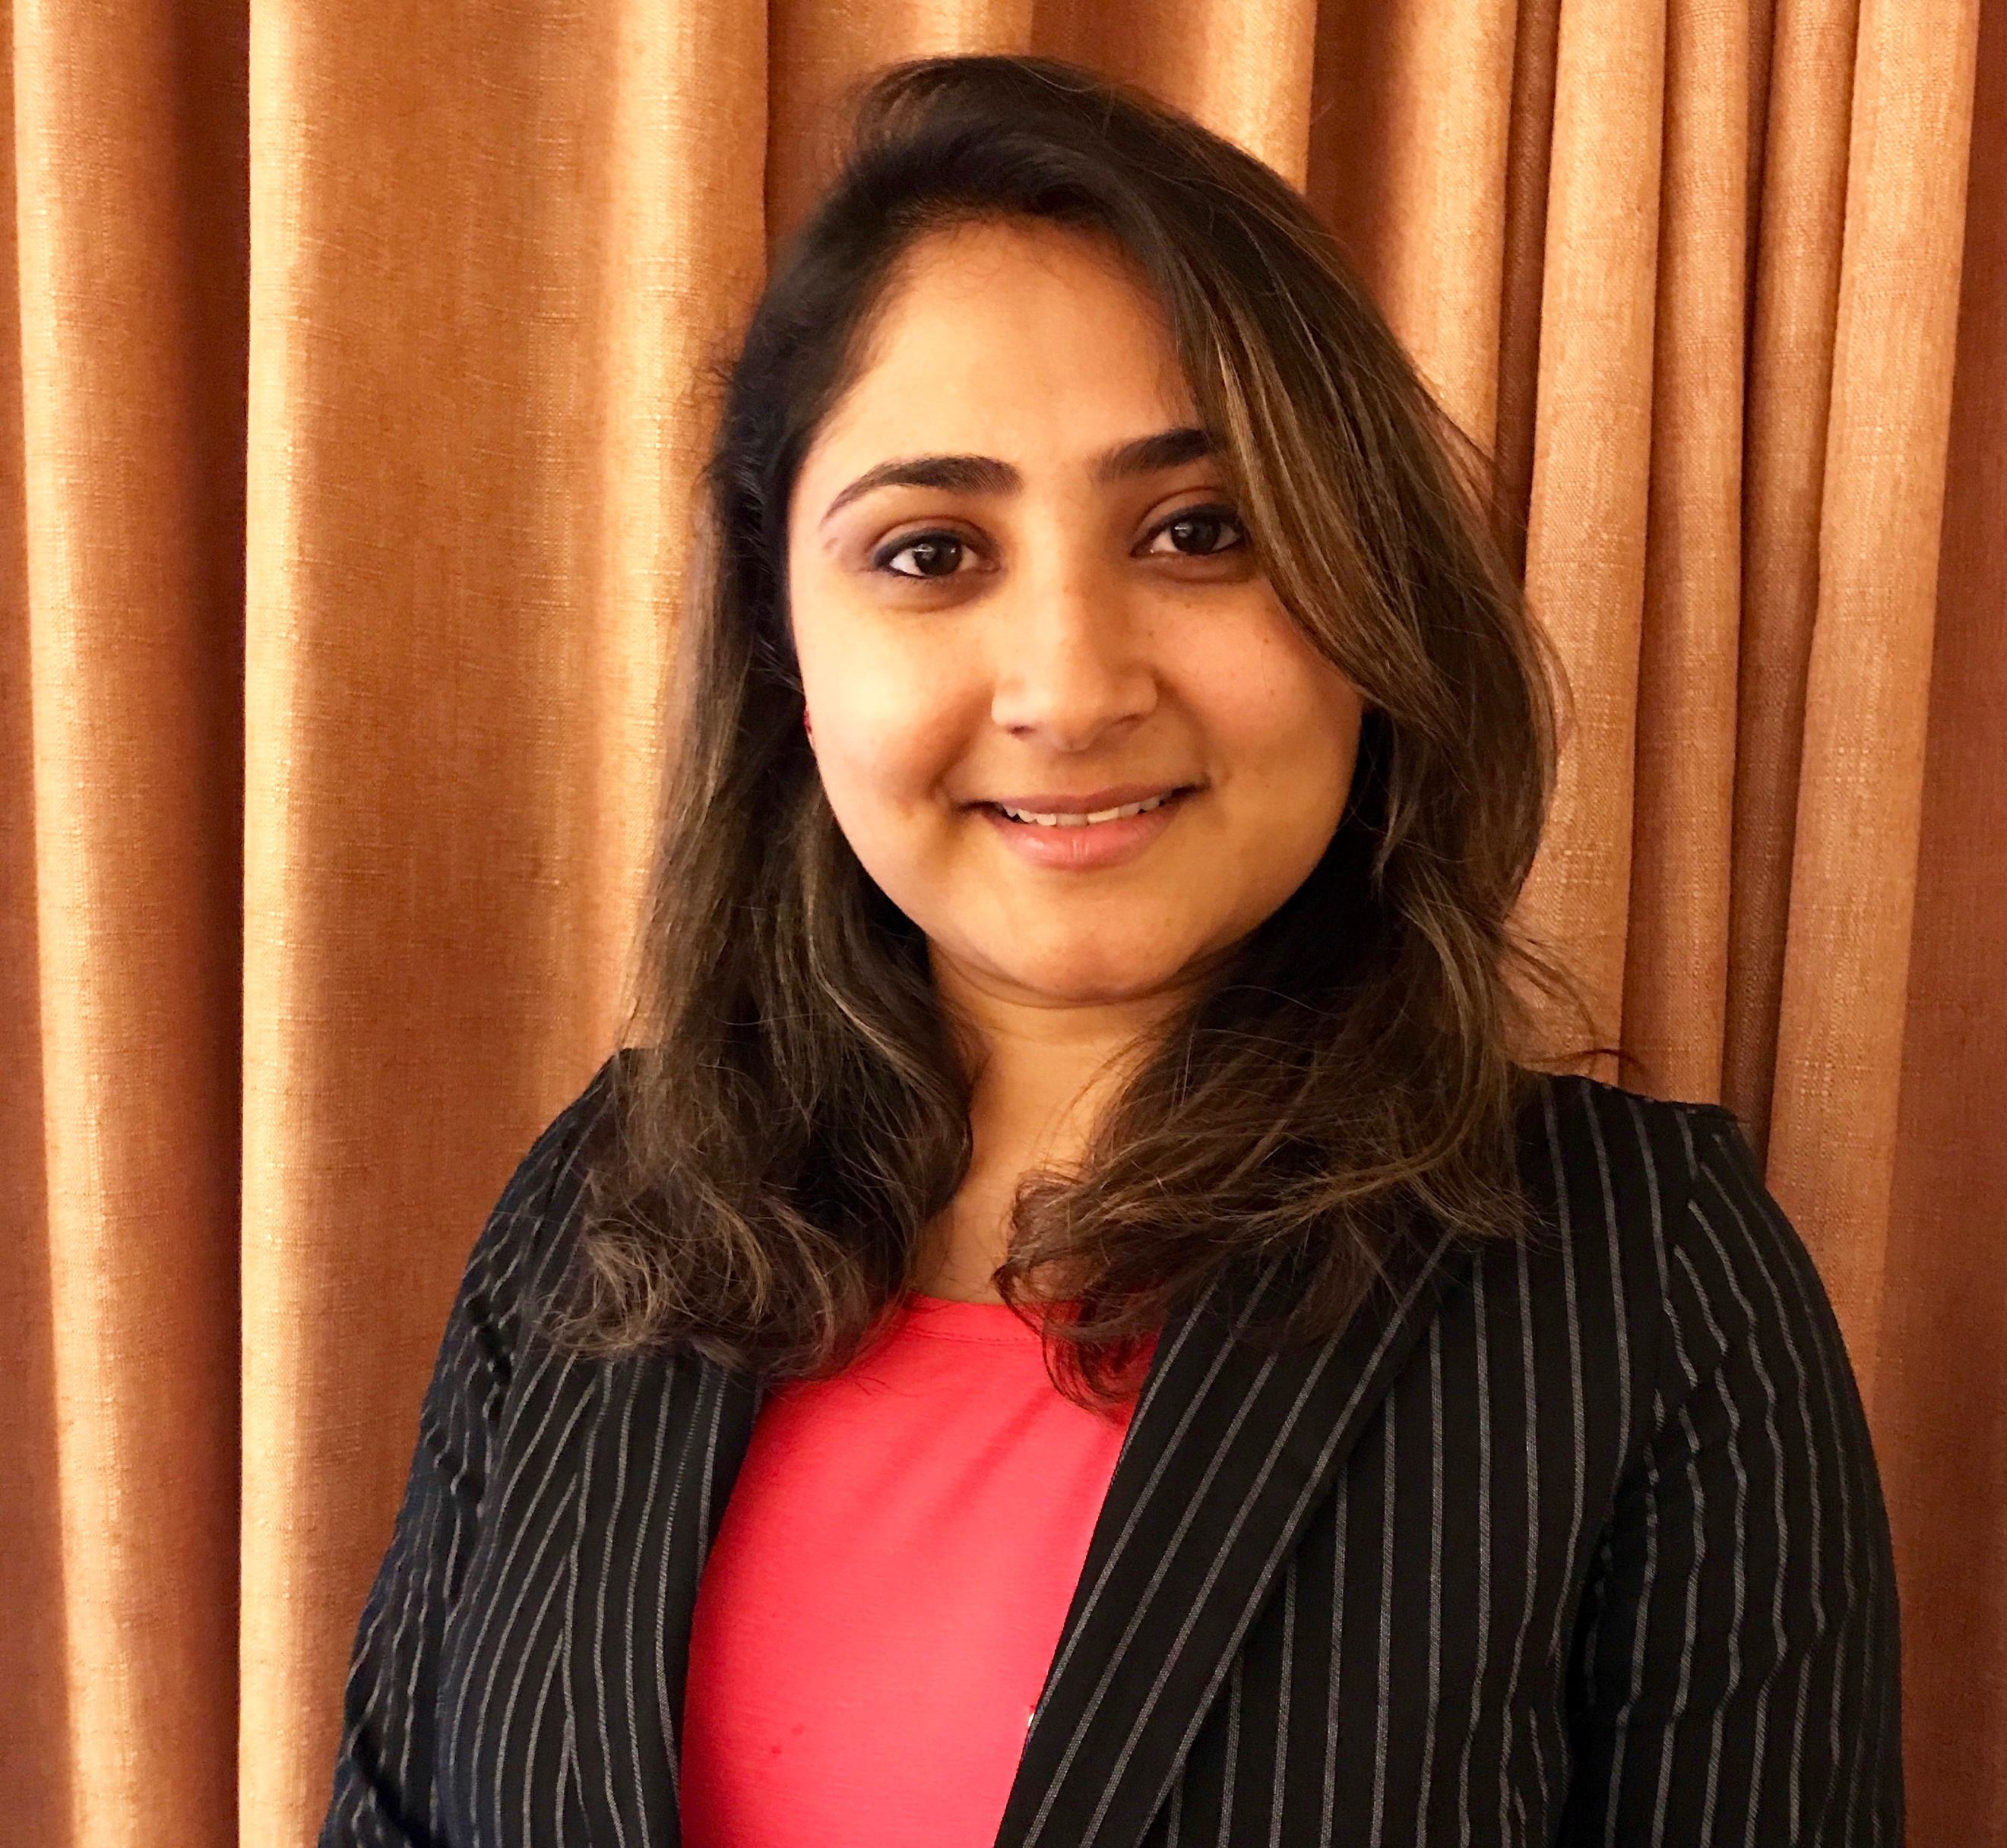
Title: Conversion of Methane to Bio-Products by an Engineered Microbial Platform

Name: Deepika Awasthi and Steven Singer
Joint BioEnergy Institute, Lawrence Berkeley National Laboratory, CA-94608, USA

Methane is an abundantly present, highly potent greenhouse gas that can be obtained from both renewable and non-renewable sources. The United States is the highest global natural gas producer, with a production capacity of 750 billion cubic meters annually. Methane is the major ingredient of natural gas. At the same time, about 300 billion cubic meters of annual methane production occurs biologically from landfills and waste in the United States. Methane is biologically assimilated by organisms categorized as methanotrophs. In the search of alternative carbon source that is not competent to food derived carbon, for manufacturing chemicals to replace petroleum-based products, methane and methanotrophs provide hope. With emerging metabolic engineering practices, recent focus has included engineering and establishing methanotrophs as hosts for bio-based chemical production. Biologically synthesized chemicals are sustainable and are often bio-degradable. Thus, a class of petroleum derived, non-biodegradable chemicals, called surfactants is looked at for their biological synthesis. Surfactants are agents that reduce the surface tension of a solvent and increase its solubility, hence, surfactants play a crucial and commercially important role in many industries including, pharmaceuticals, agriculture, food and cosmetics. Rhamnolipids (RLs), are a class of microbial glycolipid- surface active agents that have been classified as the next generation surfactants. RL production requires expensive substrates, additionally, mostly pathogenic bacterial strains are known for high RL production. Use of the plentiful methane as a carbon source for the biological synthesis of RL from non-pathogenic methanotrophic bacteria, offers many advantages. This study focuses on engineering methanotroph as a platform for rhamnolipid synthesis. In the present work, efforts are centered to engineer Methylomicrobium alcaliphilum strain 20Z, a GRAS methanotroph, harboring and expressing, heterologous genes essential for RL synthesis (rhlY, rhlZ, rhlA, rhlB) from Pseudomonas aeruginosa.

Biography

Dr. Deepika Awasthi has completed her Ph.D. in Microbiology and Cell Science from University of Florida, USA. She is currently working as a Biologist Postdoc Fellow at Joint BioEnergy Institute in Lawrence Berkeley National Lab, CA, USA.

Presenting author details
Full name: Deepika Awasthi
Contact Number: 3523011375
LinkedIn: https://www.linkedin.com/in/deepika-awasthi-phd/
Session name/number: Biogas
Category: Oral presenter.

