Detection of food toxins and Cancer biomarkers using Nano based Dipstick and Metal Enhanced Chemiluminescence biosensing techniques: An affordable diagnostics
M.S. Thakur, Veda S.N. and Ganavi H.S, Sadhana H Upadhya Nitte Meenakshi Institute of Technology, Bangalore- India

Abstract
Nanobiotechnology has advanced in the field of biosensor with the application of quantum dots (QDs), gold, silver, carbon nanoparticles. These particles have characteristic size, high photo-stability and size tunable emission properties make them highly attractive materials in the field of biological analysis with high sensitivity and rapid analysis for many bioassays. Studies on the immobilization of antibodies with nanoparticles to detect pesticides, toxins and pathogens have recently been reported ( Fig1). Now attempts are being made to detect cancer using biomarkers. Cancer is one of the most life threatening disease. Most common type of cancer is Breast Cancer and it is the leading cause of cancer related disabilities and deaths in women throughout the world, there is a strong need to develop the rapid and reliable clinical method for the highly sensitive detection of the breast cancer bio-marker (BCB) CA 15-3 using gold/quantum dot nanoparticles based immunosensor ( Figure 1). Signals of Nanobiosensor will be enhanced by using metal enhanced chemiluminescence (MEC, Figure 2) . Gold nanoparticle has inherent nature of displaying different colours based on size and shape. This is due to localized surface plasma resonance (LSPR), this colour is increased or decreased based on antigen-antibody reaction on the paper strip/nitrocellulose strip,thus this phenomenon will be standardized for the detection of the pesticides, Toxins ( Aflatoxin) vitamin B12, cancer marker such P53 and CA 15-3. In the system, up to 100%enhancement of chemiluminescence was observed in the presence of citrate capped gold nanoparticles (Figure 2). Based on this technique, a dipstick based enhanced chemiluminescence for detection of various cancer biomarker, can be developed for the sensitive detection. Point-of-care diagnostic devices present a viable option for the rapid and sensitive detection and analysis of various diseases .

Figure 1: Gold nanoparticle based detection of pesticides/BCB using dipstick Biosensing Technique

Figure 2. Schematic representation of dipstick based MEC assay for detection of Aflatoxin B1
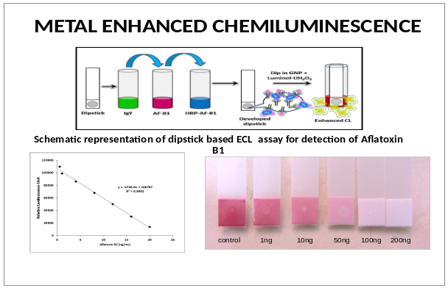

Recent Publications (minimum 5)
- M.Lisa, R.S.Chouhan, A.C.Vinayaka, H.K.Manonmani, M.S.Thakur. 2009, Biosensors and Bioelectronics, 25,224-227.
- Akshath US, Selvakumar LS, Thakur MS, 2012, Detection of formaldehyde in food samples by enhanced chemiluminescence, Analytical Methods 4 (3), 699-704.
- Abhijith KS, Sharma R, Ranjan R, Thakur MS ( 2014), Facile synthesis of gold–silver alloy nanoparticles for application in metal enhanced bioluminescence Photochemical & Photobiological Sciences 13 (7), 986-991

- Padmaja RJ, Akshath US, Abhijith KS, Halami PM, Thakur MS, 2014, Gold nanoparticle-based immunodetection of Staphylococcus aureus leukotoxin M/F′-PV in subclinical samples of bovine mastitis, Analytical Methods 6 (14), 5214-5220
- Vinayaka, AC, Thakur MS, (2013)Focus on quantum dots as potential fluorescent probes for monitoring food toxicants and foodborne pathogens. Analytical and Bioanalytical chemistry 397 (4), 1445-1455

Biography (150 word limit)
Biography
Dr. M.S. Thakur has made significant contribution in biotechnology especially in biosensor research in India since past 35 years. He has published more than 120 outstanding research papers along with 15 patents. He has transferred his biosensor technologies to industries. As an expert in biosensor and biotechnology he has delivered many invited lectures, keynote addresses and chaired many in national and international symposia/conferences. Dr. M. S. Thakur has made fundamental discoveries in bio-inspired biomolecular electronics and biophotonics, interfacing the biochemical events with opto-electronic systems making bioassay simple, specific, rapid and ultrasensitive which is very unique contribution. He has made appreciable contribution in understanding the opto-physical properties of nanoparticles and biomolecules using Fluorescence Resonance Energy Transfer and Bioluminescence Resonance Energy Transfer (BRET/FRET) phenomenon. He has solved the intricate problems associated with ultrasensitive detection of toxins, pesticides and vitamins using biophotonics and nanoparticles.
Email: msthakur@yahoo.com

Notes/Comments:

