Application of biomethanol to advanced CI engines – A review
Soo-Young No, Dept. of Biosystems Engineering, Chungbuk National University, 28644, Korea

Abstract
According to the importance of methanol as an alternative biofuel and the current research trends towards more advanced internal combustion (IC) engine, it is required to fully understand the combustion and emission characteristics of advanced compression ignition(CI) engines fueled with methanol. Biomethanol can be produced from various biomass such as agricultural waste, forestry waste, livestock and poultry waste, fishery waste and sewage sludge through pyrolysis, gasification, biosynthesis and electrolysis etc. The main concern in this review is the application of biomethanol to advanced CI engines such as HCCI, PPC, DF, RCCI combustion mode. This review is a part of an on-going review project of application of bioalcohols to the advanced CI engines. In this review, it is found that the method for HCCI combustion in CI engine fueled with biomethanol can be divided into by three categories: i.e. external, internal, and combined mixture preparation. DF combustion mode can be divided into four categories, i.e. blends, emulsion, fumigation, and dual fuel injection. In DF combustion mode, dual fuel injection can also be divided by two strategies, i.e. 1) PFI of the methanol and DI of the diesel in cylinder, 2) PFI of the methanol and DI of straight vegetable oil, Of two techniques, the methanol PFI and diesel DI was the prevailing technique to be studied in the dual fuel combustion. RCCI combustion mode can be divided into three categories, i.e. 1) methanol PFI/diesel or biodiesel DI, single injection, 2) methanol PFI/diesel DI, double injection, 3) methanol PFI/ diesel DI, triple injection.

Image

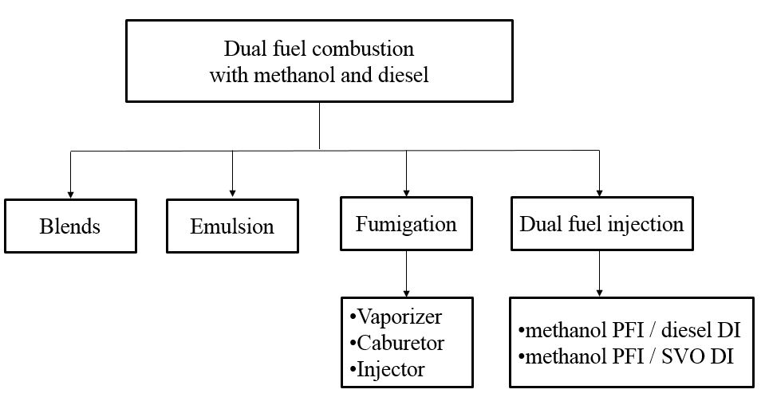
Fig. 1 Classification of dual-fuel combustion with methanol
and diesel
Recent Publications
- Bhaskar PB. Srihari S. A Study of Emission and Peformance Characteristics on HCCI engine Using Methanol Blend. SAE Technical Paper 2017-28-1963

- Shamun S. Shen M. Johansson B.tuner M. Pagels J. Gudmundsoon A. Tunestal P. (2016) Exhaust PM Emissions Analysis of Alcohol Fuelled Heavy-duty Engine Utilizing PPC. SAE technical paper 2016—01-2288.

- Boretti A (2012) Advantages of converting Diesel engines to run as dual fuel ethanol-Diesel. Applied Thermal. Engineering 47:1-9.

- Sarjovaara T, Alantie J, Larmi M (2013) Ethanol dual-fuel combustion concept on heavy duty engine. Energy 63:76-85.

- Pedrozo VB. May I. Noran MD. Cairns A. Zhao H. (2016) Experimental analysis of ethanol dual-fuel combustion in a heavy-duty diesel engine: An optimization at low load. Applied Energy 165:166-182.

Biography
Soo-Young No has his expertise in atomization and sprays, combustion and emission characteristics in applying the liquid biofuels to internal combustion engines, particularly compression ignition engines. The review papers on liquid biofuels published by him include the biodiesel obtained from inedible vegetable oils (Renewable and Sustainable Energy Reviews 2011,131-140, Atomization and Sprays 2011,87-105), alcohols such as methanol, ethanol (submitted to Applied Energy) and butanol (Fuel 2016, 641-658), bio-oil (Renewable and Sustainable Energy Reviews 2014, 1108-1125), straight vegetable oil (Renewable and Sustainable Energy Reviews 2017, 80-97), BTL diesel, hydrotreated vegetable oils (Fuel 2014, 88-96).
Email:sooyoung@cbnu.ac.kr

Notes/Comments:

