Development of portable ultra-small biomass gasification and power generation system
Kunio Yoshikawa PhD, Tokyo Institute of Technology, Japan

Abstract
A portable and small-scale biomass gasification system has a potential for use in damaged areas by natural disasters (earthquake, flooding, Tsunami, etc.) or un-electrified rural areas in developing countries. However, the available feedstocks are usually high moisture content ones with different size, shape and properties. Therefore, some pretreatments are essential for efficient gasification of these feedstocks. In this study, woody biomass samples were first carbonized/torrefied by a carbonizer without usage of electricity. Then the carbonized/torrefied biomass were crushed and molded into briquette shape to be supplied into a fixed bed updraft gasifier. The syngas produced in the gasifier was first cleaned up by physical tar removal processes (the oil scrubbing, the centrifuge misty tar collection and the char bed adsorption) and was then supplied into a gas engine with 30kW electrical output. In the presentation, some detail results on the carbonization/torrefaction process, the briquetting process, the gasification process, the gas clean-up process and the gas engine operation will be presented. Then the mass balance and the energy balance of the total system will be analyzed to show the self-sustainability of this system. This work was supported by Innovative Science and Technology Initiative for Security, ATLA.
Image

Fig. 1 Total process flow

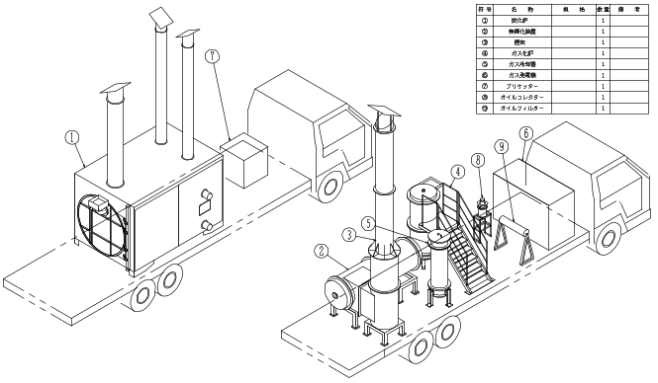

Fig. 2 Commercial image
Recent Publications (minimum 5)
- Hu Wu, Qi An, Yafei Shen, Noboru Harada, Lihao Chen and Kunio Yoshikawa (2015) The CO₂ Gasification Kinetic Study of WEEE Plastic Char Derived from Medium Temperature pyrolysis. Energy and Environment Research 5: 82-93.
- Shunsuke Nakamura1, Siriwat Unyaphan, Kunio Yoshikawa, Shigeru Kitano, Shuji Kimura, Hiroyuki Shimizu and Kazuya Taira (2014) Tar removal performance of bio-oil scrubber for biomass gasification. Biofuels 5: 597-606.
- Yafei Shen, Peitao Zhao, Qinfu Shao, Dachao Ma, Fumitake Takahashi and Kunio Yoshikawa (2014) In-situ catalytic conversion of tar using rice husk char-supported nickel-iron catalysts for biomass pyrolysis/gasification. Applied Catalysis B: Environmental 152-153: 140-151.
- Bayu Prabowo, Kentaro Umeki, Mi Yan, Masato R. Nakamura, Marco J. Castaldi and Kunio Yoshikawa (2014) CO₂–steam mixture for direct and indirect gasification of rice straw in a downdraft gasifier: Laboratory-scale experiments and performance prediction. Applied Energy 113: 670-679.
5. A. Paethanom P. Bartocci, B. D’ Alessandro, M. D’ Amico, F. Testarmata, N. Moriconi, K. Slopiecka, K. Yoshikawa and F. Fantozzi (2013) A low-cost pyrogas cleaning system for power generation: Scaling up from lab to pilot. Applied Energy 111: 1080-1088.

Biography (150 word limit)
Prof. Kunio Yoshikawa was born in 1953 in Tokyo, Japan. He is a professor of Tokyo Institute of Technology and an associate editor of Applied Energy. His bachelor, master and doctor degrees were awarded from Tokyo Institute of Technology. His major fields are energy conversion, waste management and environmental engineering. He has been working in Tokyo Institute of Technology for more than 38 years as a research associate, an associate professor and a professor. He has published nearly 200 journal papers with the major award of AIAA Best Paper Award, ASME James Harry Potter Gold Medal, JSME Environmental Technology Achievement Award and Best Educator Award of Tokyo Institute of Technology.
Email: yoshikawa.k.aa@m.titech.ac.jp

