STUDIES ON THE DATING OF NATURAL GAS IN VINDHYAN ROCKS SAGAR- DAMOH DISTRICT, SOUTH GANGA BASIN ,MADHYA PRADESH. INDIA.

Arun K. Shandilya
Department of Applied Geology
Dr.Hari Singh Gour University Sagar M.P
email - akshandilya_u@rediffmail.com

ABSTRACT:
The dating of natural gases were carried out for the gas sample were collected from the 50 tube wells in Sagar and Damoh District of M.P. The discovery of the rare gas helium in hydrocarbon rich zone in the tube wells in agricultural field in the various Tahsils of Sagar District and Damoh District of M.P. , in the south ganga basin in rocks of the Vindhyan Super Group. On the basis of geochemical analysis, it is remarkable to note that average values of helium contents varies from 0.34 % to 0.732 % along with the 72% to 99 % of methane and ethane, and minor amount of oxygen, nitrogen and CO2 gases in the hydrocarbon rich zone are recorded.
The stable isotope analysis. It has been found in the stable isotope δ C¹³ value the values for the methane is - 43.6 per mil w. r. t. to - 54.9 per mil w.r.t. PDB and for the Ethane gas is --24.9 to --26.4 per mil w. r. t. PDB in the gas samples .The occurrence of rare helium gas in the Hydrocarbon rich zone is reported first time in Jan, 2007 from the tube wells of Sagar Distt, which were geochemically and stable isotopically analyzed in the labs of KDMIPE Dehradun & NGRI Hydrabad. The gaseous hydrocarbon analysis show the presence of moderate to low concentration of methane ( C1) 1 to 104 ppb, Ethane( C2)-1 to 14 ppb, Propane( C3) 1 to 10 ppb, i- Butane ( i C4) 1 to 9 ppb and n Butane ( n C4) 1 to 8 ppb in the soil samples collected from different locations.
The Result of the dating & stable isotopic analysis of Ethane gas in these samples δ C¹³ value are ranging from -24.9 per mill w.r.t. PDB and -26.9 per mill w.r.t. PDB are indicative that this gas is of thermogenic origin, which must have been formed at very high temperature & pressure condition in the deeper horizon of the Great Vindhyan sedimentary basin of an early Proterozoic ( > 600 m.y.) period.
INTRODUCTION:
The present studies on the dating of gas samples in the seepages and leakages of natural petroleum and rare gas Helium gases in the agricultural field of Sagar and Damoh district has been done in the hydrocarbon rich zone. These hydrocarbon gases and helium gas were escape from the reservoir and migrated to the surface, the secondary porosity in the rocks, sediment and soil or diffuse into the atmosphere or added in the ground water. These leakages of natural gas is an indication of petroleum gas in the form of oil and gas seeps from precursor under ground.

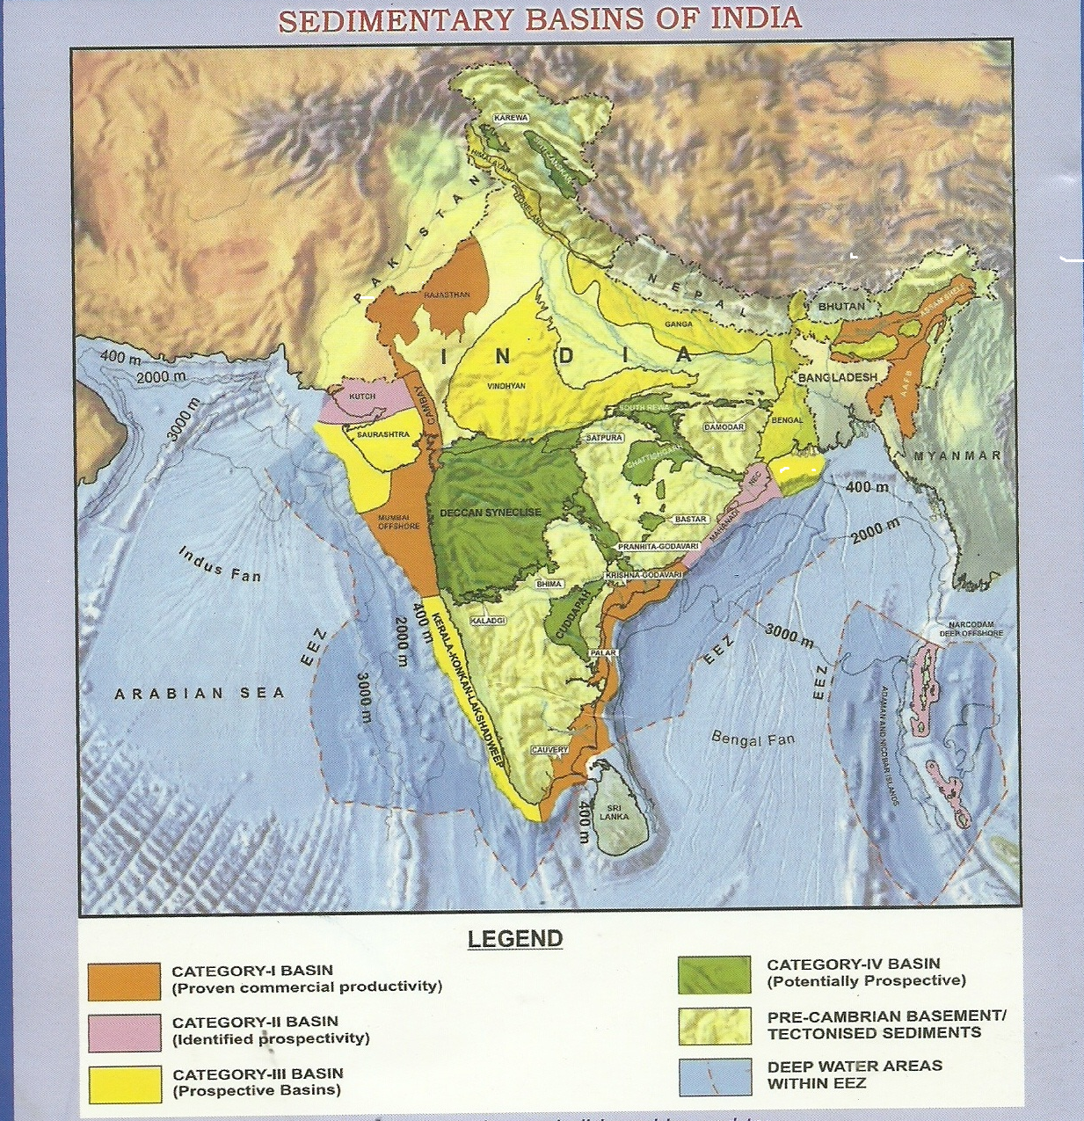 The attempt has been made through the cheaper and faster method of geochemical prospecting ,which provides the direct evidence for the presence of petroleum accumulation under ground. The samples of soil, water and gas were collected from the tube wells of agricultural field are located in the agriculturl feild of various villages in the Meerkheri, Rahatgarh (tahsil) Pipariya –Bhutoli villages in Garhakota tahsils of Sagar and Mahalwara village in Sukha block of patharia tahsil of Damoh distt. in the southern fringes of Bundelkhand region in M.P. The first time leakage of petroleum gas was reported in 1980 from the Meerkheri village located on the Sagar to Vidisha road, at about 15 km from the Rahatgarh town. In 1993, in another tube well at Rahatgarh the leakages was reported by the author.

The carbon isotope studies of methane and other gases were done to know whether these petroleum gases are of biogeneic of thermogenic origin. Coleman et al (1977) in a study on the leakage of gas from the underground storage reservoir, showed that isotopic analysis is a reliable technique for differentiating between methane from thermogenic and biogenic source. A useful geochemical method to correlate gases with their source rocks is δ C¹³ determination. The isotopic composition of methane was found to be a more reliable indicator of hydrocarbon reservoir. Shandilya( 2007) has reported the occurrence of the petroleum gas in the Sagar District and suggested that theses petroleum gas is of thermogenic in origin
Shandilya, (2008) made Discovery of Natural Gas leakages from Bore wells in the rocks of the Vindhyan Super group in Sagar and Damoh Distts. M.P. and forecasted the reserve of Natural Gas Reserves in Sagar District . Shandilya(2009) published a article on GAS IN THE BACKYARD. in the BUSINESS INDIA MAGZINE suggesting that this gas is of thermogenic origin. Shandilya (2009) has suggested the possibility of Petroleum Gas reserve in Southern Bundelkhand Region. M.P. Shandilya, & Gajbhiye. (2010) made the Discovery of Rare Helium Gas in Sagar Distrcit, M.P.

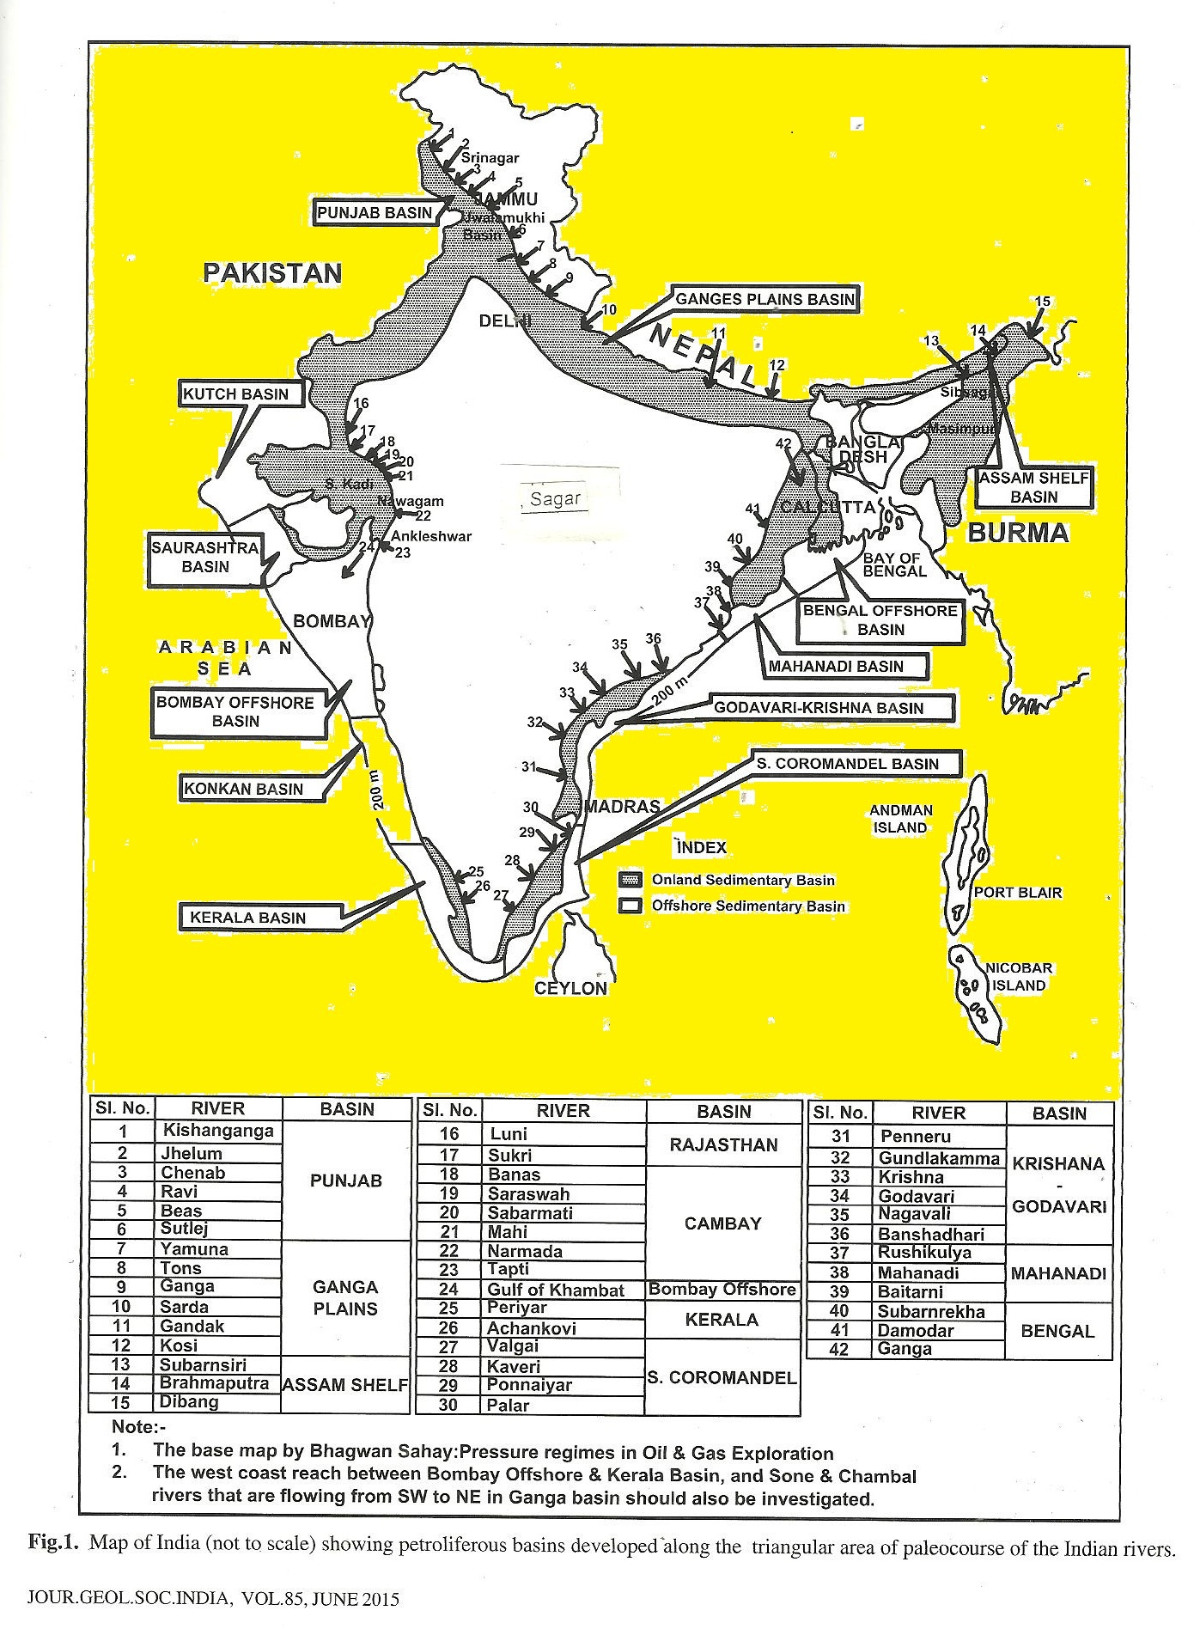
Prasanna et al (2010) were done the detail investigation of light gaseous hydrocarbon anomolies in the surface soil around Sagar using the geochemical exploration methods for hydrocarbon leakages has been focused on the detection of absorbed petroleum gases by gas chromatohraphic method, in Vindhyan basin using composition and ratio of the light hydrocarbons methane, ,ethane, propane, butane.

GEOLOGY:
The present natural gas leakages has been discovered in the dried tube wells, located on the rocks of Sandstone, shale and limestone rocks of the Rewa and Bhander Group of the Vindhyan Super Group as the basement rocks. These petroliferous rocks are overlain by the Lameta bed ( late Cretaceous ) in the western part of the Pipariya and Bhutoli area in Garhakota tahsil. On the western part of present area is overlain by the rocks of Upper Cretaceous Deccan Trap Basaltic flows, which are intercalated with intertrappean limestone. The area were the leakages of petroleum gas has been discovered located on the alluvial soil cover. The Deccan Trap Basaltic rocks are exposed west of the Chinnoua village in Garhakota Tahsil .The dips of the sandstone and shales rocks are 10 - 15 degree toward SE direction. The topography is more or less flat with some low lying areas near the stream. The geological formation of Sagar area consists of 09 flows of Deccan Trap
With several intertrappean limestone beds, whole area being underlain to the east and south by the Lameta limestone. which forms the plains and some hills to the south.
Western fringe of The Rahatgarh and Meerkheri areas are covered mostly by the Basaltic flows of Deccan Traps except few inliers of the shale and sandstone rocks of Rewa Group and Bhander Group of the Vindhyan Super Group. The Deccan Trap basalt rocks are mostly covered by the black soil. The Decan volcanism during late Cretaceous must have generated the proper thermal conditions and acted as a catalyst in triggering Mesozoic hydrocarbon generation processes in the Vindhyan sedimentary basin in Central India.

Table 1- THE STRATIGRAPHIC SUCCESSION IN SAGAR DISTRICT, M. P.

AGE | FORMATION
RECENT- SUBRECENT/  QUATERNARIES | Alluvium soil  Black soil
UPPER CRETACEOUS | Deccan Trap Basalt  ( with Intertrapean limestone )
LOWER CRETACEOUS | Lameta Formation
LATE PROTEROZOIC  VINDHYAN SUPER GROUP  _____________________  MIDDLE PROTEROZOIC  BIJAWAR SUPER GROUP  ______________________  EARLY PROTEROZOIC  BUNDELKHAND GRANITIC COMPLEX  __________________________  Archean  Mehroni Super Group | Bhander (Containing the Petroleum gas & Helium gas)  Rewa  Kaimur  Semri  _____________________________________________  Phosphastic Dolomite  Dolomite.  Ferrugenous Shale  Ferrugenous Sandstone  Iron Formation / BHQ  Quartzite  Conglomerate bed.  ____________________________________________________  Quartz reef intrussion  Pegmatitic intrussion  Ultramafic intrusive  Granite Intrussive rocks.  Granite Gneiss  Biotite Schist.  _________________________________________________  Intrussive body  Dolomitic Marble  Slate  Ferrugenous Formation  Quartzite  Schist
(Modified after Rang rajan 1978)

OBSERVATION:

On the request of authors, the Director Exploration, KDM IPE, ONGC Dehradun and Director, NGRI Hyderbad has sent a team of scientists for the detailed investigation had visited the various places including Piparia-Bhutoli and Rahatgarh and Meerkheri area and collected the samples of soil, water and gas.
GEOCHEMICAL ANALYSIS :
(1) At ONGC Dehradun - . The samples were analysed in the geochemical laboratory of KDM IPE Kaulagarh Road, ONGC, Dahradun. The finding of the geochemical analysis of the natural gas, water, and soil are as follows-
Table-2 – Geochemical Composition of Natural Gas and stable Isotope values.
s.n. | Bore Well | Chemical Composition % (v/v) |  |  |  |  |  | Isotopic Values  (δ C¹³)
s.n. | Bore Well | He | O₂ | N₂ | CO₂ | C₁ | C₂₊ | δ C¹³
1 | Pipariya Bhatoli | 0.34 | 1.6 | 24.87 | 0.93 | 72.14 | 0.01 | -61.5
2 | Rahatgarh | 0.72 | 0.65 | 14.37 | 0.28 | 84.00 | 0.02 | -54.0
(After Shandilya2007)

The Oil and Natural Gas Commission Dehradun has concluded with, The seepaged gases of Pipariya Bhatoli and Rahatgarh are predominantly methane (72.14%-84 % in Pipariya Bhutoli and 99% in Tiwari Dhaba, Rahatgarh Bore well and are devoid of higher hydrocarbons. the hydrocarbon gases seem to have predominance of bacterial methane. The pressure of both the seepages is extremely low. As per the owners, the quantity of gas is diminishing day-by-day. The results this time of methane is concerned. Genetically the seepage gases from Pipariya Bhatoli and Rahatgarh seem to be different from thermogenic gases encountered in exploratory well jabera-1, drilled by ONGC in Distt. Damoh(M.P.).
In January 2008 in Bhutoli village further land owner bore the well up to 400 ft. deep there is huge quantity of natural gas has been reported to governmental agencies.In the Fab.2008 two villagers at Pipariya- Bhutoli have drilled two more tube wells upto the depth of 300- 350 feet about 600-700 m away from the earlier wells in the shales and sandstone rocks of Lower Bhander they could not got the ground water, but there is leakages of natural gas, which is also giving the blue flame.
(2) At NGRI, HYDERABAD :
The samples of petroleum gas, soil, water were also collected by the scientists Dr.A.M. Dayal,Dr.Ravi Srivastava, and Dr.D.J.Patil of NGRI Hyderabad alongwith the author on 4-5 May 2008.The detail geochemical and stable Isotopic studies of the natural petroleum gas , soil and water sample has been done in the Laboratories of NGRI.

Table 3- STABLE ISOTOPIC VALUE OF HYDROCARBON GAS IN SAGAR DISTT. M.P. INDIA.
LOCATION | NAME OF PETROLEUM GAS | STABLE ISOTOPIC VALUE  δ C¹³
Piparia – Bhutoli | Methane  Ethane | -43.6 per mil w.r.t. PDB  -24.6 per mil w.r.t. PDB
Rahatgarh – Mirkheri | Methane  Ethane | - 54.9 per mil w.r.t. PDB  - 26.4 per mil w.r.t. PDB
(After Shandilya 2008)
Table - 4. THE ABSORBED SOIL HYDROCARBON GAS CONCENTRATION IN SAGAR DISTT. M.P. INDIA.
 | C1 | C2 | C3 | i C4 | n C4 | ∑C3+
Minimum | 1 | 1 | 1 | 1 | 1 | 1
Maximum | 104 | 14 | 10 | 09 | 08 | 41
Mean | 19 | 2 | 1 | 0.5 | 0.3 | 4
Standard Deviation  Soil Gas sample (%) | 22 | 4 | 2 | 2 | 1 | 8
( After Prasanna et al 2010 )
Table- 5 - ABSORBED HYDROCARBON RATIO IN SOIL SAMPLES IN SAGAR DISTT. M.P. INDIA.
Ratio | Thresold value | % of at incidence in survey at Sagar | Reference
C1/C2+C3 | <10 | 79 | 16
C1/C2 | <16 | 96 | 18
C2 /∑ C3 + | <1.3 | 50 | 17
( After Prasanna et al 2010)
The presence of the ethane gas in both the Localities, and δ C¹³ value in the range of -24.9per mil.w.r.t.P.D.B. and - 26.4 per mil.w.r.t.P.D.B. indicate the thermogenic source of these gases. On the basis of the geochemical and stable isotopic studies of the natural petroleum gas, soil and water suggest that the samples of the Piparia-Bhutoli-Rahatgarh-Meerkheri of Sagar District containing 72% to 99% of methane,0.34% -0.742% of Helium ,alongwith the oxygen ,carbon dioxide and Nirogen gases.The stable isotopic δ C¹³ value in the range varying from -43.6 per mil. w.r.t PDB for methane -24.66 per mil. w.r.t PDB for ethane at Piparia –Bhutoli to-54.9 per mil.w.r.t PDB for methane and per mil. w.r.t PDB for at Rahatgarh are indicative of the THERMOGENIC origin and also that methane Is associated with oil. Bernard ( ) suggested a geneticdiagram by correlating C1/ C2+C3) ratio with δ C¹³ 1 concentration of methane to classify natural gas types. Molecular ratio C1/C2+C3 less than 50 are typical for the thermogenic hydrocarbon gases with δ C^{13 values} between-30% and -55%(PDB). This suggests that most of the samples fall in the thermogenic range.
The adsorbed soil gas result indicate the presence of methane, ethane, propane and butane in Sagar District M.P. The adsorbed soil gas and carbon isotope studies suggest that these seeped hydrocarbon are of thermogenic origin and petroliferous in nature and indicate the area is warm for hydrocarbon exploration.area

CONCLUSION:
In my opinion the natural petroleum and helium gas are containing the higher amount of Methane(72-99 %), and remarkable content 0.34 % to 0.742 % of Helium, and minor amount of oxygen, ,nitrogen, and carbon di oxide, it suggests that it must have been formed at higher temperature condition at deeper horigen in the Pre-Cambrian Vindhyan sedimentary basin( Proterozoic in age). The reservoir must be lying below the ground at least 500 m or more deep level. The present leakages of natural gas releasing through many hairline cracks/ fracture and feather joints in the sandstone, shales and limestone rocks of the Rewa and Bhander group rocks of the Vindhyan Super Group.
As per dating & stable isotopic studies of Gas samples analysed at NGRI. find out the methane and ethane gas. The presence of ethane gas collected from the above mentioned localities the δ C¹³ stable isotopic value in the range of -24.9 per mil.w.r.t. per mil to - 26.9 per mil w.r.t. PDB. indicative of the Thermogenic sources.

ACKNOWLEDGEMENT:
The authors are thankful to the Director, NGRI and Dr. A. M. Dayal Asstt. Director(Rtd) of NGRI Hyderabad, and the Director, KDMIPE, ONGC, Dehradun for the Geochemical and Stable isotopic analysis of the various samples. The author is highly thankful for the critical comments and valuable suggestions on this manuscript by Prof. R.P.Tiwari, Vice Chancellor, Dr.HSG University, Sagar Prof. S.P. Banarjee (Rtd),Deptt. of Chemistry, Dr. Hari Singh Gour University, Sagar. M. P.and the critical comment on the manuscript by Prof. P. S.Saklani, Ex Vice Chancellor, H.N.B.Garhwal University Srinagar Garhwal is thankfully acknowledge.

REFERENCES:
Bernard,B.B.( 1978) Light Hydrocarbon in Sediments. Ph.D dissertation. Texas A&M University, USA p.144.
Coleman, D. D., Meents, W.F, Liu, C.L and Keogh, R.AS (1977) Isotopic identification of leakage gas from underground storage reservoir- a progress report III,Petrology, 1977,111, 1-10.
Fuex, A.N(1977) The use of stable carbon isotopes in Hydrocarbon exploration. Jour.Geochem.Explor.,1977,7,155-188.Lones,V.T and Drozd,R.J (1983)- Prediction of oil and gas potential by near surface geochemistry. Ameri.Asso.Petr.Geol.Bull.,983, 67,932-952.
Horvitz, L(1979) Near surface evidence of hydrocarbon movement from depth problems of petroleum migration. Am. Asso. Pet. Geol.1979,10,241-269.

Prasanna M.V, Rasheed, M.A, Madhavi. T, Kalpana. G, Patil D.J. and Dayal A.M.(2010)- Light gaseous hydrocarbon anomalies in the near surface soils of Sagar District, Vindhyan Basin, India. Published in Current Science, Vol.99(11) Dec.10, 2010 p.1586-1590.
.Rajrajan, K (1978)- Geology of Sagar district and western part of Damoh distt. Memoirs, GSI, Vol.109,).
Raina . & Tiwari et. al. (2007) Unpublished report of ONGC 2007.
Shandilya, Arun K. (2007) Natural Petroleum Gas found in Piparia-Bhutoli- Rahatgarh in Sagar District, Bundelkhand Region M.P. University Journal- MadhyaBharati, Vol.53, p.122-124.
Shandilya Arun K. (2008a) Discovery of Natural Petroleum gas in the rocks of the Vindhyan Super Group in Sagar Distt.Bundelkhand Region,M.P. Qtrly Jour. of GARC,Vol.16(I) p.24-27.

Shandilya, Arun K. (2008b) FUEL HO - Leakages of Gas in Tube wells spew natural gas. The NEWS MAGZINE mach 2008, p.31-32
Shandilya, Arun K. (2008c) Natural Gas leakages from Bore wells in the rocks of the Vidhyan Super group in Sagar and Damoh Distts.M.P..Jour. Himalayan Geology,Vol.29(2)2008,p.174 175.
Shandilya, Arun K. (2008d) Natural Gas Reserves in Sagar District. "SRUJUN" UNIVERSITY NEWS LETTER.Vol.9,Jan-March 2008, p.19.
Shandilya, Arun K. (2009a) GAS IN THE BACKYARD. in the BUSINESS INDIA MAGZINE Feb.22. 2009 Page 144.
Shandilya, Arun K. (2009b) Thermogenic Petroleum Gas found in tube wells of Sagar District. M.P. Madhya Bharati, Diamond Jubilee Volume P.314-319
Shandilya, Arun K. (2009c) The possibility of Petroleum Gas reserve in Southern Bundelkhand Region. M.P. UNIVERSITY NEWS LETTER, Vishwavidyalaya Samvad. Vol. 2 Page3,Jan.2009.
Shandilya, Arun K. & Gajbhiye N.S. (2010) Discovery of Rare Helium Gas in Sagar District, M.P. INDIA. Proc. V th International Conference, South Valley University QENA, EGYPT. Jan2-7,2010 .p.26
Shandilya, Arun K. ( 2011) The Discovery of natural petroleum and Helium gas in Tube wells of Sagar- Damoh Distt. in Vindhyan Rocks , M.P. Proc. Sedimentary Basins of India, Gondwana Geological Society, NAGPUR 2011. p. 125-130.
The News of Discovery of Petroleum gas was published in News papers - : Dainik jagran, Dainik Bhaskar, Raj express, Nav Bharat, Nai dunia, Hindustan times, Acharan etc.
Shandilya,Arun k.,,,Shandilya Anurag,& Shandilya Anupam- (2012) Hydrocarbon gaseous anomalies found in Agriculture Field around Sagar and Damoh Distt. Southern fringes of Bundelkhand region, M.P.Int.Jour.of Chemical and lifescince Vol.1(3) Dec 2012.p-1039-1044.
Shandilya, Arun k., Shandilya Anurag,& Shandilya Anupam- (2013) The Discovery of Hydrocarbon gas in Sagar Distt. ,M.P.India. Int.Humboldt Kolleg, & Int. Conf. Environ. Managament.,Fab2013,JNU,Newdelhi.
The News of Discovery of Petroleum Gas was broad casted in T.V. Channels : - Door Dhashan(DD) state and National both, Sahara National, India T.V., ETV, Times, and AajTak, Khabar Bharti, & P-7 TV channel,
______________________________________________________________________________
Phone- 07582-265818 (o) 07582 236597 (R) 09977576665 (M)
email –akshandilya_u @rediffmail.com
Prof. Arun K.Shandilya,
Ex-Head, Deptt. of Applied Geology
Dr. H.S.G University, SAGAR ( pin-470003) M.P. INDIA.

