Community Based Eradication Strategy and Response Tactics of the IAS Lantana camara Early Infested Rangeland in Eastern Hararghe, Ethiopia
Edeget Merawi¹* Girma Eshetu², Girum Faris², Yeneayehu Fantahun², Abebe Worku²
^{1,2} Ethiopian Biodiversity Institute, Addis Ababa, Ethiopia
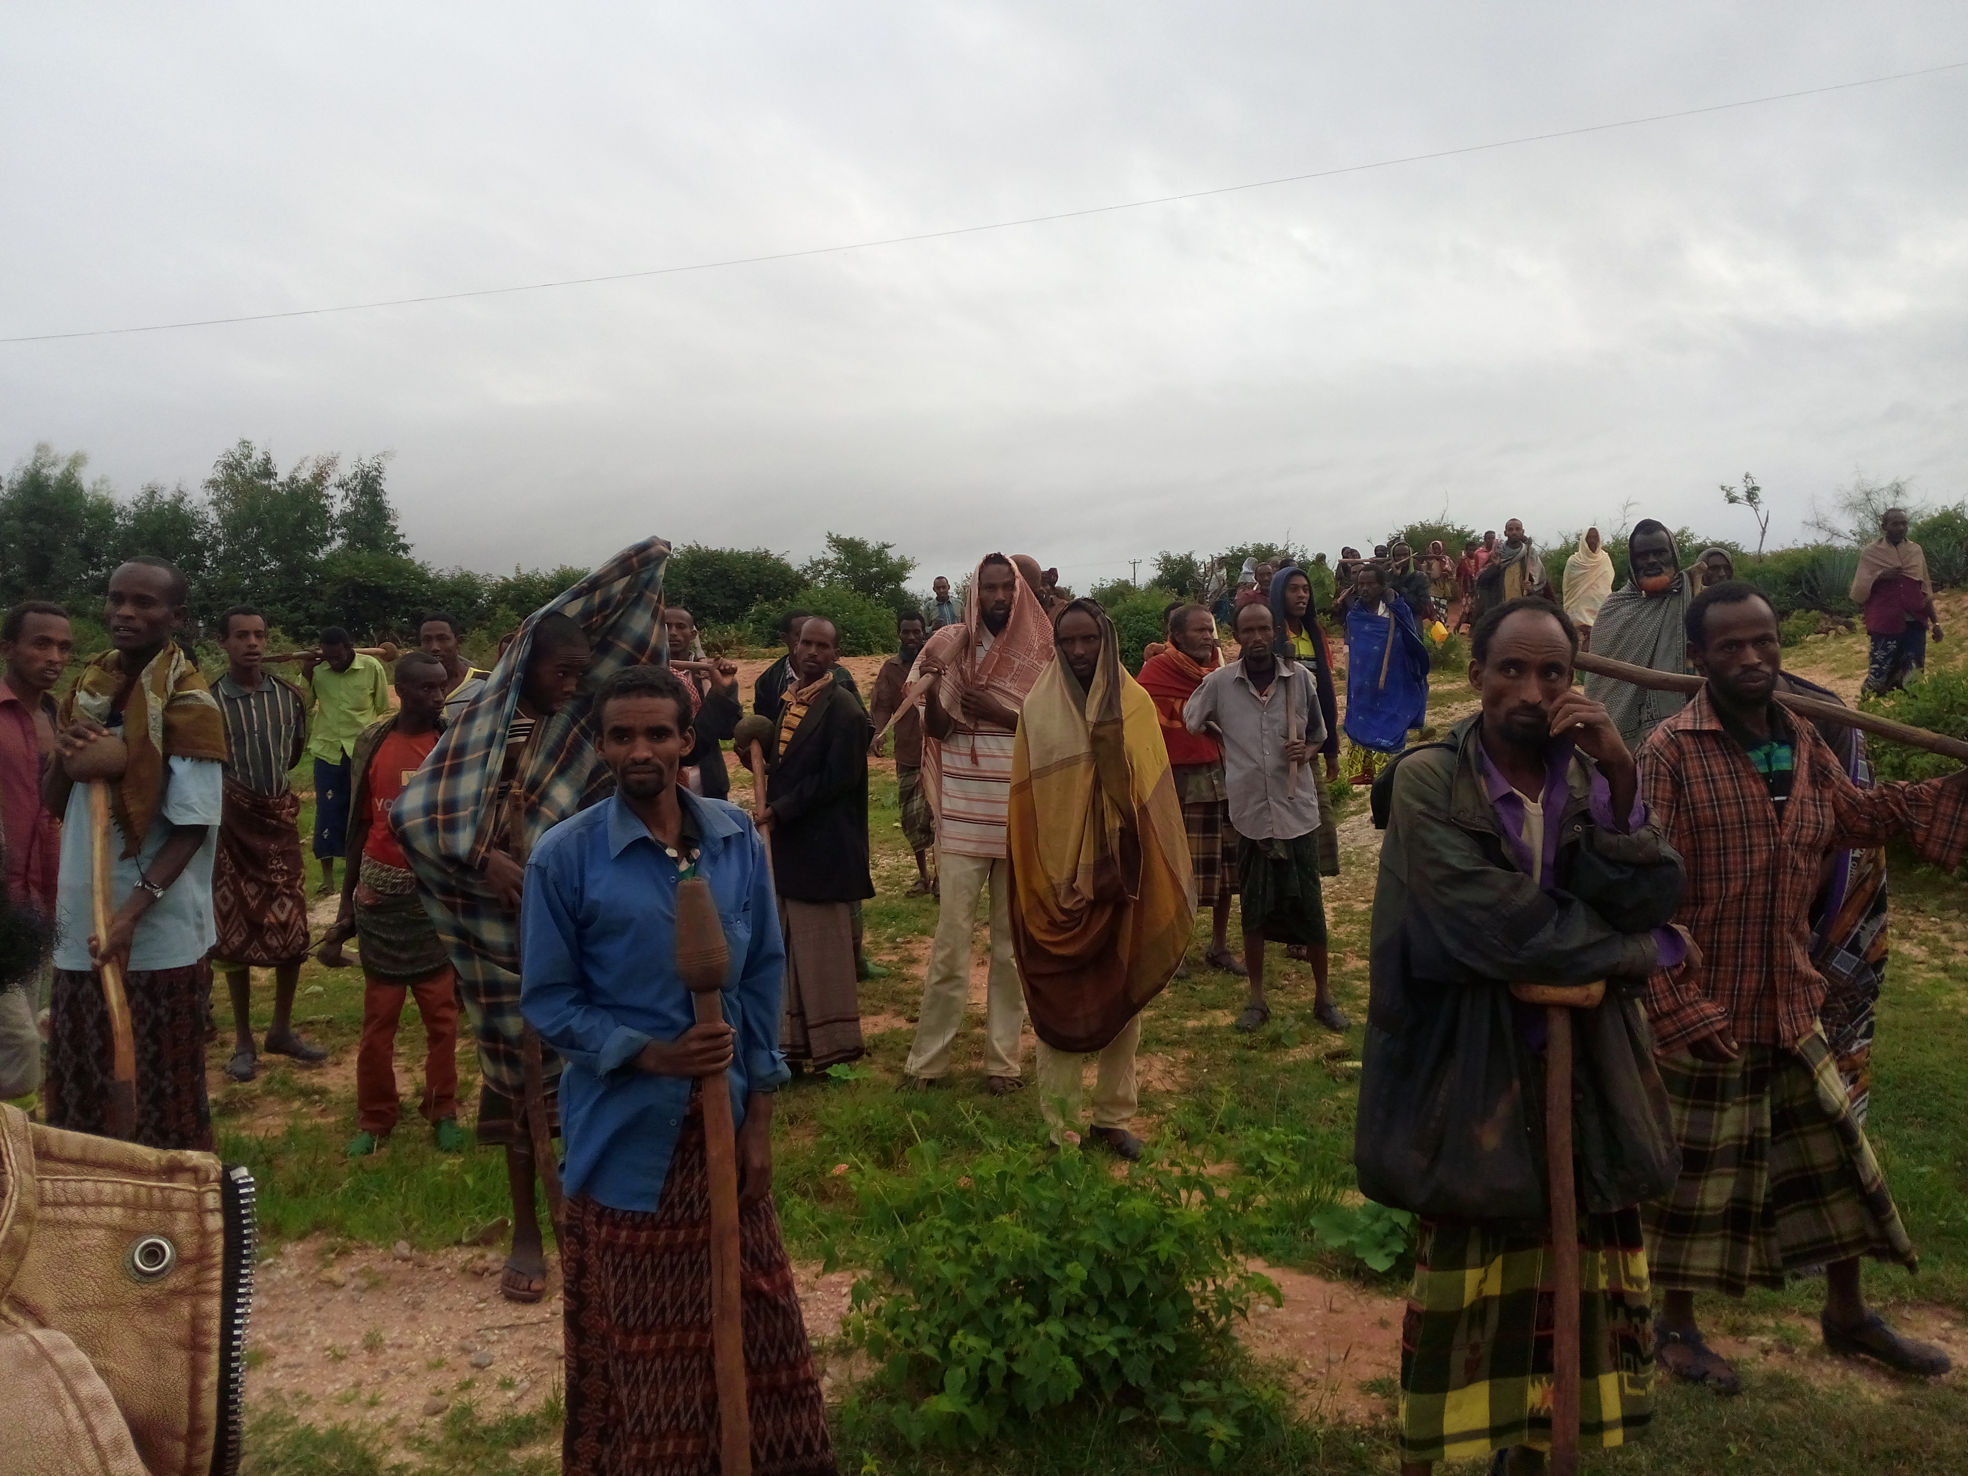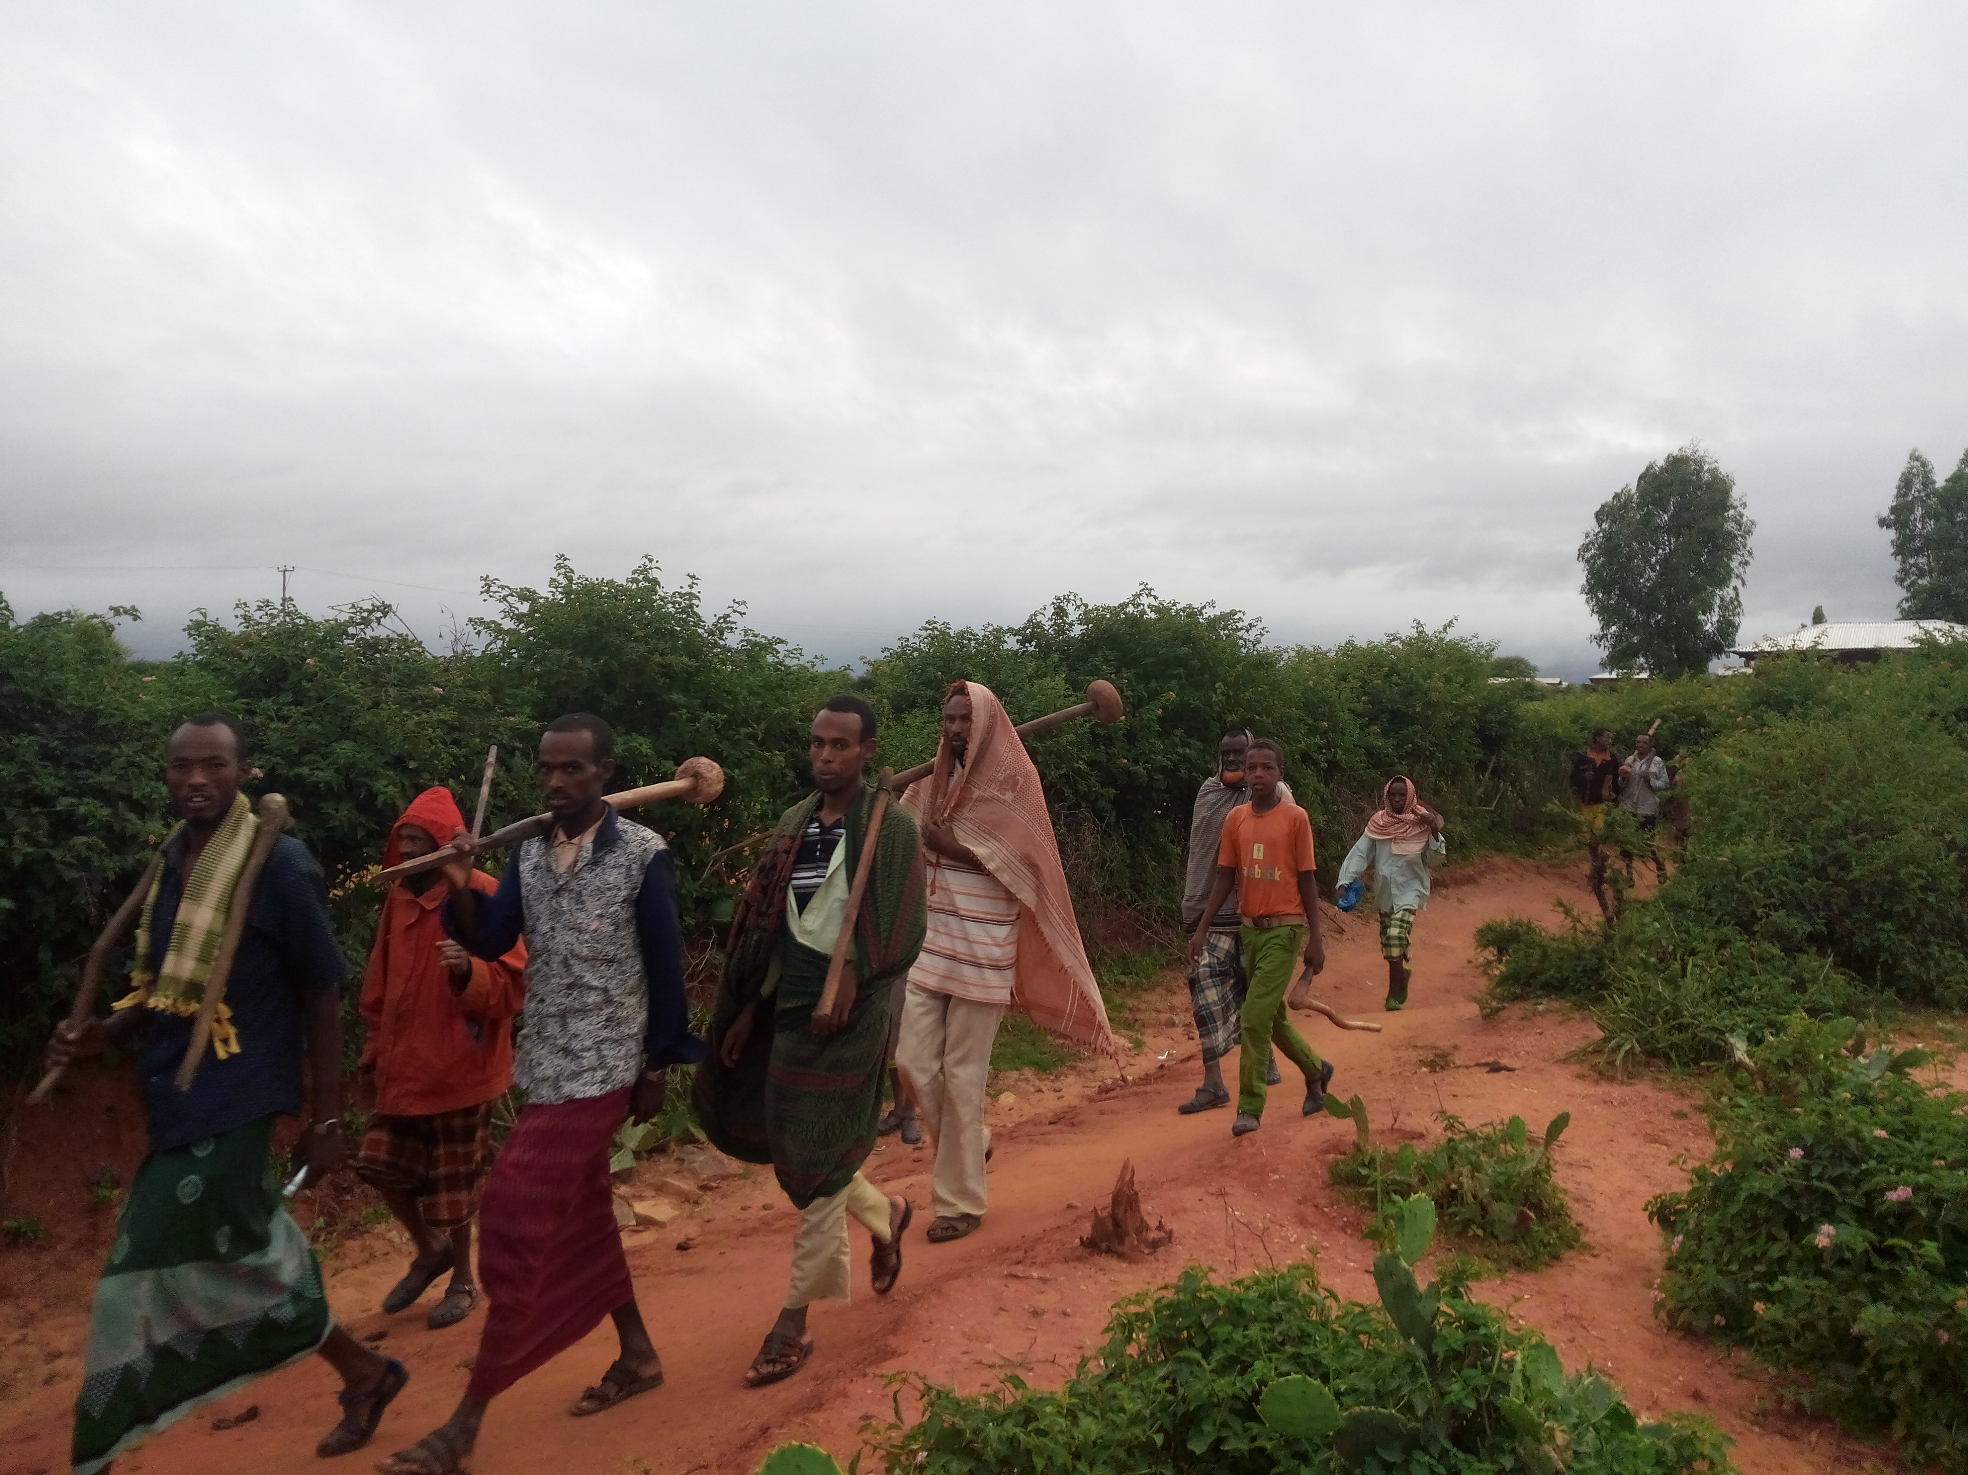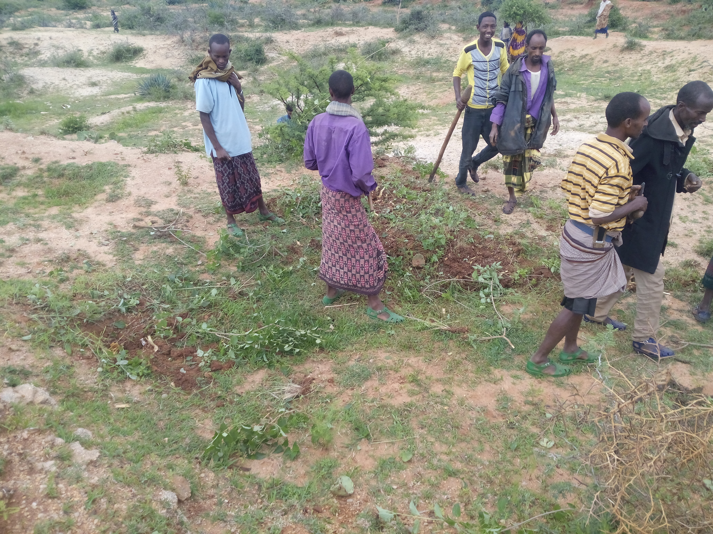Plates during Eradication campaign 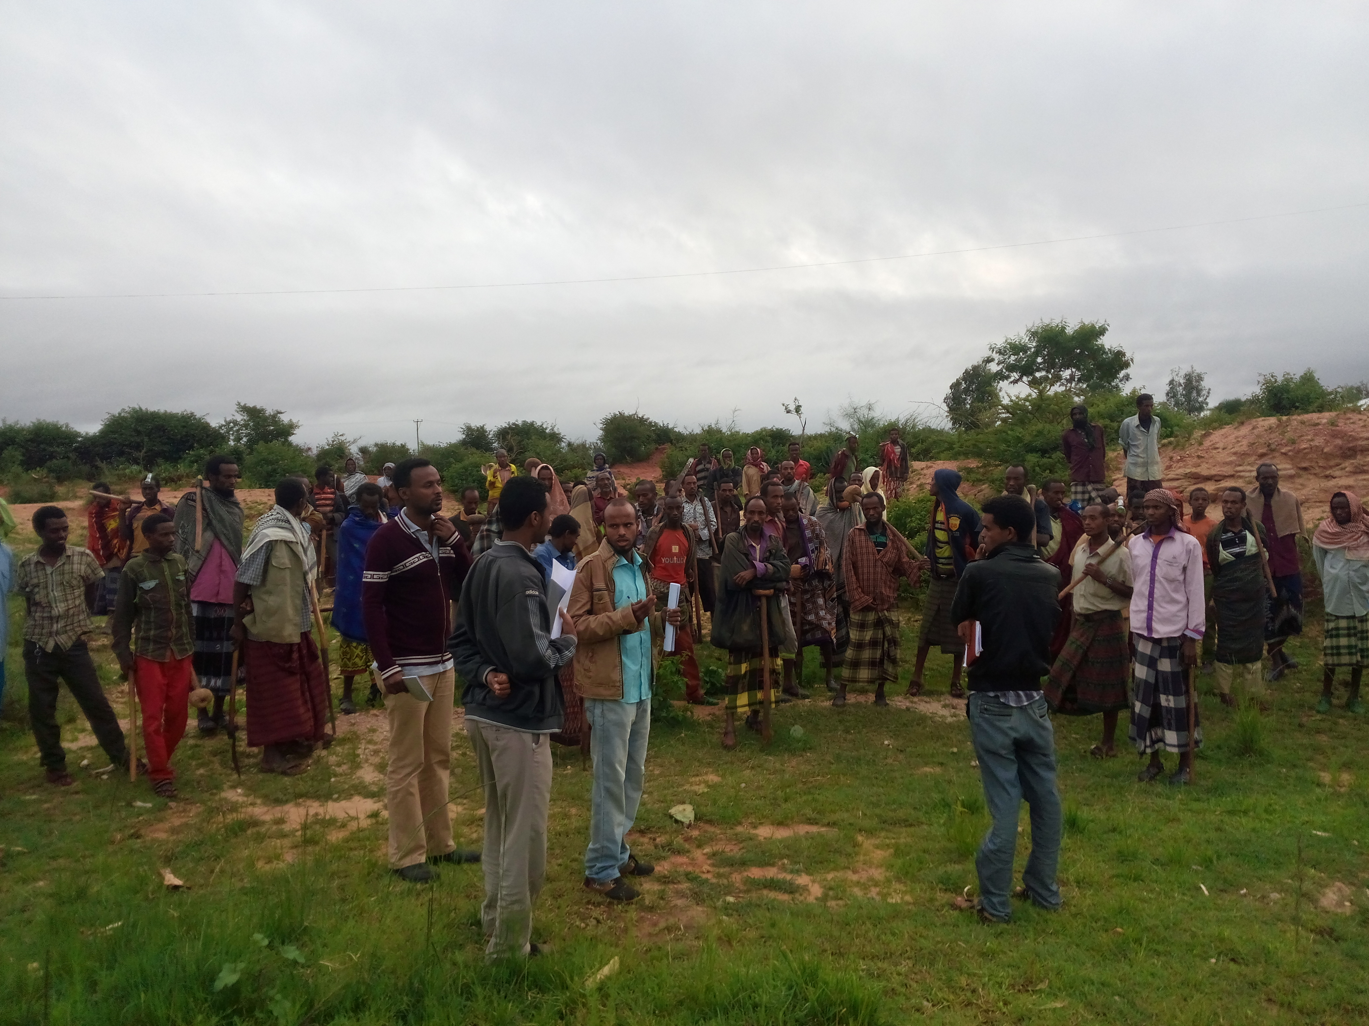

Abstract
Lantana camara is one of the world’s worst weeds of South American origin that threatens native biodiversity of rangeland and forest ecosystems across Ethiopia. This study is therefore, designed to evaluate community based eradication strategy and response tactics of the IAS Lantana camara early infested rangeland Eastern Hararghe, Ethiopia. 20 hectare Lantana camara early infested area was taken as experimental land around 15 km distance south to Babille City. The cover abundance and distribution of Lantana Camara was estimated by laying 3 imaginary transect line to guess the amount of human power needed during controlling intervention. Diagnosing the real problem, realistic appraisal of the situation, understanding the overall problem, exploring potential technologies, setting plan of action, execution of the planned action and follow up were used as a strategy to eradicate the early infested rangeland. Accordingly, Mechanical removal specifically uprooting using localized tool called “Mencha” followed by Rehabilitation and restoration of lands using forage grasses, shrubs and trees were designed as a response tactics. A total of 120 voluntary trained farmers were involved for 3 hours to eradicate the sampled Lantana camara. The result revealed that successive mass participatory approach using mechanical uprooting by localized tools followed by rehabilitation; restoration and repeated follow up alleviate the effect of early infested Lantana camara on native biodiversity. In conclusion, mechanical intervention (uprooting, grafting the floral and leaf part before fruiting, destruction of seeds and area enclosure until restoration and rehabilitation suppress the reproduction of Lantana camara early infestation.
Recent Publications
- 1. Edeget .Metal.(2016); Surveying illegal access to genetic resources: a case study in Borena Zone, Southern Ethiopia
- 2.Edeget.M etal. (2016);Assessment of the Invasive Alien Species Argemone ochrolueca in Northern Ethiopia
- 3. Edeget. M etal. (2016);Surveying the Impact of IAS Mimossa diplotricha, in Jimma Zone
- 4.Edeget. M etal. (2016);Bioprospecting Potential of Ocimum basilicum in Bahirdar and North Gonder, Ethiopia
- 5.Edeget. M (2016); Identification of ecological threats, pressure and their relative severity of Temcha Riverine Forest, Northern Ethiopia.
Key word: Restoration, Uprooting, Response tactics, Realistic approach, Rangeland, Eradication

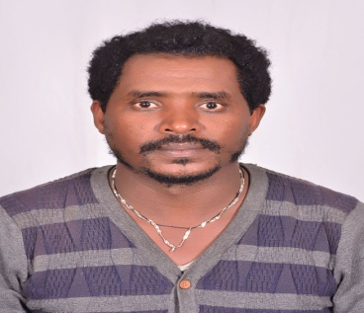
Biography
Edeeget Merawi is a botanist expertise in Invasive alien species and passion in controlling the spread of Invasive Alien Species and wellbeing of Biodiversity. His idea and practical experiment in managing Invasive Alien Species is a breakthrough in the eradication campaign of IAS. He has developing Eradication strategy and response tactics of many Invasive alien species through experimental research. He has an additional experience in teaching, collaborative consultancy work and administration in different Institution.
Email- Edegetmerawi@gmail.com

