Small Mammal Diversity and Composition in the Wildlife and Livestock Grazing Lands, A Case Study of Rodents and Shrews
Monica Shilereyo^{*1,3}, Flora Magige¹, Ally Nkwabi², Grayson Mwakalebe² and Eivin Røskaft³
¹University of Dar es Salaam,
²Tanzania Wildlife Research Institute (TAWIRI),
³Norwegian University of Science and Technology

Livestock grazing is among the common land use practices in several parts of Tanzania. Apart from being useful for regrowth, grazing acts as mechanical disturbance and reduces availability of plant biomass and changes composition that may affect various animal taxa. The impact of livestock grazing on small mammals in the Serengeti ecosystem was investigated by assessing the diversity and composition of the lower taxa of mammals in three different land use types with different conservation statuses i.e., National Park, Game Reserve, and livestock grazing land. Capture-mark-recapture methods was employed in which Sherman traps and bucket pitfall traps were used. Within the10,304 trap-nights a total of 347 individuals (249 rodents and 98 shrews) representing 17 small mammal species were captured. Among the captured species, generalists such as Arvicanthis niloticus, Crocidura hirta and Mus minutoides were the most abundant in the livestock grazing habitat while habitat specialist species such as Dendromus melanotis and Thallomys paedulcus were found only in the protected areas (Game Reserve and National park). Furthermore, species diversity was slightly lower in the livestock grazing land i.e., Shannon entropy was 7.2 in the Game reserve, 6.6 in the National Park and 6.4 in the livestock grazing land but not significant (Df 2,14=0.1542), P>0.05). Using small mammals as an indicator, pressure from livestock grazing practices appear to favour communities of generalist species due to habitat homogeneity while isolating specialist species. Low grass cover and height as compared to the habitat in the Serengeti National Park and the game reserve, explains the effect of changes in the vegetation structure to small mammal diversity. The finding is an indication that protected areas are still viable in protecting rare/habitat specialist species which could not coup with rapid change of habitats while human inhabited environment favours generalist species therefore, both help in maintaining ecosystem resilience.

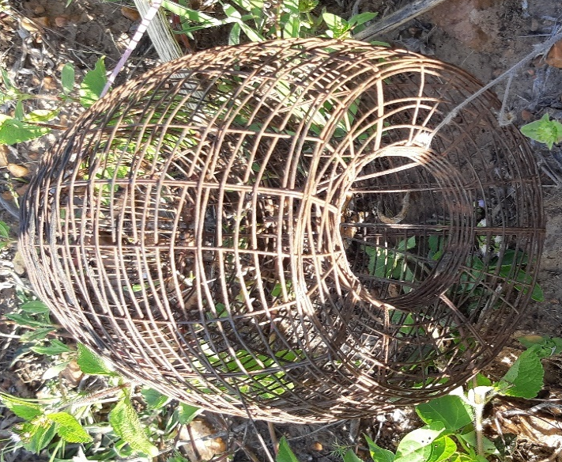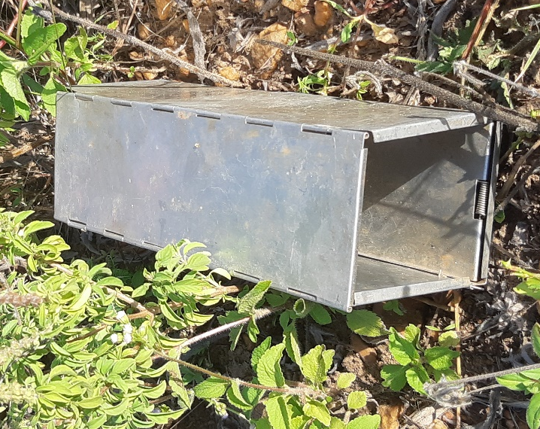
Wire marsh trap Sherman trap
Byrom, A. E., Nkwabi, A. J., Metzger, K., Mduma, S. A., Forrester, G. J., Ruscoe, W. A., . . . Sinclair, A. (2015). Anthropogenic stressors influence small mammal communities in tropical East African savanna at multiple spatial scales. Wildlife Research, 42(2), 119-131.
Cao, C., Shuai, L.-Y., Xin, X.-P., Liu, Z.-T., Song, Y.-L., & Zeng, Z.-G. (2016). Effects of cattle grazing on small mammal communities in the Hulunber meadow steppe. PeerJ, 4, e2349.
Chao, A., Gotelli, N. J., Hsieh, T., Sander, E. L., Ma, K., Colwell, R. K., & Ellison, A. M. (2014). Rarefaction and extrapolation with Hill numbers: a framework for sampling and estimation in species diversity studies. Ecological Monographs, 84(1), 45-67.
Magige, F. (2016). Variation of small mammal populations across different habitat types in the Serengeti ecosystem. Tanzania Journal of Science, 42(1), 15-23.

Sunyer, P., Munoz, A., Bonal, R., & Espelta, J. M. (2013). The ecology of seed dispersal by small rodents: a role for predator and conspecific scents. Functional ecology, 27(6), 1313-1321.

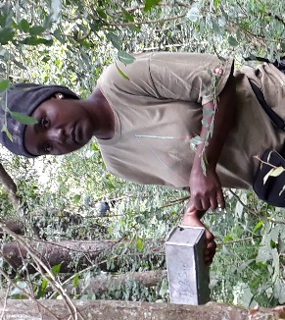Biography
Monica is interested in ecology, teaching and supervising ecology students. She works closely with colleagues at the Department of Zoology, University of Dar es Salaam in developing research, project ideas and proposals. Her areas of research interest are span ecology, community conservation, mammalogy and animal population dynamics. Currently, Monica is doing her PhD in Biology focusing on the distribution, population dynamics and habitat selection by small mammals in the Serengeti-Mara ecosystem.

