FAIR AND EQUITABLE BENEFIT SHARING ARISING FROM THE USE OF BIOLOGICAL/GENETIC RESOURCES: PRACTICAL CASE OF ETHIOPIA; IMPLICATION FOR BIODIVERSITY CONSERVATION
Edeget Merawi*
^{1,} Ethiopian Biodiversity Institute, Bahir Dar Biodiversity Center
Telephone Number- 251-0913489413
Abstract
Plates showing Major Endeavor 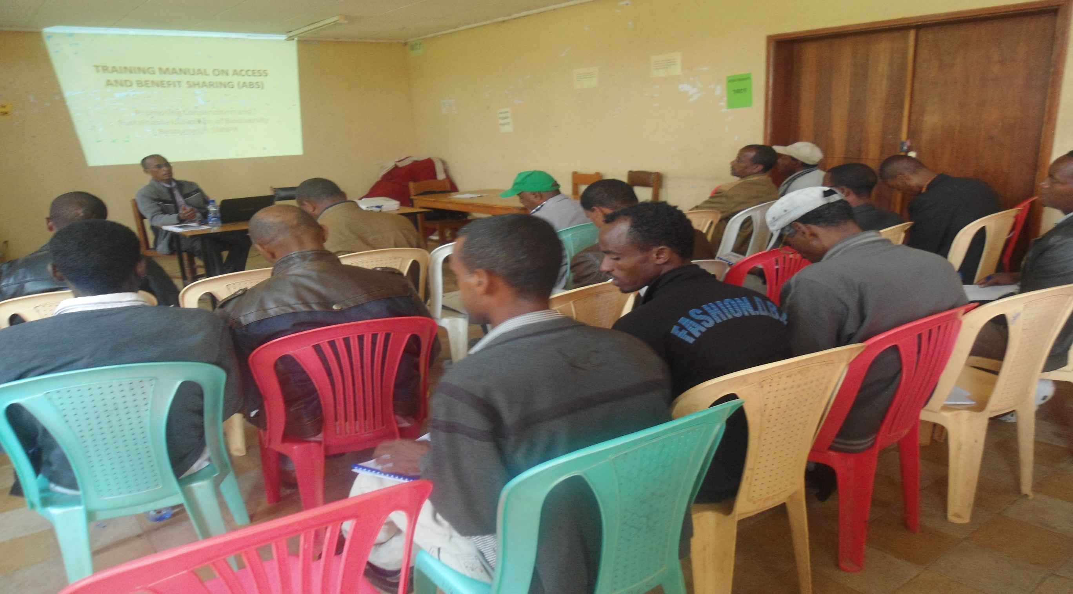
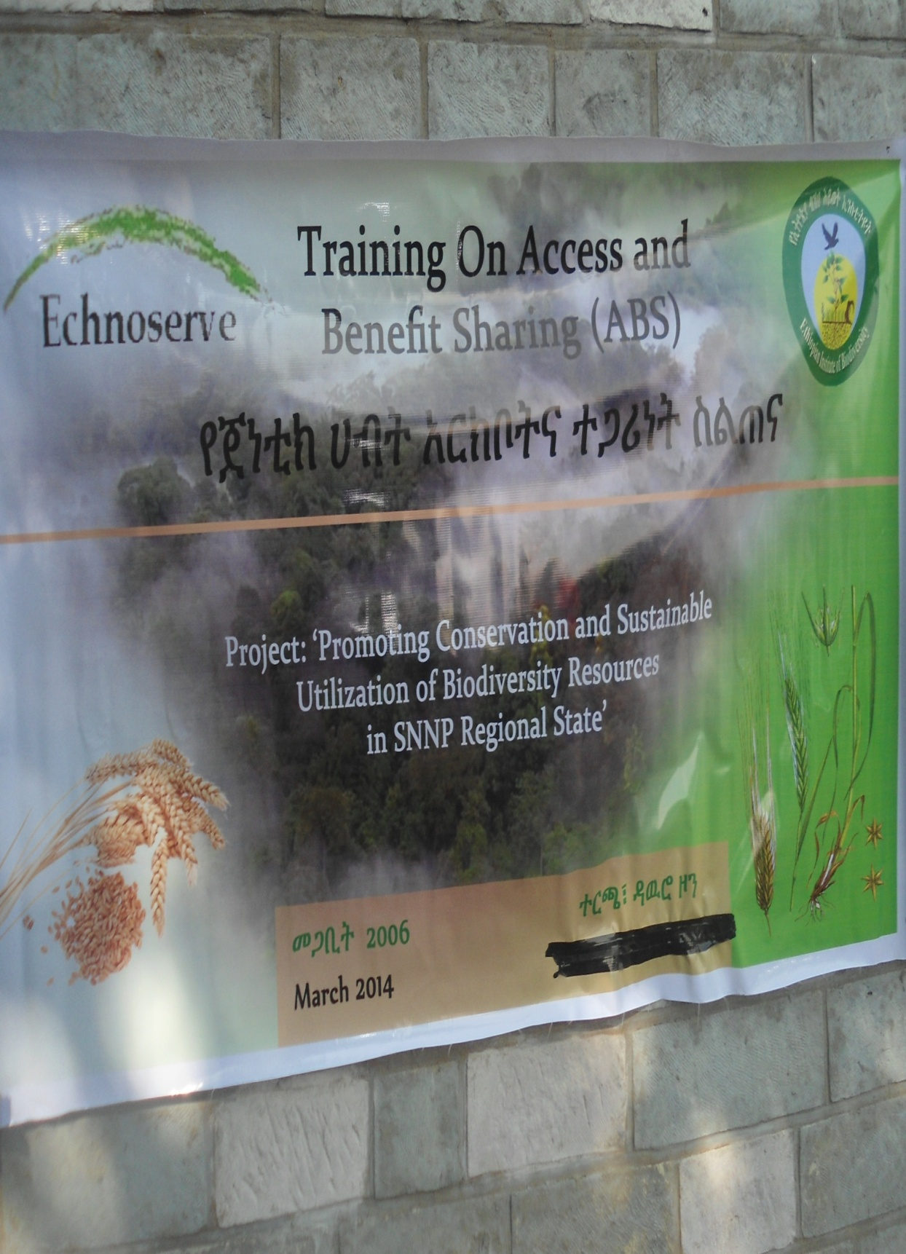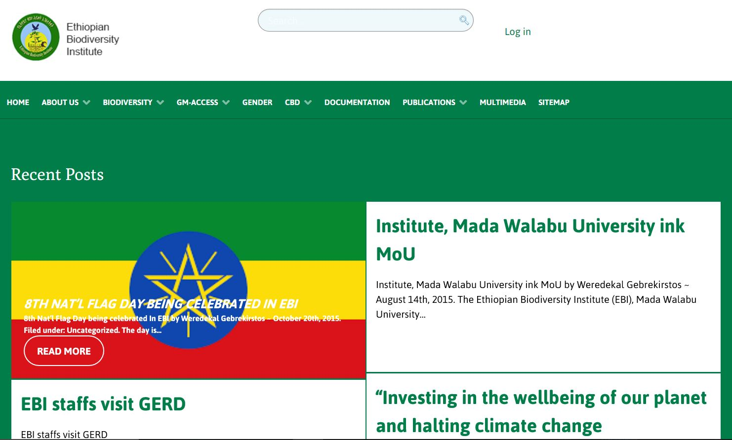
Before the coming in to force of convention on biological diversity in 1993, genetic resources were regarded as common heritage of humankind. As a result any one were used to collect, transfer and use genetic resources without prior informed consent of the genetic resource owners. However, after the coming into force of CBD principles of national sovereignty of parties on genetic resources have been set in order to strengthen legitimate ownership and protection from misappropriation and piracy. In line with the convention with regard to access to genetic resource, the national legislation of Ethiopia ‘access to genetic resources and community knowledge and community rights proclamation with its implementing regulation puts a requirement of access permit to establish a fair and equitable benefit sharing arising from the use of genetic resources and associated community knowledge between users and providers. As a result, Ethiopia signed a mutual agreed term with thirteen national and international genetic resources user companies and obtained 100,000 USD in return. According to the domestic legislation of Ethiopia, 50 % of the money obtained from access permit shall be used for Promoting conservation and sustainable utilization of biodiversity and the remaining money shall be used for common interest of the local people. As a result, three project was lunched to restore, manage and conserve indigenous tree species where in areas User Company consumed genetic resources. Major achievements like technology transfer, identifying potential genetic resources for bioprospecting and raising awareness of the local peoples are some of the endeavor.
Recent Publications
- 1. Edeget .M. etal.(2016); Surveying illegal access to genetic resources: a case study in Borena Zone, Southern Ethiopia
- 2.Edeget.M etal. (2016);Assessment of the Invasive Alien Species Argemone ochrolueca in Northern Ethiopia
- 3. Edeget. M etal. (2016);Surveying the Impact of IAS Mimossa diplotricha, in Jimma Zone
- 4.Edeget. M. etal. (2016);Bioprospecting Potential of Ocimum basilicum in Bahirdar and North Gonder, Ethiopia
- 5.Edeget. M.(2016); Identification of threats, pressure and their relative severity of Temcha Riverine Forest, Northern Ethiopia.
Key word: User Company, genetic resources, Bioprospecting, fair, equitable
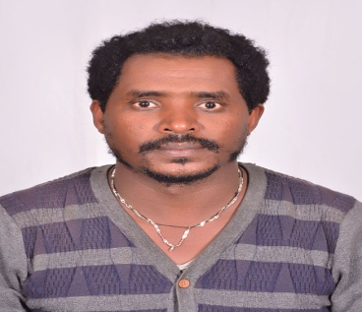
Biography
Edeeget Merawi is a botanist expertise in Invasive alien species and passion in controlling the spread of Invasive Alien Species and wellbeing of Biodiversity. His idea in managing Invasive Alien Species is a breakthrough in the controlling campaign of IAS. He has developed management strategy of many Invasive alien species and published in peer-reviewed journals.
Email- Edegetmerawi@gmail.com

