How to solve water problem of Nagaur ? Interlinking of Rivers and reviving traditional water sources

can solve the water problem in Rajasthan

Dr Rashmi Sharma

Associate Professor

AJMER

RAJASTHAN
sharmarashmigca@gmail.com

Abstract

Nagaur is located in the center of Rajasthan (INDIA) between 27 ⁰ 25’& 27 ⁰ 40 ‘ N Latitude and 73 ⁰ 10 ‘ &75 ⁰.15’ E Longitude covering a geographical area of about 17,718 sq k m . it has Bikaner in west Churu in North , Sikar north west Jaipur East Ajmer south east Pali in south and jodhpur in southwest.Flora of Nagaur is endemic to Arid and are specially adapted to survive in the dry waterless region of the state. Nagaur is Flouride affected district ( Flouride is high in underground water).10 Tehsils and 1610 villages are there in Nagaur. Average rainfall is 36.16 cm. Echinops echinatus , Vachellia nilotica ,Dalbergia sisso, Tachomella undulate ,Ficus religiosa, Calotropis procera Argemone maxicanum are principal plants . Water problem is the is great problem of Nagaur . Due to Scarcity of Rains . Giving subcanals from Indira Gandhi Canal towards east & Subcanals from Banas towards west can solve water problem of arid Rajasthan .
Interlinking of Rivers like Indira Gandhi canal and Luni River and Banas River and revival of traditional water sources can solve the water scarcity problem of Rajasthan.
Key words : Interlinking rivers ,Nagaur , Rajasthan .

Introduction
Nagaur is located in the center of Rajasthan (INDIA) between 27 ⁰ 25’& 27 ⁰ 40 ‘ N Latitude and 73
⁰ 10 ‘ &75 ⁰.15’ E Longitude covering a geographical area of about 17,718 sq k m . it has Bikaner in
west Churu in North , Sikar north west Jaipur East Ajmer south east Pali in south and
jodhpur in southwest.Flora of Nagaur is endemic to Arid and are specially adapted to survive
in the dry waterless region of the state. Nagaur is Flouride affected district ( Flouride is high in
underground water).Average rainfall is 36.16 cm.
Interlinking of rivers can solve water problem of Rajasthan .
Nagaur has drinking water supply from Indira Gandhi canal ( IGC ) with the help of Japan
International Corporation Agency ( JIAC) , during summers because demand of water increases
, A branch of IGC should be given to Nagaur. Due to Scarcity of Rains .
Interlinking of Rivers like Indira Gandhi canal and Luni River and Banas River can solve the
water scarcity problem of Rajasthan.
Rajasthan has 5 Rivers and one Indira Gandhi Canal , Five rivers of Rajasthan are Banganga,
Banas, Ghaggar, Luni, Chambal, Mahi.
Interlinking of these Rivers can solve the problem of Drought and flood both.
The interlinking of rivers is major venture to create additional storage facilities and transfer
surplus water to drought areas. This is an integrated approach becomes necessary when
dealing with water resource. This was issued in 1926 by Sir C.P. Ramaswamy , Aivarand ,
K.L. Rao and Capt. Dastur in 1970 and 1980 respectively.
Benefits of interlinking rivers are in irrigation, flood prevention, hydropower generation,
and navigation. This paper highlights interlinking of rivers, ecological and economic benefits,
Leading to sustainable development.

Status of water resources.

Due to spatial disparity in the rainfall in Rajasthan some regions become water

Surfeit due to inundation and other regions become water meager due to drouth .

Catenating of tributeries and planting trees bring enduring solution to negative impact

of drought and deluge. It brings transfer of water from water surfeit region to water

scant regions.

Due to rapid growth of inhabitants and increase in demand of fresh water .l
Precipitation in Rajasthan is below 100 mm. and in Meghalaya it is above 11000mm.
Due to global warming and climate change , rainfall pattern will change, more rains in
wet areas and drought in dry areas. This will also affect water resources, & Biodiversity loss.
By 2020 the world population will increase to 7.9 billion, water constitutes more than ¾
Part of the land so earth is also known as blue planet. Of the total water 99 % is not
utilizable 97.2% ocean water, 2.15% in the form of glacier, 0.3% is underground water, so very
few portion as exterior water is available for use. So proper planning is essential for
utilization of limited surface water.

Methods

Map of Rajasthan was studied with special references to rivers of Rajasthan and how they
can be interlinked.

 | Click here for Customized Maps |  | 

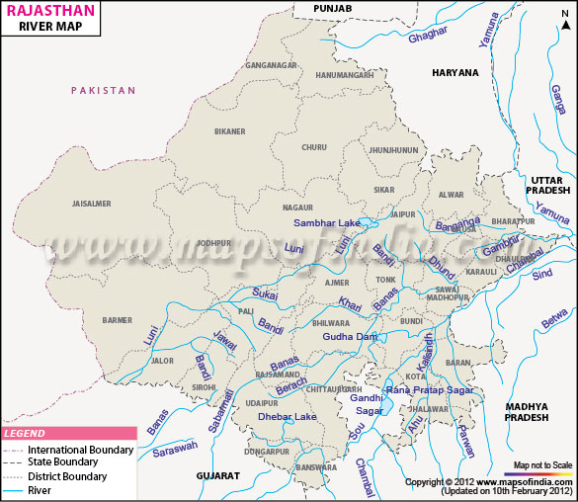

River Map of Rajasthan

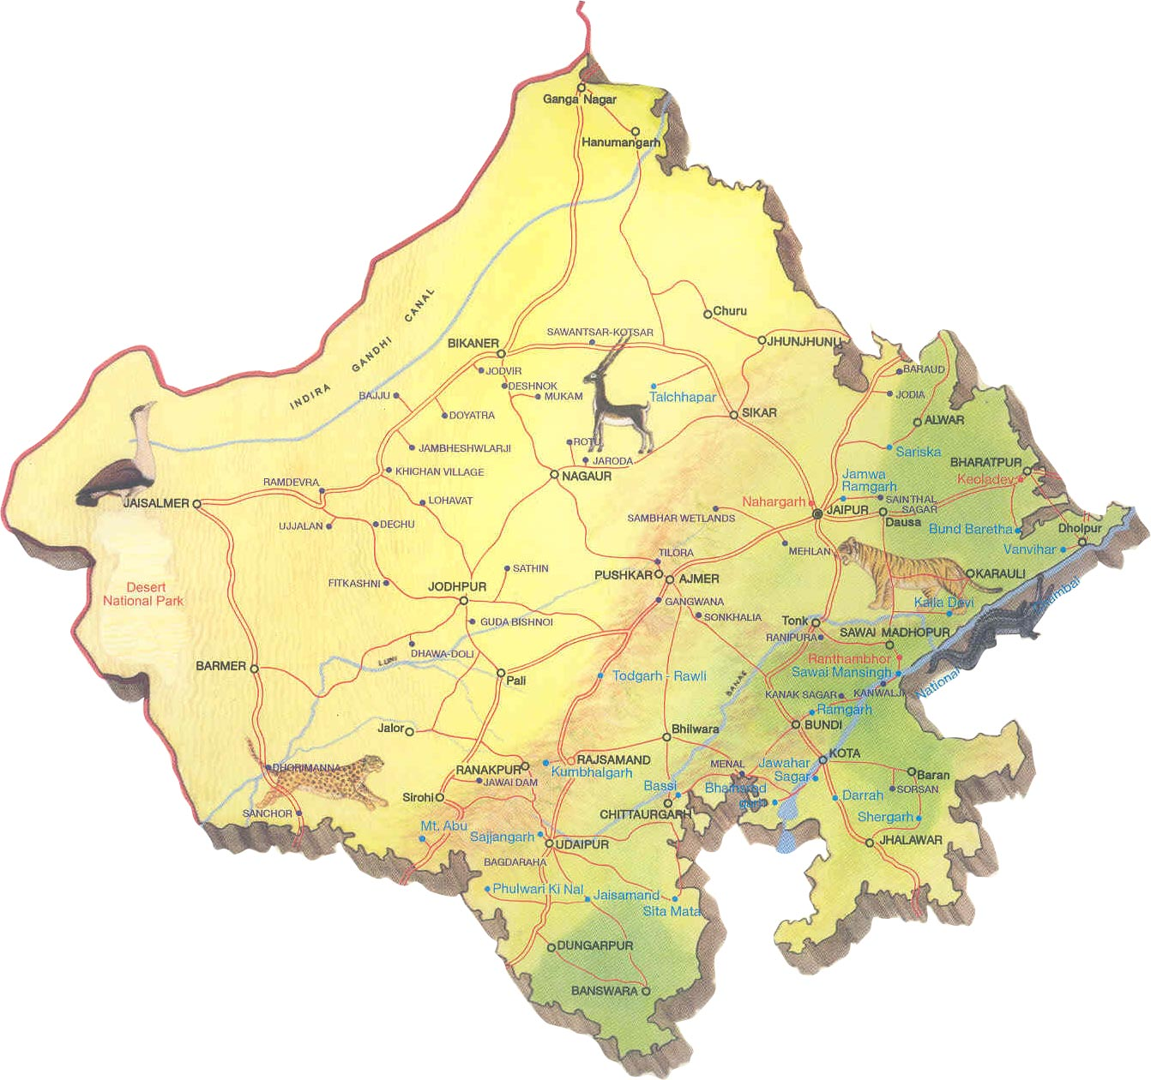
Map : Rivers of Rajasthan

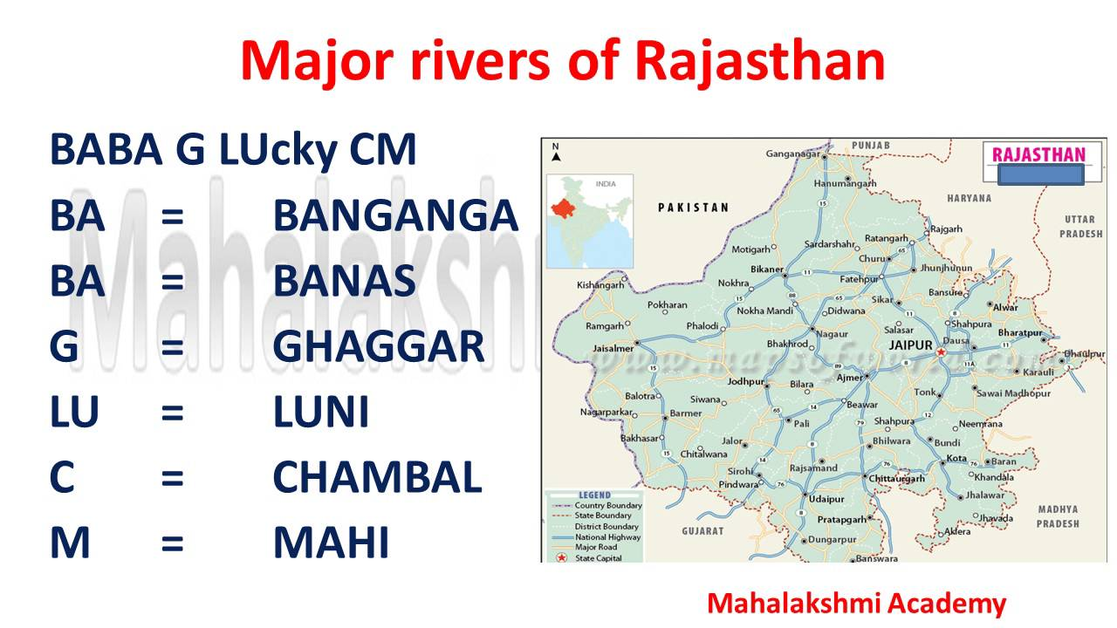

PREREQUISIT TO CONSERVE FRESH WATER

Agriculture

More than 90% of fresh water is used for irrigation to produce plenteous amount of food.

Drinking Water

The total population of Nagaur is 1,10,800 (2011) persons. The human body contains more
than 71 % of water for proper functioning of body more than 7 liters of water is required
per day. Nagaur has drinking water supply from Indira Gandhi canal ( IGC ) with the help
of Japan International Corporation Agency ( JIAC) , during summers because demand of water
increases , A branch of IGC should be given to Nagaur.

Washing

Water is also used for washing vegetables, fruits, clothes etc. Because it forms emulsions and
solutions. Water is also used in industrial process . Chemicals dissolve in water.
For hygene also water is used.
Transportation
Transportation of material through rivers and oceans (Shipping).
Chemical use (Dying etc.)
Water is also used in chemical reactions as solvent.

Heat Exchange

Water is also used as heat exchange fluid due to its high heat
capacity. Water is also used as Neutron moderator.

Fire Extinction
Water is used for fire annihilation. Water is inert and it has high
heat of vaporization.

Recreation

Humans use water for dalliance like swimming, sports, boating,
surfing, diving , ice staking water parks etc. water is also used in
fountains. Aquarium also use water.

Power generation

Water is also used in power generation. Electricity is produced from
hydropower.

Industrial Applications

Water is also used in Industries. Hydroelectricity is obtained from
hydropower. Water is also used in industrial processes and also as
chemical solvent. But discharge untreated water from industries
cause pollution. Purification techniques should be used to purify
polluted water.

Food Processing

Water is also used in cooking food, Food hydrolysis. Boiling, steaming, simmering.
Water is also used as dishwashing. So we should safeguard water as much as possible to
meet our future needs.
The advantage of interlinking rivers is excess flood water is redirected to basins having
meager rainfall.
This has twofold advantage it protect flood prone areasfrom large amount of water and
supplies drought prone areas with a source of water NWDA planned interlinking of rivers
under late PM Indira Gandhi (1982).

SUCCESS OF INTERLINKING RIVER PROJECTS

There are many benefits of interlinking rivers like solving drought and flood problems, water
available for irrigation, water is available for drinking, hydropower, more navigation,
employment generation.
Successful Interlinking river projects are:
Indira Gandhi Canal
Embarked in 1958. It utilizes 9,367 Mm3/yr of total 10,608 Mm3 /yr
assigned to Rajasthan from surplus water of Ravi and Beas rivers.
The project is devided into two stages:
Stage I - 204 Km long feeder canal discharge capacity of 460 m3/sec. start from
Harike Barrage. 170 Km feeder canal lie in Punjab and Haryana and 34 Km in Rajasthan.
RSEB to install a total 12.76 MW of mini hydroelectric power stations to utilize available
waterfall in canal one such powerstation started in Suratgarh branch.

Stage II 256 Km long main canal and 5,606 Km lined distribution system. Utilising 4,930 Mm3
/yr water. The canal in entire length completed in 1986.

Colorado Big Thomson USA

Vindication of ILR
The interlinking is about linking surplus water rivers to water deficient rivers.
So that rivers that have large amount water can be transported to water scarce regions.
For example from Kashmir to Rajasthan.
This will help inundation, commercial use, industries, drinking purpose, washing , cleaning
to generate hydroelectricity etc.

Rainfall
Rajasthan is western state of India and climate is arid or semiarid.
Temperature is extreme in summer temperature reaches above 45-48 ⁰ C. and in winters sometimes below 10 ⁰ C.
Rajasthan has hot desert. Receives low rainfall.
Annual average rainfall is 14- 300 cm. Summer is longest season.
Water availability is low. Strong dusty wind in summer known as loo.
In winter weather is pleasant. Water is scarce in Rajasthan and waisted as flood in
northern and eastern states. So interlinking of rivers can help.

Storage Capacity

Rajasthan is not having storage formulations resulting in dearth of water. USA has per
capita storage capacity 5961m 3 per person and India 200m3 per person.
Rajasthan is scarce in water so increasing storage capacity will be beneficial.

Food production

Food production will be improved if good amount of water is present for irrigation.
Grain demand for India by 2050 is 425 million tons. Rajasthan irrigation potential should also
be increased to increase grain production.

Improving Rural as well as urban life

More than 70 % Indias population lives in villages. And most population
depend for livelihood on agriculture. If water resources are proper and
manageable ther will be good grain production and improve the life
of rural population.
Hydropower 34000 will be generated. These will create employment also.
But there are also adverse impacts of Inter l inkingL River .
Danger of seismic hazard in Himalayas due to ILR transfer of river
pollution will also be there.

Traditional water harvesting systems

Jhalara : This is traditional water harvesting system present in Thar desert.
Talab : Talab is a large pond used to harvest water. Stockpile to store water.
Pokhariyan is natural talab and Tikamgarh in Bundelkhand .
Talai : Small pond used to harvest rainwater.
Bandhi : Old Rain water harvesting system.
Sagar :. Conserve water .
Bawari : Stepwells to store water in Rajasthan.
Samand : Ponds are made to conserve water.
Jhalaras : Rajasthan specially in Jodhpur 8 Jhalaras are there to conserve water . Mahamandir
jhal is oldest one.
Tanka : Cylindrical underground well to store rainwater ( For 7 persons in summers ) in
Jaisalmer. Made artificially
Ahar Pynes : Artificial water channels ( to irrigate rice fields ) from falgu river in
South Bihar.
Johads : Small fictile dams to store rain water. Makad in Karnataka. Pemghara in
Odhisa.
Panam keni : Wodden cylindrical structures are made to store water by Kuruma tribe in
Wayanad .
Khadin dhana : Long earth bank to slope land is gravel. Used by Paliwal Brahmins to
store water in Jaisalmer.
Kund : Bowl shaped area to store water used in Gujarat. First made by Raja Sur Singh.
(1607).
Baoli
: Stepwells to store water in Rajasthan Made for Philanthropic reason.
Nadi : In Jodhpur , used to conserve water, Large water storage capacity.
Bhandara : In Maharashtra it is phad community based irrigation system, canals build to carry
water to fields.
Zings : Ladakh small tanks Zings collect melting snow from mountains. Which is channeled to
farm.
Kuhls : In Kangra ( Himachal Pradesh ) water harvested through Khuls.
Zabo ( Ruza ) : Hilly areas rainwater collected in puddles . It is used for agriculture.
Bamboo drip irrigation : Asam , Meghalaya , Manipur , Mizorum , Nagaland , Tripura , Sikkim and
Arunachal Pradesh water is passaged from strings using bamboo pipes to fields ( Khasi and
Jaintia and Khasi hills black pepper fields.
Ramtek network : Maharashtra , Malguzars ( Landowners ) chain of tanks connect ground and
surface water. This conserve 80 % rainwater.
Jackwells : In Nicobar pits or Jackwells made to conserve water surrounded by woods and
logs.
Pat system : Madhya Pradesh ( Bhitada, Jhabua and villages ) , Bunds are made near stream
,lined with leaves. These passaged in diches .
Eri (Tank). Water harvesting system used in Kerala. Tamilnadu , Karnataka (Kares ) , Andhra
Pradesh ( Cheruvus ) , Asam ( Dongs ) Rainwater harvesting percolation skills.

Rainwater harvesting
To stop extra water flow into river or sewage systems.

Ground water and surface water

Techniques of irrigation

Desalination
Remaval of salt from hard water is another solution for the problem but hard water is
also not available in Ajmer. Desert is spreading rapidly due to cutting of Aravallis and
mining activities. Desert is spreading.

Cloud seeding
Intentional rains and weather changing . amount and type of precipitation change.
Orice nuclei cloud condensation. This is done to increase precipitation.

Criteria for Interlinking rivers
Surplus water should be there in donor rivers. So Canal like Indira Gandhi Canal should
be developed and interlinked to solve water problem of Nagaur ,Ajmer ,Bikaner ,Jodhpur
,Jaisalmer ,Barmer, Rajasthan.

Conclusion

Nagaur is water scarce place , Flouride is present in water These ILR (Interlinking of River )

are extremely useful for Nagaur ,Ajmer , Jaipur , Bikaner ,Jaisalmer , Jodhpur ,Barmer & Rajasthan , India and specially Rajasthan Reliable projects should be made for Interlinking rivers. Each village and town should be made responsible for its own water conservation
Lakes ,Tank s ,Ponds , Tanka s , Eri, Pat , Jackwells , Ramtek , Bamboo drip , Bhandara ,
Baoli , Kuhls , Zings , Jhalara , Talab , Talai , Bandhi , Sagar , Bawari , Samand , Jhalaras,
Tanka , Ahar Pynes , Panam keni ,Johad , Panam keni ,Khadin Dhana ,Kund ,Baoli , Nadi ,
Zabo . These are all important Traditional water conservation and harvesting methods.

References

1. Dyson,T (1996) Population and food : Global Trends and future prospects.
(London : Routledge ).
2. IWRS (1996) Theme paper on Inter basin transfer of water for National Development :
Problems and Perspectives Indian Water Resources Society.
3. www.nih.ernet.in; National Institute of hydrology.
4. B.S. Prakasa Rao P.H.V. Vasudeva Rao , G. Jaisankar , E. Amminedu , M. Satyakumar and
Koteswara Rao, ‘Interlinking of River Basins : A Mega Harvesting Plan – A Review . ‘ J. Ind.
Geophys, Union (January 2010 ) Vol.14, No.1, pp.31-46.
5. National Water Development Agency , Annual Report ‘ 2011-12.
6. Tushar Shah, Upali Amrasinghe, Peter Mc Comik, India ‘s River Linking Project : The state
Of Debate 1.
7. Bala Raju Nikku , Water Rights , Conflicts and Collective Action, Case of Telugu Ganga
Project , India Poster Presentation.
8. Canal Solar Power. The Hindu Business Line, 23rd April 2012,13 , Bandyopadhyaya J. and
Praveen , S. (2003).
9. Tangri, A. K. 2003. Impact of climate change on Himalayan Glaciers. Published in the
proceedings of the NATCOM –V&A .
10. Iyer, R (2003) Water : Perspectives, Issues Concerns, at New Delhi, Stage Publications.
11. Badiger, R. Sakthivadivel, N. Alosivus & H Sally Preliminary assessment of a traditional
approach to rain water harvesting and artificial recharging of ground water in Alwar district
Rajasthan by Interlinking River Basin s A Review 45.
.

.

